Name: __________________________________________________ Date: _______________________ Period: ______

**Unit 7 Review Packet Molecular Genetics – ANSWER KEY**

**Topic #1: DNA**

1) What conclusions did Avery, McCarty, and Macleod draw from the results of their experiment, which expanded upon Griffith’s experiment?

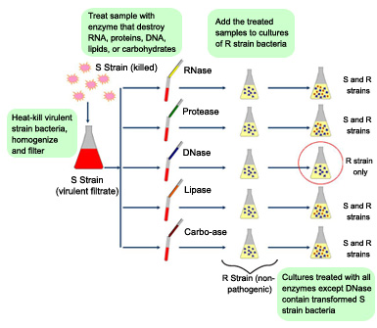

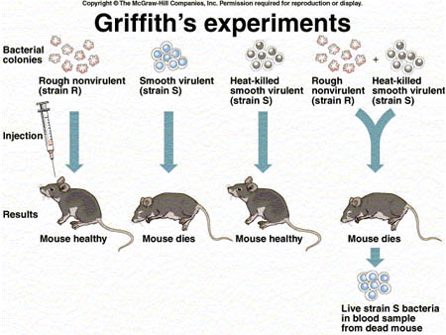

If the enzymes destroyed lipids, polysaccharides (large carbohydrates) proteins, or RNA, the heat-killed S strain bacteria were still able to transform the R strain bacteria into virulent bacteria. If the enzymes destroyed DNA, the heat-killed S strain bacteria could not transform the R strain bacteria into virulent bacteria, indicating that DNA was the genetic molecule in bacteria.

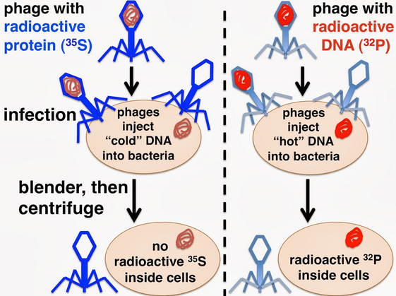

2) What conclusions did Hershey and Chase draw from the results of their experiment? Which molecule was injected from the virus into the bacteria (i.e. the genetic material of the virus), and how did they know?

They hypothesized that whichever molecule from the virus (protein coat or DNA) was injected into the host cell, that molecule was the genetic material of the virus. Viruses must inject their genetic material into a host cell, because they use the host cell to replicate their genetic material—a necessary step in viral reproduction. they radioactively labeled an isotope of phosphorus (32P) found in the DNA of the virus and then allowed the virus to infect the bacterial host cell. After infection, they detected radioactivity inside the host cell. This indicated that DNA was the genetic material of the virus.

3) The image to the right shows DNA replication. How will the new DNA strand be created on the top and bottom of the molecule using DNA polymerase?

DNA polymerase, recognizes the primer and brings in free DNA nucleotides to match up with nucleotides on the parent strand. DNA polymerase reads the template strand in its 3’ → 5’ direction. It builds a new strand in its 5’→3’ direction. 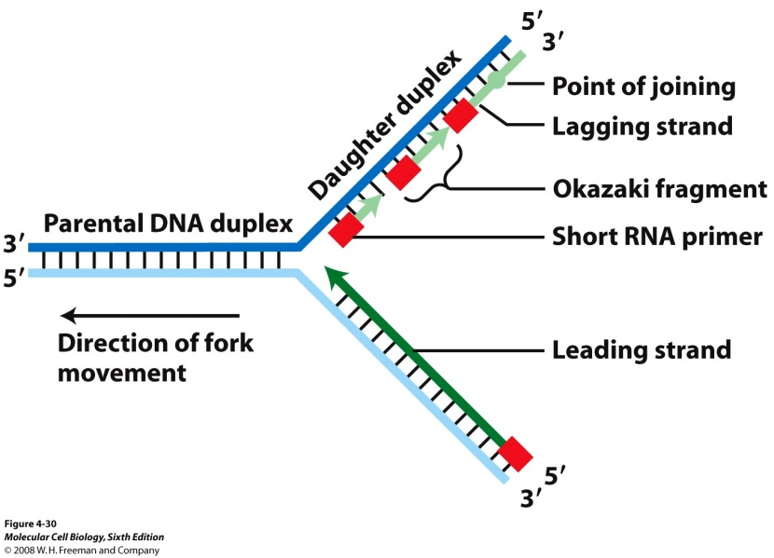The leading parent strand runs from its 3’ 🡪 5’ end heading into the replication fork (the area where helicase is unzipping the double helix), so a new strand can be built from its 5’ 🡪 3’ end continuously into the replication fork. The lagging parent strand runs from its 3’ 🡪 5’ end heading out of the replication fork, so a new strand can be built from its 5’ 🡪 3’ end in “chunks” out of the replication fork. (It must be built in “chunks” because DNA polymerase constantly needs to “backtrack” into the fork as it opens up.)

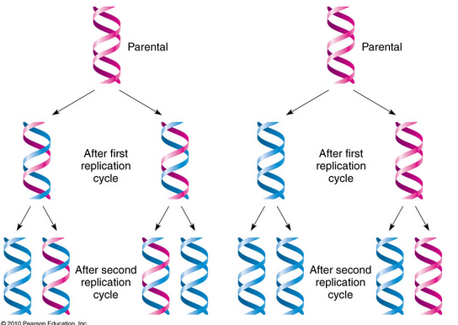

4) Which models of DNA replication—dispersive, semiconservative, or conservative—are shown in diagrams to the right? (Hint: You will need to look at the color version of these pictures!) Which one is correct?

Left = Semiconservative, Right = conservative

Semiconservative replication is more accurate because separation of the two original strands provides two templates from the original helix during the first round of replication, and this helps limit the number of replication errors or mutations that occur.

5) Guanine makes up 23% of the nucleotides in a sample of DNA from an organism. Approximately what percentage of the nucleotides in this sample will be adenine and why?

G = 23%, so C = 23% 🡪 total of 46%

54% left over for A and T. They must equal each other so 54%/2 = A

6) Identify the roles of the following enzymes in DNA replication: helicase, primase, DNA polymerase, and ligase.

* helicase, which breaks the hydrogen bonds between complementary nitrogenous bases
* primase, creates a short strand of RNA nucleotides to start a daughter strand that is complementary to one of the parent (aka template) strands.
* DNA polymerase, recognizes the primer and brings in free DNA nucleotides to match up with nucleotides on the parent strand.
* The chunks on the lagging strand are called Okazaki fragments and they are joined together by an enzyme called ligase.

**Topic #2: From Gene to Protein**

7) Use the following chart to compare transcription and translation:

|  |  |  |  |  |
| --- | --- | --- | --- | --- |
| **Process** | **Starting Molecule** | **Ending Molecule** | **Location in a Eukaryotic Cell** | **Helper Enzymes / Molecules Used** |
| Transcription | DNA | mRNA | Nucleus | DNA, mRNA and RNA polymerase |
| Translation | mRNA | Polypeptide | Ribosome | mRNA, tRNA, rRNA |

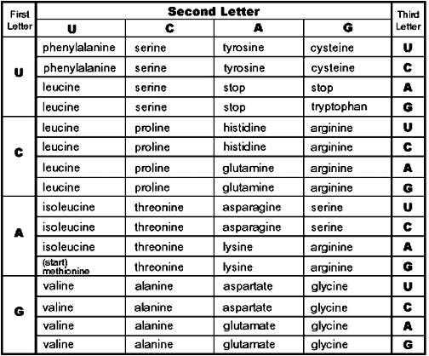8) Some geneticists consider the third base of a codon to be less important than the first two bases as a code for a specific amino acid. Why is this the case? Provide a specific piece of evidence from the codon chart to the right to support your explanation.

3rd base “wobble” = codons for the same amino acid often differ in the 3rd base

9) What is a possible mRNA sequence (written from its 5’ to 3’ end) that could produce the following amino acid sequence?

Leu – Lys – Gly – Val – Ser – Tryp

5’ CU(U/G/C/A) - AA(A/G) - GG (U/G/C/A) - GU(U/G/C/A) - UC(U/G/C/A) - UGG 3’

OR

5’ UU (A/G) - AA(A/G) - GG (U/G/C/A) - GU(U/G/C/A) - UC(U/G/C/A) - UGG 3’

10) Using your mRNA sequence from #9, write out the DNA sequence (from 3’ to 5’) that could produce this mRNA sequence.

3’ GA(A/C/G/T) - TT(T/C) - CC(A/C/G/T) - CA(A/C/G/T) - AG(A/C/G/T) - ACC 5’

OR

3’ AA(T/C) - TT(T/C) - CC(A/C/G/T) - CA(A/C/G/T) - AG(A/C/G/T) - ACC 5’

11) Describe the mutation that occurred in the mutated DNA sequence given below. Predict the effect on the resulting polypeptide

Original DNA: A G G T C T A A A G T G

Mutated DNA: A G G G T C T A A A G T G

Frameshift mutation – insertion. All of the amino acid sequence will be changed following the insertion

12) A cell has a defective enzyme that attaches the alanine amino acid (Ala), instead of a valine amino acid (Val), to tRNAs with the anticodon CAA. Will any polypeptides in the cell contain valine? Why or why not?

Yes because the tRNAs with CAC, CAG and CAU will all still produce valine

13) How is the mRNA strand altered during mRNA processing (the intermediate step between transcription and translation)? How are these modifications helpful?

1. Modification #1: GTP “cap” - guanine added to 5’ end of RNA to prevent degradation and enable the mRNA to bind to the ribosome during translation
2. Modification #2: PolyA “tail” - AAA added to the 3’ end to prevent degradation and enable the mRNA to pass through the pores in the nuclear membrane
3. Modification #3: Removal of introns from the pre-mRNA

**Topic #3: Viral and Bacterial Genetics**



14) What is occurring in the process shown below? Is this process beneficial or harmful to the bacterial **population**? Explain your answer.

Transduction = bacteriophage viruses (viruses that infect bacteria) can pick up and transfer bacterial DNA to a new host along with viral DNA. This allows for genetic recombination which leads to more genetic diversity. More genetic diversity = more resistance

15) How is retroviral infection different from infection by a “normal virus?” Which type of virus has a higher mutation rate and why?

Unlike a normal virus, their genetic material is RNA, not DNA. They contain the enzyme reverse transcriptase, which uses viral RNA to make a complementary DNA strand. Reverse transcriptase can then synthesize the other DNA strand from the cDNA 🡪 full DNA double helix. The DNA can be incorporated into the host cell genome as a provirus (before virus) and later transcribed into RNA to make protein capsids and RNA genomes for the next generation. The retrovirus has a higher mutation rate because the RNA viruses do not have ways to “proofread” the creation of their cDNA from RNA, so they have higher rates of mutation.

16) What are the differences between the lytic and lysogenic cycles of viral reproduction?

|  |  |
| --- | --- |
| **Lytic Cycle** | **Lysogenic Cycle** |
| -Type of reproduction that results in the death of the host  -Virus injects DNA into the host cell  -Takes over the enzymes (ex: DNA and RNA polymerase, ribosomes, etc.) to make copies of viral DNA and capsid proteins  -Progeny (baby) viruses are assembled  -Cell is lysed (cell membrane and cell wall are digested / broken), which releases multiple copies of the virus | -Does not destroy the host  -Viral DNA is incorporated into host DNA and replicates along with the host DNA  -The incorporated viral DNA is called a prophage or provirus  -Can stay in host DNA for years  -Certain conditions can cause prophage to leave host DNA and enter lytic cycle |

17) Describe the difference between bacterial conjugation and transformation. What is the purpose of these processes?

Transformation is the alteration of a bacterial cell’s genetic material by the uptake of naked, foreign DNA from the surrounding environment whereas Conjugation is bacterial “sex” ; bacteria with F factor plasmids can form sex pili; sex pili are structures that are used to directly transfer DNA to another bacterium ; F+ cells (with F plasmid) are the donor cells during conjugation and F- cells (without F plasmid) are receivers of plasmid DNA. Both allow for genetic recombination in bacteria and more genetic diversity.