Name: __________________________________________________ Date: _______________________ Period: ______

Unit 5 Cell Signaling Review Packet

Topic #1: The Basics of Cell Signaling

- A small, nonpolar signal molecule is sent to a target cell. What type of receptor is used (intracellular vs. plasma membrane) and what type of response occurs (cytoplasmic vs. nuclear)? Explain your answers.

The type of receptor would be intracellular and the type of response would be likely to be nuclear.

- A large, polar signal molecule is sent to a target cell. What type of receptor is used (intracellular vs. plasma membrane) and what type of response occurs (cytoplasmic vs. nuclear)? Explain your answers.

The type of receptor would plasma membrane and the type of response would likely be cytoplasmic.

- Provide an example of cell signaling by direct contact in either animals or plants. What are the pros and cons of using this method of signaling?

Plasmodesmata is an example of signaling by direct contact in plants. In the human immune system, a type of white blood cell called a macrophage (literally "big eater") swallows any foreign particles (ex: viruses or bacteria). These foreign particles are called antigens. They are "chopped up" by the macrophages and presented on the surface of the cell. For that reason, these macrophages are known as antigen-presenting cells. The presented antigens make direct contact with other white blood cells called helper T cells. The helper T cells then respond by causing the creation of antibodies (by B cells) that bind to that specific antigen when it is free-floating in the blood. The helper T cells also aide in the creation of killer T cells (cytotoxic T cell) that bind to cells infected by the specific antigen and destroy them.

Pros – signal is right there – unlikely to be used with the wrong type of cell. Cons – cannot send the signal over a long distance.

- The endocrine system is used for signaling across long distances. What are the pros and cons of using this method of cell signaling?

Hormones are chemicals that are secreted into the bloodstream by a tissue called a gland. These chemicals have multiple "target organs" in which they trigger a response. Pros are that they are able to activate a wide range of responses; however they would have issues getting a very specified response.

- In class, we learned about the epinephrine signaling pathway involved in the fight or flight response. If the second messenger molecule cyclic AMP (cAMP) cannot be created during the transduction step of this pathway, what will be the final effect on the signaling pathway?

In the long term – no blood glucose would be secreted into the bloodstream. Short term – you wouldn’t be able to activate the protein kinases, which wouldn’t activate the phosphorylase to break down the glycogen.

- If ATP is not present in the cell pictured to the right, what would be the most immediate effect on the receptor tyrosine kinase pathway?
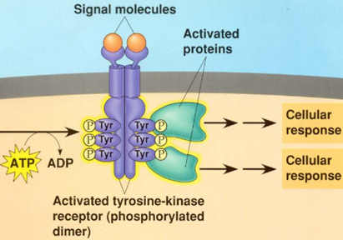
If there was no ATP then the tyrosine kinase couldn’t be activated. Without this activation, the other proteins in the pathway would remain inactive and there would be no cellular response.

- Explain how insulin is used in the pathway pictured below to lower blood glucose.

Normally, insulin (a hormone) is secreted from cells in the pancreas in response to high blood glucose levels. There are insulin receptors on the surface of liver cells that bind to insulin and then cause a glucose transport protein called GLUT to open and allow the entrance of glucose from the bloodstream into the liver cells. Once in the liver cells, glucose can be joined in chains to make glycogen (a storage polysaccharide). This lowers the amount of sugar in the blood to keep it within a safe range.
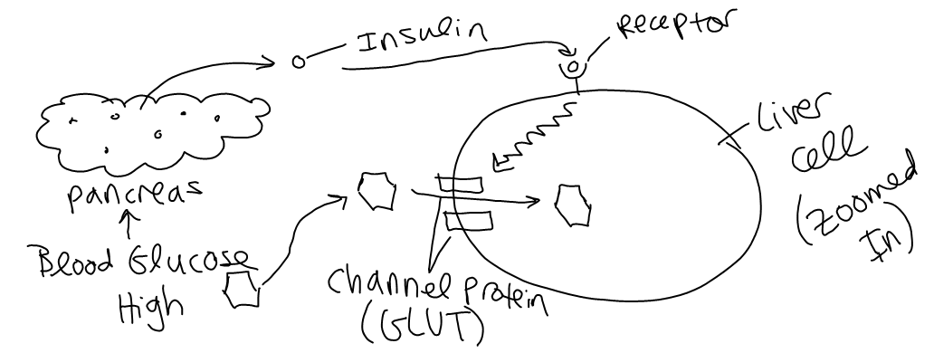

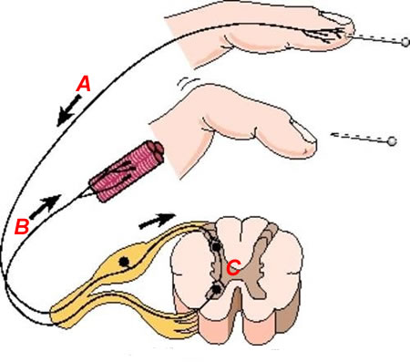
Topic #2: The Nervous System

- Identify the neurons (A, B, C) involved in the polysynaptic reflex arc pictured to the right and explain how they interact to produce a response to the stimulus.

A is the sensory neuron, B is the motor neuron and C is the interneuron. The sensory neuron receives the signal and sends it to the interneuron in the spinal cord. The signal is then transferred to the motor neuron which causes the finger to move.

- How is an excitatory neurotransmitter different from an inhibitory neurotransmitter?

Excitatory signals cause depolarization / action potentials in the post-synaptic neuron, and inhibitory signals cause hyperpolarization (no action potentials) in the post-synaptic neuron.

- What is the role of Schwann cells in nerve signaling?

Schwann cells aid in the production of myelin sheath – a protective and insulating covering over the axon. This helps speed up the signaling process due to salutatory conduction. The depolarization jumps from space to space in between the schwann cells.

- Which ion channels are involved in the depolarization phase of the action potential? How does the opening of these channels affect the membrane potential inside the neuron?

Voltage-gated Na+ channels open during the depolarization phase and it allows the membrane potential to become more positive (move towards 0mV).

- Which ion channels are involved in the repolarization phase of the action potential? How does the opening of these channels affect the membrane potential inside the neuron?

Voltage gated K+ channels open (more slowly than Na+) in response to the -55mV threshold. Once they open, the K+ channels allow K+ to diffuse out of the cell, lowering the cell’s voltage back to its resting potential (-70 mV)

- How do nerve cells reach threshold potential (-55 mV)? What happens when a nerve cell reaches threshold?

The action potential is an explosion of electrical activity that is created by a depolarizing current. This means that some event (a stimulus) causes the resting potential to move toward 0 mV. (an excitatory neurotransmitter). Once it reaches the threshold the action potential must fire and go through depolarization.

- List the steps involved in the transmission of a signal across a synapse. Start from the wave of depolarization (the action potential) reaching the presynaptic neuron’s axon terminal. End with the postsynaptic neuron reaching threshold potential.

  - The axon terminal of the pre-synaptic neuron receives an action potential signal. The depolarization in the axon terminal causes voltage-gated calcium (Ca²⁺) channels to open and allow calcium ions to enter the axon terminal.
  - The influx of calcium causes synaptic vesicles carrying signal molecules called neurotransmitters to fuse with the axon terminal membrane and release neurotransmitters in the synaptic cleft.
  - Neurotransmitter molecules diffuse across the synaptic cleft and bind to ligand-gated ion channels on the post-synaptic (dendrite) membrane.
  - The ligand-gated ion channels open and allow Na+ to enter the cell, triggering depolarization / action potential in the post-synaptic neuron.
  - Synaptic transmission ends when the neurotransmitter diffuses out of the synaptic cleft, is reabsorbed by the pre-synaptic cell, or is degraded by enzymes in the synaptic cleft.

Topic #3: The Endocrine System

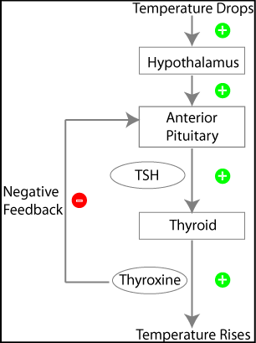
- When the concentration of solutes in the blood (blood osmolarity) is high, the pituitary gland releases antidiuretic hormone (ADH). ADH stimulates the kidneys to reabsorb water in order to increase blood volume and decrease blood osmolarity. When the kidneys reabsorb water, this causes the urine to be extremely concentrated (i.e. have a low water content). How would a person respond to a massive intake of water, which results in a high blood volume?

In response, the kidney would not absorb water (no ADH) because the blood osmolarity would be low (low solutes). This would cause the urine to be less concentrated or have a higher water content.

- The hypothalamus and pituitary release hormones to stimulate the thyroid gland to create thyroxine, a hormone that speeds up metabolism. How does the production of thyroxine affect the hypothalamus and pituitary? Is this an example of positive or negative feedback? Why?

When enough thyroxine is created, there is a negative feedback where it shuts off the production by the pituitary (no stimulation of the thyroid).

- Let’s say the hormone oxytocin causes uterine contractions during mammalian labor. The uterine contractions, in turn, cause the release of more oxytocin, which causes even stronger contractions. Is this an example of positive or negative feedback? Why?

Positive feedback because as the product is produced, it cause an increase in the production of the product (oxytocin).

- When your blood calcium levels are too high, the hormone calcitonin causes the absorption of excess calcium into the bones, lowering the level of calcium in the blood. Is this an example of positive or negative feedback? Why?

Negative feedback because as the product (calcium) is produced it signals for the calcitonin to absorb it into your bones, thus decreasing the product in the blood.

Topic #4: Defense (The Immune System)

- Describe the difference in humans between their specific and nonspecific processes in their immune response.
Your defense system starts with non-specific immunity, also known as innate immunity. This system is comprised of general mechanisms your body deploys every day to keep you safe. They are always working in the background, no matter what pathogens you are exposed to. There are also specialized immune cells that fight intruders once inside the body. The first type of cell is a macrophage, which patrols the body through your blood. When an invader enters, the macrophages move into the tissue like soldiers and remove the threat by swallowing the pathogen and digesting it in a process called phagocytosis

Specific immunity, also known as adaptive immunity, is specialized immunity for particular pathogens. Helper T-cells, cytotoxic T-cells, and B-cells are involved in specific immunity. The non-specific cells, like macrophages, tell the T- and B-cells that an intruder is present. The macrophages show the T- and B-cells parts of the pathogen, called antigens, so they know what to look for. Later, a special kind of cell called a memory cell creates a record of which intruders entered the body, so they can attack it faster during the next infection. There are two types of specific T-cells: helper T-cells and cytotoxic T-cells. Helper T-cells recognize antigens from the macrophages and help to organize other cells in the immune system for a fight. Cytotoxic T-cells recognize infected cells and kill them before the infection spreads. They are like assassins, going in to kill the infected cells for the greater good.

- An individual’s response to an antigen differs depending on whether or not the individual has been previously exposed to that antigen. Explain how the response is different in these two circumstances.

The first part of a response requires: A specific type of macrophage called an antigen –presenting cell (aka APC), which is part of the innate immune system, swallows an antigen released by a pathogen, chops it up, and presents it on its cell surface (Antigen = a molecule (usually a protein or carbohydrate) found on the surface of a pathogen or released by a pathogen that triggers the production of specific immunity molecules called antibodies) The APC binds with a helper T cell, which initiates the specific immune response. Helper T cells trigger the differentiation of several types of lymphocytes (specific types of leukocytes, or white blood cells).

The first portion is no longer needed once exposed to the initial antigen. Then Memory B and cytotoxic T cells can quickly develop into plasma B cells and active cytotoxic T cells to rapidly eradicate a pathogen recognized by the body. This is called the secondary immune response.

- Explain how macrophages initiate an immune response when a new antigen is first encountered.

In the human immune system, a type of white blood cell called a macrophage swallows any foreign particles (ex: viruses or bacteria). These foreign particles are called antigens. They are "chopped up" by the macrophages and presented on the surface of the cell. For that reason, these macrophages are known as antigen-presenting cells. The presented antigens make direct contact with other white blood cells called helper T cells. The helper T cells then respond by causing the creation of antibodies (by B cells) that bind to that specific antigen when it is free-floating in the blood. The helper T cells also aide in the creation of killer T cells (cytotoxic T cell) that bind to cells infected by the specific antigen and destroy them

- Differentiate between the humoral response and the cell-mediated response.

The humoral response (or antibody‐mediated response) involves B cells that recognize antigens or pathogens that are circulating in the lymph or blood (“humor” is a medieval term for body fluid). The cell‐mediated response involves mostly T cells and responds to any cell that displays foreign markers, including cells invaded by pathogens, tumor cells, or transplanted cells.

