Name: __________________________________________________ Date: _______________________ Period: ______

Unit 4 Cellular Structure and Transport Review Packet Answer Key

Topic #1: Cell Structure and Function

- Identify the differences between a prokaryotic and a eukaryotic cell. Discuss the structures found in these cells, their relative size, and the types of organisms in which these cells are found.
Prokaryotic is smaller and less complex – there is no nucleus and no membrane bound organelles (like mitochondria, ER, etc.) Eukaryotic cells are found in plants, animals and fungi Prokaryotic cells are found in eubacteria and archaebacteria.

- Why is it an advantage for eukaryotic cells to have different compartments (aka organelles) in the cell (separated by membranes) with different environments (ex: different pH’s, different enzymes present, etc)?

Eukaryotes have organelles that allow for compartmentalization of cellular processes, which increases the efficiency of those processes and allows for differentiation of functions.

- Discuss the pathway that secretory proteins (proteins destined to leave the cell) take through the endomembrane system starting with their synthesis and ending with their secretion from the cell.

Ribosomes on the nuclear envelope or rough ER create proteins. These proteins enter the ER inner space (called the lumen) and may be modified by enzymes in this inner space. The proteins that have been created and modified travel to the Golgi apparatus via vesicles (small membrane sacs) that bud off of the ER and later fuse with the cis side of the Golgi. In the tubes/sacs of the Golgi (the cisternae), proteins are modified by more enzymes that can break off parts of proteins or add additional molecules on. These proteins are then packaged into new vesicles that bud off the trans side of the Golgi and later fuse with the cell membrane to release their contents outside of the cell.

- Cells with a large amount of Rough ER might be specialized for which function?
Protein production and modification

Cells with a large amount of Smooth ER might be specialized for which function?
Lipid production and detoxification

Cells with many vacuoles might be specialized for which function?
Storage of ions

Cells with cilia and flagella might be specialized for which function?
Movement

Cells with many ribosomes might be specialized for which function?
High protein production

Cells with cell walls but no other organelles (i.e. dead cells, like some found inside the trunks of trees) might be specialized for which function?
Structure

- In what organelles are microtubule proteins used?

The similarities between the cytoskeleton in all eukaryotic cells provides evidence for the relatedness of all eukaryotic organisms. Cilia and flagella are found on single-celled prokaryotic and eukaryotic organisms. They are also found on certain eukaryotic cells within multicellular organisms. (For example, sperm cells have cilia so they can swim to the egg. Also, cells lining the windpipe in humans have cilia to prevent dust and other particles from entering the lungs.)

- How are animal cell tight junctions and desmosomes (aka adhesion junctions) different?

Plasmodesmata are holes / pores in the cell walls of two adjacent (neighboring) plant cells that connect their cytosols and allow water / small solutes / proteins to pass freely from one plant cell to another to make the whole plant a continuous unit and Gap junctions act like plasmodesmata in plant cells and provide channels between adjacent cells to allow molecules to pass between cells.

Tight junctions and desmosomes (aka adhesion junctions) fasten cells together

Topic #2: Cell Membrane and Transport

- How do phospholipid molecules arrange themselves in the cell membrane? How does this give the cell membrane selective permeability (aka semipermeability)?

Phospholipids form a double layer with the hydrophilic (polar / water-loving) heads facing the water on the outside and the inside of the cell and the hydrophobic (nonpolar / water fearing) tails on the inside of the membrane so they can separate themselves from the water on the outside and the inside of the cell

The greater the lipid solubility of the diffusing particle, the more permeable the membrane will be (in other words, nonpolar / hydrophobic particles will diffuse more easily through the nonpolar tail region of the membrane)

- List the possible functions of membrane proteins.

- channel proteins, which are tubes through the membrane that open when a particular molecule binds to them
- carrier proteins that change shape when a particular molecule binds to them, causing the protein to release the molecule on the outside of the membrane
- holder for a glycoprotein on the outer surface of the cell membrane

- What is the function of carbohydrate chains on the outside surface of the cell membrane?
These carbohydrate chains serve as markers to distinguish one cell from another (i.e. a red blood cell has different carbohydrate chains on its surface than a bone cell) and assist with recognition between cells

- How would increasing the amount of saturated phospholipid tails in the cell membrane affect the membrane’s flexibility? Explain your answer.
Increase in saturated tails = increase in structure, less flexibility because they can stack close to each other.

- The solutions in the two arms of this U-tube are separated by a membrane that is permeable to water and glucose but not to sucrose. Side A is half-filled with a solution of 4 M sucrose and 3 M glucose. Side B is half-filled with 2 M sucrose and 5 M glucose. Initially, the liquid levels on both sides are equal.

After the system reaches equilibrium, what changes are observed in side A? (Circle the correct term that completes the statement)

- The concentration of sucrose increases / decreases / stays the same
- The concentration of glucose increases / decreases / stays the same
- In response to the movement of solutes, the water level increases / decreases / stays the same

You may want to draw a sketch (see images below) to indicate solute concentrations in the “U-Tube” before and after movement of solutes across the membrane. You may also want to draw an arrow on your “after” picture to indicate the direction of water movement.
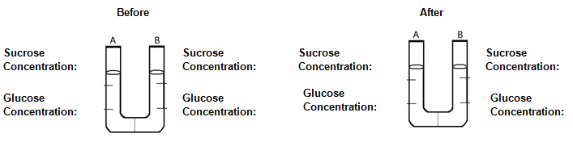
4

4
2

4
2

5
4

3

- Five dialysis bags, constructed from a semipermeable membrane that is impermeable to sucrose, were filled with various concentrations of sucrose and then placed in separate beakers containing an initial concentration of 0.6 M sucrose solution. At 10-minute intervals, the bags were massed (weighed) and the percent change in mass of each bag was graphed.
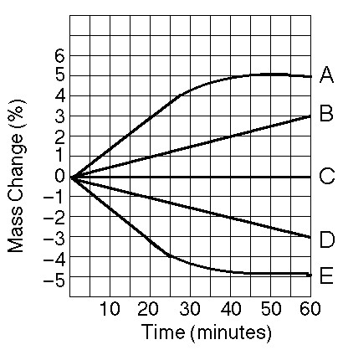
- A positive percent change in the mass of the bag indicates that water has entered / left the bag.
- A negative percent change in the mass of the bag indicates that water has entered / left the bag.
- Bags A and B contain a solution that is hypotonic / hypertonic / isotonic to the outside solution
- Bag C contains a solution that is hypotonic / hypertonic / isotonic to the outside solution.
- Bags D and E contain a solution that is hypotonic / hypertonic / isotonic to the outside solution.
- Bag A / E has the highest initial concentration of sucrose.
- Bag A / E has the lowest initial concentration of sucrose.
- Bag A / E has the highest initial concentration of water.
- Bag A / E has the lowest initial concentration of water.

- What kind of molecules pass through the cell membrane most easily? (small vs. large, nonpolar vs. polar or charged)

Smaller particles will typically diffuse more rapidly than larger particles, nonpolar more than polar or charged

Ex: O₂, H₂O, CO₂ rapidly diffuse across the lipid bilayer

- Explain the terms that describe the effect of water movement into and out of real plant and animal cells.

- When placed in hypotonic solution, a plant cell becomes plasmolyzed / flaccid / turgid.
- When placed in isotonic solution, a plant cell becomes plasmolyzed / flaccid / turgid.
- When placed in hypertonic solution, a plant cell becomes plasmolyzed / flaccid / turgid.
- When placed in hypotonic solution, an animal cell may shrivel / lyse.
- When placed in hypertonic solution, an animal cell may shrivel / lyse.

- In the picture given below, identify the carrier protein and the channel protein. What type of membrane transport is shown in this image? Facilitated Diffusion

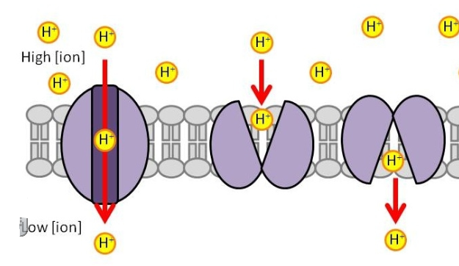

- Describe how sucrose is transported into the cell using the H+ / sucrose cotransporter. Use the image below to help you
  - H⁺ is actively pumped out of the cell by a protein pump when ATP is hydrolyzed (broken by adding water)
  - H⁺ accumulates outside the membrane,
  - H⁺ binds to another membrane protein, but sucrose must also bind. When both are bound, the configuration changes, and the protein opens to the membrane interior.

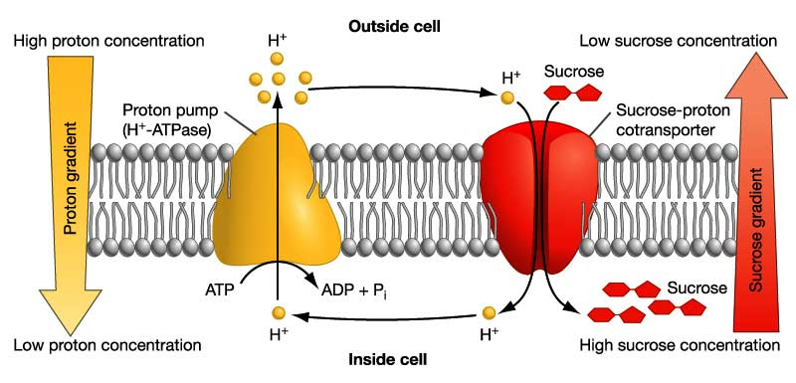

- What is a symporter? How is it different from an antiporter?

Symport as both molecules are crossing in the same direction. If the molecules are moving in opposite directions it is known as an antiport

- Is the H+ / sucrose cotransport system involved in passive or active transport? How do you know?
H⁺ is actively pumped out of the cell by a protein pump when ATP is hydrolyzed – active because ATP is used.
H+ is being pumped against its concentration gradient.

Topic #3: Water Potential and Cell Size Calculations

- Which cells (smaller or larger cells) have higher surface area to volume ratios? How does this relate to the efficiency of transport across the membrane?

Small cells. The large surface area allows for a lot of transport across the cell membrane and the low volume allows of the transported materials to get to the entire cell.

- Plant cells have a large central vacuole. How does this affect the surface area to volume ratio of the cell? (Hint: See the Unit 5, Part 1 Notes section on vacuoles)

The large vacuole reduces the area of the cytosol, so the surface area / volume ratio of the cell increases

- If a cell’s Ψ_{P} = 3 bars and its Ψ_{S} = -4.5 bars, what is the resulting Ψ?

Ψ = Ψ_{S} (-4.5) + Ψ_{P} (3) = -1.5 bars

- The cell from question #21 is placed in a beaker of sugar water with Ψ_{S} = -4.0 bars. In which direction will the net flow of water be?
The pressure potential of a solution open to the air is 0. Therefore, the water potential of the sugar water is -4.0 bars [Ψ = 0 bars +(-4.0) bars]. Since free water always flows towards the solution with a lower water potential, the flow of water would be outside of the cell.

- The original cell from question # 21 is placed in a beaker of sugar water with Ψ_{S} = -0.15 MPa (megapascals). We know that 1 MPa = 10 bars. In which direction will the net flow of water be?
-0.15 MPa = -1.5 bars
The water potential of the sugar water is -1.5 bars [Ψ = 0 bars + (-1.5 bars)]. Since the water potential of the original cell was also -1.5 bars, there would be no net flow of water. The cell and the sugar water are in equilibrium

- The value for Ψ in root tissue was found to be -3.3 bars. If you take the root tissue and place it in a 0.1 M solution of sucrose at 20°C in an open beaker, what is the Ψ of the solution, and in which direction would the net flow of water be?

ΨS = -iCRT
ΨS = -(1)(0.1 mol/L)(0.0831 L*bars/mol*K)(293 K) = -2.43 bars
Ψ = ΨP + ΨS = 0 bars + -2.43 bars = -2.43 bars
The Ψ of the root tissue is -3.3 bars and the Ψ of the sucrose solution is -2.43 bars. Water will flow into the root tissue because free water always moves towards the lower overall water potential.

