Name: ________________________________ Date: ___________________ Period: ____
Web Quest: Transcription and Translation
Directions: Go to the website listed below and follow the instructions given in each question to complete this web quest. The web quest will be worth a LAB GRADE.
URL: http://learn.genetics.utah.edu/content/begin/dna/transcribe/
- At the bottom of the page, read through the paragraph of background information and fill in the blanks below.

- DNA is divided into sections of genetic information called _________.
- Each gene contains the code for a ____________ that has a specific ____________ in the cell.
- The human genome contains more than _________________ genes.
- Cells “read” DNA and create a string of ________________ by going through two processes: ______________ and ______________.

- At the bottom right of the page, use the diagram of transcription and translation given to label the following parts of the diagram pictured to the right: DNA, mRNA, Nucleus, Ribosome, Amino Acids, Protein.
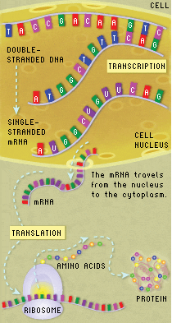
- Where is transcription occurring in this diagram? How do you know?

- Where is translation occurring in this diagram? How do you know?

- tRNA is left out of the picture. Where would we see tRNA in the picture and what is its role in translation?

- Transcription: “Are you ready to transcribe a DNA sequence and translate it into a protein?” – Click the blue box at the center of the page to begin.

- Use your keyboard to type in the mRNA sequence that base pairs with the DNA template strand given. Write out the sequence you used on the line given below.
__________________________________________
- Remember… mRNA does not contain the nitrogenous base _______________. Instead, it contains another pyrimidine called _________________.
- When transcribing DNA into mRNA…
Adenine (A) pairs with ____________
Guanine (G) pairs with ____________

- Translation: Using your mouse scroll over the mRNA strand you just created. A green box will appear that covers three amino acids at a time. These sequences of amino acids are called codons. Find the “start” codon and move the green box to cover it.

- The sequence of bases in the “start” codon is __ __ __.
- The “start” codon codes for the amino acid __________________ (full name), which is shortened to ________ (3-Letter Abbreviation).

Once you have clicked on the “start” codon, drag the codon/amino acid from the codon table into the blinking box to begin creating your amino acid chain. Continue to match codons with the proper amino acids. The blinking box should move to the next codon automatically.
- Write out your amino acid sequence on the line below. Abbreviate each amino acid with the first three letters of the full amino acid name.
______ - ______- ______ - ______ - ______ -______
- In a real cell, what structures/molecules are used to “read” the mRNA strand and create a chain of amino acids? (HINT: THERE ARE TWO!)

- A chain of amino acids is called a _______________.
Way to Go!

