**Unit 10 Review Packet Key**

**Test Format:** 18 multiple choice questions, 1 short answer question

**Topic #1: The Basics of Mendelian Genetics**

1. In garden peas, a single gene controls stem length. The recessive allele (*t*) produces short stems when homozygous. The dominant allele (*T*) produces long stems. Two heterozygous long-stemmed plants are crossed. List the expected phenotypes of the offspring as a ratio.



3 Long : 1 Short

1. In sheep, eye color is controlled by a single gene with two alleles that display incomplete dominance. When a homozygous brown-eyed sheep is crossed with a homozygous green-eyed sheep, blue-eyed offspring are produced. If the blue-eyed sheep are mated with each other, what percent of their offspring will most likely have blue eyes?

50%



1. In corn, the trait for tall plants *(T)* is dominant to the trait for dwarf plants *(t)* and the trait for colored kernels *(C)* is dominant to the trait for white kernels *(c).* In a particular cross of corn plants, the probability of an offspring being tall is 1/2 and the probability of a kernel being colored is 3/4. Based on these offspring phenotype frequencies, what are the possible genotypes for the parents?



TtCc x ttCc



1. Hemophilia is inherited as an X-linked recessive trait. If a male with hemophilia marries a normal female…

(Note: We are assuming that the female is completely normal and is not a carrier of the hemophilia allele, so her genotype is XHXH)



1. What percentage of their offspring will have hemophilia?



0%



1. What percentage of their male offspring will have hemophilia?



0%



1. What percentage of their female offspring will have hemophilia

0%

1. Galactosemia is a simple, inherited, autosomal recessive trait. A normal couple has a child affected with galactosemia.



1. What is the chance that both of their next two children will be normal?



(3/4) x (3/4) = 9/16

1. What is the chance that their next child will have galactosemia or be a carrier for galactosemia?



(1/4) + (2/4) = 3/4



1. Black fur in mice (*B*) is dominant to brown fur (*b*). Short tails (*T*) are dominant to long tails (*t*). What fraction of the progeny of crosses *BbTt* × *Bbtt* will be expected to have black fur and long tails?

Hint: You don’t need to set up a dihybrid cross to answer this question!

(3/4) x (1/2) = 3/8



1. In the cross *AaBbCc* × *AaBbCc*, what is the probability of producing the genotype *AABBCC*?



(1/4) x (1/4) x (1/4) = 1/64



**Topic #2: Human Genetics**

1. If a child has blood type O, and his mother had blood type A, what are the possible blood types for the father?

Blood Type A (genotype AO), Blood Type B (genotype BO), or Blood Type O (genotype OO)

1. Describe the relationships between the three blood type alleles—A (IA), B (IB), and O (i).

A and B are both dominant to O. A and B are codominant to one another. Therefore, the following genotypes will produce the following phenotypes (blood types)

AA and AO 🡪 Blood Type A

BB and BO 🡪 Blood Type B

OO 🡪 Blood Type O

AB 🡪 Blood Type AB



1. Hemophilia is a sex-linked recessive trait. Fill in the genotypes for all individuals on the pedigree to the right. Let Xa = the hemophilia allele, and let XA = the normal allele.

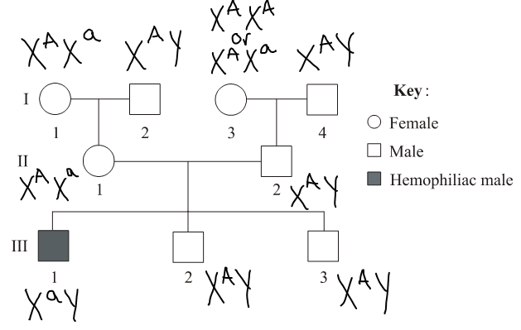

1. The ACHOO syndrome is an inherited condition that leads to sneezing in response to bright light. What evidence in the pedigree suggests that ACHOO syndrome does NOT follow an X-linked dominant pattern of inheritance?

There is an “affected male” (male with the trait) in generation II, but he cannot receive an allele for the trait from his mother, and his father gives him a Y chromosome (not an X chromosome).

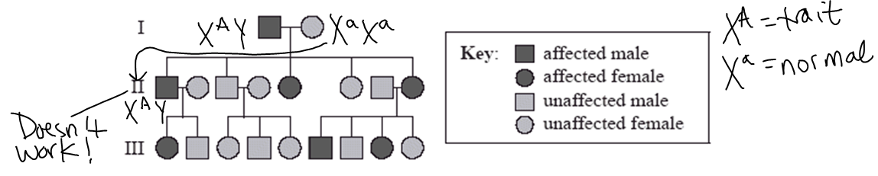



1. Explain the difference between polygenic inheritance and pleiotropy.

With polygenic inheritance, multiple genes determine one trait / phenotype (ex: human height)

With pleiotropy, one gene determines multiple traits / phenotypes (ex: the frizzle gene in chickens)

1. Explain why each of the following patterns of inheritance will NOT work for the pedigree shown below—X-linked dominant and x-linked recessive.

It cannot be sex-linked dominant because the mother would have to show the trait in generation I to have a son with the trait. (This is because the mother—not the father—gives her X chromosome to her son).

It cannot be sex-linked recessive because the last male to the right in generation II would have to show the trait. His daughter shows the trait, and she would need to receive a recessive allele from her mother AND her father.

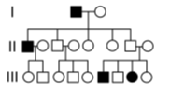

**Topic #3: Chromosomal Genetics**

|  |  |
| --- | --- |
|  | F2 Generation |
| 125 | red eyes, long wings |
| 124 | purple eyes, vestigial wings |
| 18 | purple eyes, long wings |
| 16 | red eyes, vestigial wings |
| 283 | Total |

1. A male fruit fly (*Drosophila melanogaster*) with red eyes and long wings was mated with a female with purple eyes and vestigial wings. All of the offspring in the F1 generation had red eyes and long wings. These F1 flies were test crossed with purple-eyed, vestigial-winged flies. Their offspring, the F2 generation, appeared as indicated to the right.
2. Why is there a high frequency of red eyed / long winged flies and purple eyed / vestigial winged flies?

The alleles for these traits are linked (located on the same homologous chromosome) so they are usually inherited together.

1. How is it possible to have purple eyed / long winged flies and red eyed / vestigial winged flies?

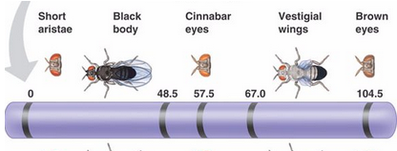If crossing over occurs between homologous chromosomes, this could separate linked genes and create new combinations of alleles (ex: purple eyes / long wings and red eyes / vestigial wings)

1. Based on the linkage map given to the right, which two genes are most likely to be separated by crossing over? Why?

Short aristae and brown eyes are most likely to be separated by crossing over because they are the furthest apart on the chromosome, which corresponds to a high frequency of recombination.

1. A karyotype shows the visual appearance of an individual’s chromosomes. The karyotype below shows a chromosomal abnormality.

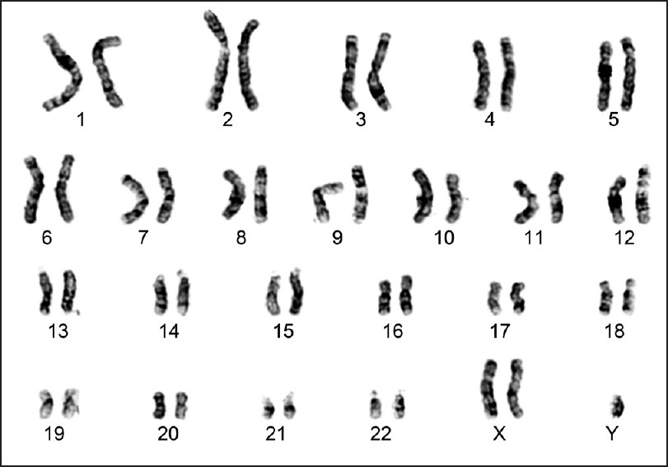

1. Explain how this type of abnormality could occur and support your claim with evidence from the karyotype.

The karyotype shown has three sex chromosomes instead of two. This is called trisomy. If separation of homologous chromosomes occurs incorrectly during meiosis (let’s say during oogenesis, the formation of egg cells), this is called nondisjunction. This results in one egg containing two copies of the homologous chromosome (in this case two X chromosomes) and the other containing zero copies. If the egg with two copies of the X chromosome is fertilized by a normal sperm containing one Y chromosome, this results in a baby with two X chromosomes and one Y chromosome.

1. Relate this abnormality to Mendel’s Law of Segregation.

Mendel’s Law of Segregation states that homologous chromosomes separate during meiosis 1 to create gametes (eggs and sperm) with half the chromosomes of a normal body cell. When these gametes (eggs and sperm) combine during fertilization, they create a zygote (and eventually a baby) with half its chromosomes from Mom and half its chromosomes from Dad. In the karyotype above, segregation of homologous chromosomes occurred incorrectly for the sex chromosomes, so Mendel’s Law of Segregation was violated.