Name:___________________
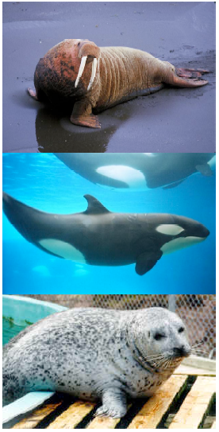
PRE-LAB
Walruses and whales are both marine mammals. So are dolphins, seals, and manatee. They all have streamlined bodies, legs reduced to flippers, blubber under the skin and other adaptations for survival in the water. Although mammals evolved on land, these species have returned to the sea. Did they evolve from a single ancestor who returned to the ocean, or were there different return events and parallel evolution? We can’t go back in time to observe what happened, but DNA sequences contain evidence about the relationships of living creatures. From these relationships, we can learn about the evolutionary history of marine mammals.

In past labs, you learned about changes in gene frequencies in a population over time. This perspective of evolution is called microevolution. In this lab, we will discuss macroevolution, which can be described as the sum of long periods of microevolution. Macroevolution is occurring when one species changes, becoming two different species. Based on this, the two resulting species have a common ancestor. A cladogram, or phylogenetic tree, shows the evolutionary history and relationships of these species.

In this lab, we will use sequence information in GenBank (the public repository of all known DNA sequences from many species) and bioinformatics software to test hypotheses about the relationship between aquatic mammals (seals, whales, dolphins, walruses, manatees, and sea otters) and their potential ancestral relationship to land mammals.

We will use a protein that all mammals share: the hemoglobin beta protein. Hemoglobin is a good test molecule since it shows both conservation across species (since it performs the essential function of carrying oxygen in the blood), and variation between species. Species with unique challenges such as holding their breath for long underwater dives, may have evolved changes in their hemoglobin which improved their supply of oxygen. In addition, hemoglobin has been studied by many evolutionary biologists, so sequences are available in GenBank from many different organisms.

PRE-LAB QUESTIONS

- Marine mammals have the adaptations mentioned above. What is an adaptation?

- How can we tell how organisms evolve if we cannot go back in time?

- Describe macroevolution in your own terms.

- Why is evolutionary history important in creating a phylogenetic tree?

Part A

1. Make a hypothesis about the evolutionary relationship between dogs, whales, cows, and seals. Which ones do you think are more closely related?

2. List two reasons why you chose to pair the organisms you did.

3. Draw a phylogenetic tree/evolutionary tree/cladogram for your prediction.
Example of an evolutionary tree for reptiles.

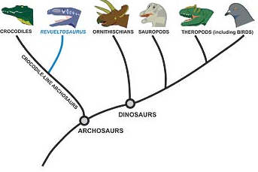

4. What is one thing that you notice from the example evolutionary tree above about the evolutionary history of birds?

5. At what level of protein structure does the ClustalW2 website compare the different proteins? (Primary, secondary, tertiary, or quaternary?)

6. How closely related are each of these species? Complete the table using their alignment scores:

 | Dog | Whale | Seal | Cow
Dog | X | X | X | X
Whale |  | X | X | X
Seal |  |  | X | X
Cow |  |  |  | X

7. Draw the phylogenetic tree based on a comparison of amino acids that make up the Beta subunit of Hemoglobin found in the clustalW2 analysis.
Phylogenetic Tree

8. Was your hypothesis correct? Which animals are more closely related?

Part B

1. Draw a hypothetical phylogenetic tree for each of the following hypotheses:

- Marine mammals are more closely related to each other than to land mammals.
Phylogenetic Tree

OR

- Some marine mammals are more closely related to land mammals than to other marine mammals.
Phylogenetic Tree

2. Which hypothesis do you predict will be supported by your data? (circle one)

3. What made you choose this hypothesis?

ANALYSIS

- What does the phylogenetic tree suggest about the evolutionary history of marine mammals? Refer to the scientific question and hypothesis on page 2 to help.

- If marine mammals share common morphological characteristics, what do your conclusions about their evolutionary history imply about these common characteristics? Think about the development of adaptations…

- Make a conclusion about what you learned through this lab.

