Tutorial: Graphing using Excel
AP Biology

Step 1
Open a new spreadsheet in Microsoft Excel. You can do this by clicking on blank workbook.
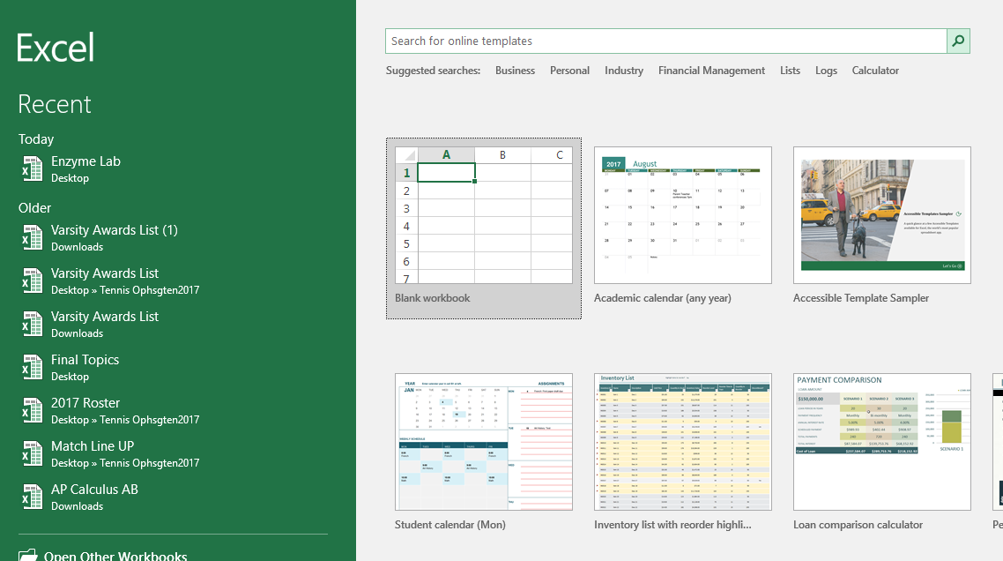
Step 2
Identify your Independent Variable values and place them in column A.
Identify your Dependent Variable values and place them in column B.
(My I.V. is concentration of substrate and the D.V. is the speed of enzyme)
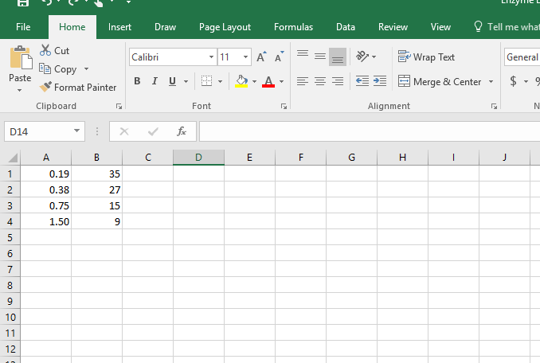
Dependent Variable
Independent Variable

Step 3
Select and highlight all values.
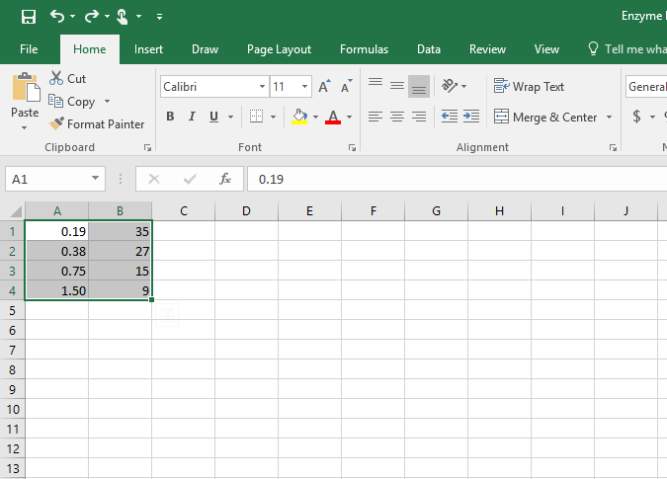

Step 4
Click on the tab Insert and select recommended charts.
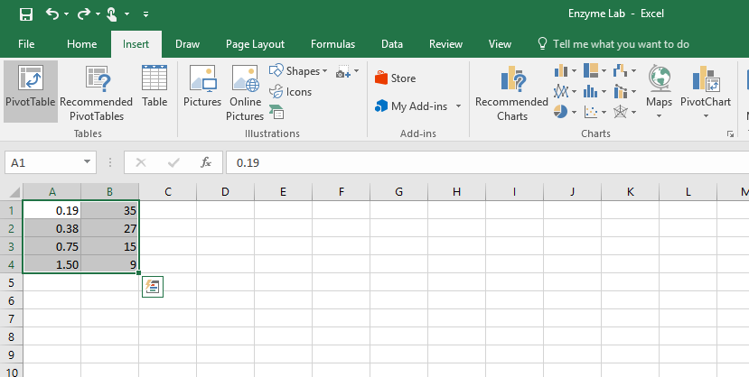

Step 5
Make sure the chart fits the parameters of what your teacher requested (i.e. bar graph, line graph, etc.) Now double click on the chart and choose a simple design that is easy to read.
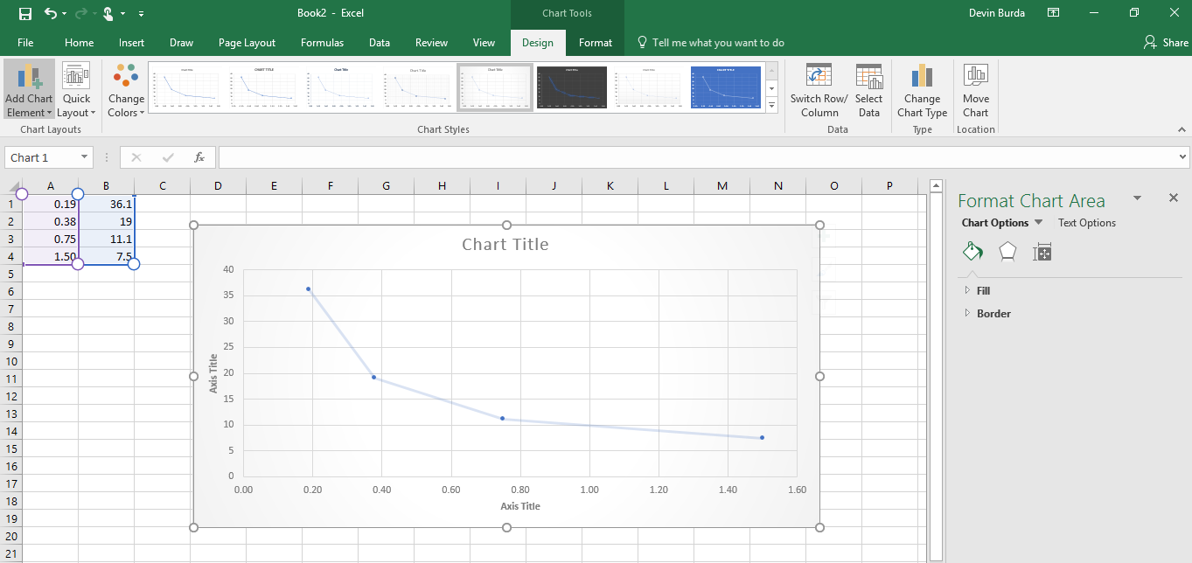

Step 6 (Final Step)
After double clicking the chart click on the dropdown box labeled quick layout. Select the model that has labels for the title, x-axis, and y-axis (layout #1 or layout #5). Fill in the axis labels with the proper information and units. Your done! You may now copy and paste this chart wherever you want

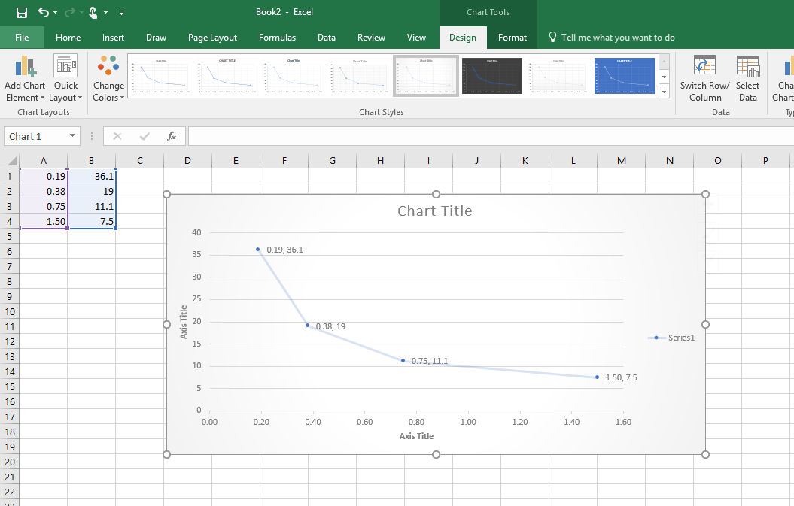
Sample Graph

