Name: _____________________________________________ Date: ____________________________ Period: ______

AP Biology Exam Review: Gene Regulation / Biotechnology (Unit 12) and Organism Form and Function (Unit 13)

Helpful Videos and Animations:
- Sumanas Animation: Trp Operon (Repressible Operon)
- Sumanas Animation: Lac Operon (Inducible Operon)
- Bozeman Biology: Gene Regulation in Prokaryotic vs. Eukaryotic Cells
- Sumanas Animation: Gel Electrophoresis
- McGraw-Hill Animation: Restriction Enzymes (AKA Restriction Endonucleases)
- McGraw-Hill Animation: Restriction Fragment Length Polymorphisms
- Sumanas Animation: Polymerase Chain Reaction (PCR)
- Cold Spring Harbor Lab Animation: Bacterial Transformation
- Bozeman Biology: Response to External Environments
- Bozeman Biology: Plant and Animal Defense
- Bozeman Biology: Development - Timing and Coordination
- Bozeman Biology: Gene Regulation in Embryonic Development
- Bozeman Biology: Cellular Specialization
- Bozeman Biology: Mechanisms of Timing and Control

Topic Outline: (Thank you to Megan Chirby and Amy Litz!)

Unit 12, Part 1 Notes: Gene Regulation

- Prokaryotic Gene Regulation
- Bacteria are prokaryotic with a single circular chromosome
- Bacteria express all the genes needed for a product (more than one gene at a time)
- Organization includes the promoter region of DNA, operator, and structural genes
- Trp operon = repressible; anabolic pathway; used to make enzymes that help make tryptophan if none is present
- Repressor is naturally INACTIVE so it will make tryptophan
- Repressor only becomes ACTIVE when trp (called corepressor) is in excess and binds to repressor changing its shape
- Lac operon-catabolic pathway; inducible; used to make enzyme to break down lactose when it is available
- Repressor is naturally ACTIVE so it will block gene transcription unless lactose (allolactose- called inducer) binds and makes repressor INACTIVE

- Eukaryotic Gene Regulation
- Enhancers- Areas on genome that are non-coding that are located at a distance from a promoter. Transcription factors / activators can bind to these areas and cause transcription of certain genes. (turns on)
- MRNA Degradation by RNA interference- mRNA has a life span in the cytoplasm (can last a few hours to a week). (turns off)
- RNA processing (intron splicing, poly a tail, gtp cap) (turn on and alter expression)
- Histone Acetylation (turn on)
- DNA methylation (turn off)
- Translation Repressors (turn off)
- Posttranslational modifications- folding, cleaving, etc. (alter expression)

Unit 12, Part 2 Notes: Biotechnology A and Unit 12, Part 3 Notes: Biotechnology B

- Creation of Recombinant DNA and Bacterial Transformation
- Toolkit includes plasmid (piece of round DNA from bacteria/yeast) or other vector such as viruses; restriction enzymes; host cell (usually bacteria like E. coli)
- Restriction enzymes cut genes at restriction sites to make blunt or sticky ends
- Cut gene of interest (g.o.i.) with same enzyme to get same ends
- Use ligase to seal gene of interest into the plasmid
- Insert vector into host
- Used to clone and make copies or to produce a foreign protein such as HGH or insulin
- Polymerase Chain Reaction (PCR)
- Used to make large amounts of clones of DNA without using a host; heat which opens ; use a primer to mark the place in the sequence where Taq polymerase begins replication; cool; repeat

- Gel Electrophoresis
Used to look at unique pattern created by fragments of DNA; cut DNA using enzyme; load into a gel; turn on electricity; DNA runs from negative to positive; larger chunks move less; unique for each person if testing variable areas of DNA (ex: RFLP’s); can be used for protein or mRNA too

Unit 13, Part 1 Notes: Development

- The Steps of Embryonic Development
- Pattern Formation
- Cytoplasmic Determinants
- Homeotic Genes
- Morphogenesis
- Apoptosis
- Cell Differentiation
- Embryonic Induction
- Transcription Factors (Stimulatory or Inhibitory)

Unit 13, Part 2 Notes: Timing and Coordination

- Physiology basics
- Organization in multicellular organisms: cell tissue organ organ system organism
- Cooperation between organs (ex: stomach and small intestine)
- Cooperation between organ systems (ex: respiratory system and circulatory system; nervous and muscular system; root system, shoot system, and leaves in plants)
- Using physiology to respond to the environment
- Phototropism in plants
- Photoperiodism in plants
- Maintaining body temperature in humans
- Fruiting body formation in myxobacteria
- Using behavior to respond to the environment
- Innate behaviors (ex: fixed action patterns) vs. learned behaviors (ex: imprinting)
- Some behaviors are partially innate and partially learned (ex: migration patterns in black cap birds)
- Cooperative behaviors within or between populations can enhance the survival likelihood in the population (ex: the interactions between plants and their insect pollinators)

Unit 13, Part 3 Notes: Defense (The Immune System)

- Plants, invertebrates and vertebrates have multiple, nonspecific immune responses, ex: phagocytes (i.e. macrophages) engulf and digest pathogens with the help of lysosomes
- Mammals use specific immune responses triggered by natural or artificial agents that disrupt dynamic homeostasis.
- The mammalian immune system includes two types of specific responses: cell mediated and humoral.
- In the cell-mediated response, cytotoxic T cells, a type of lymphocytic white blood cell, target‖intracellular pathogens when antigens are displayed on the outside of the cells.
- In the humoral response, B cells, a type of lymphocytic white blood cell, produce antibodies against specific antigens.
- Antibodies are proteins produced by B cells, and each antibody is specific to a particular antigen.
- A second exposure to an antigen results in a more rapid and enhanced immune response.

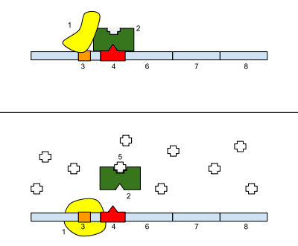
Practice Multiple Choice Questions

With regard to the operon pictured to the right, the image on top shows the operon in its normal state, and the image on the bottom shows the operon in the presence of molecule #5 (looks like a + sign). The identities of some of the molecules shown in the picture are given below.
1. RNA polymerase
3. Promoter
4. Operator
6, 7, and 8. Genes of the operon

***Note: In the picture on top, RNA polymerase is UNABLE to bind correctly to the promoter region and initiate transcription of the genes of the operon***

1) What type of operon is shown in the image, and how do you know?
A. An inducible operon; it is usually off but can be turned on.
B. An inducible operon; it is usually on but can be turned off.
C. A repressible operon; it is usually off but can be turned on.
D. A represible operon; it is usually on but can be turned off.

2) What is the role of molecule #5 in regulating the operon?
A. It is an inducer, which is used to inactivate the repressor protein (#2) and prevent it from binding to the operator.
B. It is an inducer, which is used to activate the repressor protein (#2) and allow it to bind to the operator.
C. It is a repressor, which is used to inactivate the repressor protein (#2) and prevent it from binding to the operator.
D. It is a repressor, which is used to activate the repressor protein (#2) and allow it to bind to the operator.

3) This question is unrelated to #1-2 given above!!! Why is an anabolic operon usually repressible?
A. It is used to break down a molecule in the environment (ex: maltose sugar) so it should usually be on.
B. It is used to break down a molecule in the environment (ex: maltose sugar) so it should usually be off.
C. It is used to build an essential molecule in the cell so it should usually be on.
D. It is used to build an essential moelcule in the cell so it should usually be off.

4) Adding acetyl groups to the histone proteins interacting with the DNA of the insulin gene causes the DNA to coil less tightly. What will be the effect on gene expression?
A. This will prevent expression of the insulin gene and result in decreased amounts of insulin protein produced.
B. This will prevent expression of the insulin gene and result in increased amounts of insulin protein produced.
C. This will facilitate expression of the insulin gene and result in decreased amounts of insulin protein produced.
D. This will facilitate expression of the insulin gene and result in increased amounts of insulin protein produced.

5) How can multiple types of antibodies (proteins created in the immune system that attack specific bacteria and viruses) be synthesized from the same “antibody gene”?
A. Changing the tightness of coiling of the DNA can result in the creation of different antibody proteins.
B. Changing the speed of transport of mRNA out of the nucleus can result in the creation of different antibody proteins.
C. Changing which introns are “spliced” out of the premRNA can result in the creation of different antibody proteins.
D. Changing the regulatory proteins that bind to the 5’ end of the mRNA and prevent ribosome attachment can result in the creation of different antibody proteins

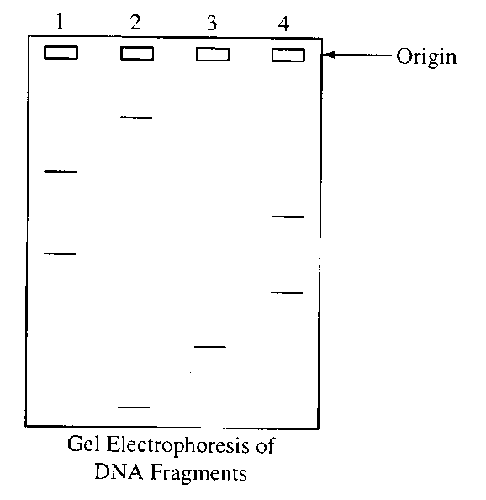
6. The electrophoretic separation of the pieces of DNA in each of the four samples was achieved because of differential migration of the DNA fragments in an electric field. This differential migration was caused by the
(A) relative amounts of radioactivity in the DNA
(B) number of cleavage points per fragment
(C) size of each fragment
(D) overall positive charge of each fragment

7. The DNA was labeled with ³²P in order to
(A) stimulate DNA replication
(B) inhibit the uptake of unlabeled ATP
(C) show which fragments included the 5' end and which fragments included the 3' end
(D) visualize the fragments

A scientist is using an ampicillin-sensitive strain of bacteria that cannot use lactose because it has a nonfunctional gene in the lac operon. She has two plasmids. One contains a functional copy of the affected gene of the lac operon, and the other contains the gene for ampicillin resistance. Using restriction enzymes and DNA ligase, she forms a recombinant plasmid containing both genes. She then adds a high concentration of the plasmid to a tube of the bacteria in a medium for bacterial growth that contains glucose as the only energy source. This tube (+) and a control tube (-) with similar bacteria but no plasmid are both incubated under the appropriate conditions for growth and plasmid uptake. The scientist then spreads a sample of each bacterial culture (+ and -) on each of the three types of plates indicated below.
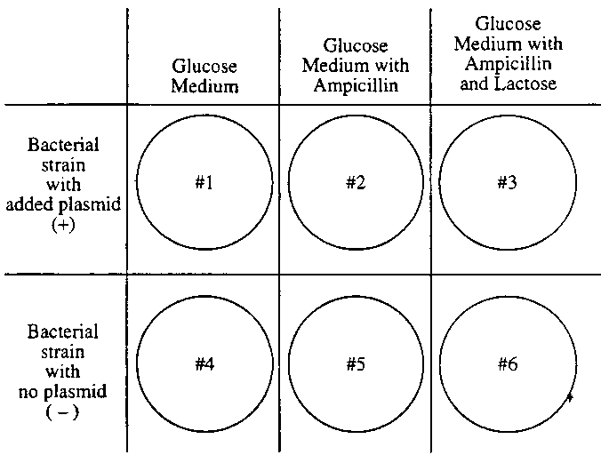
8. If no new mutations occur, it would be most reasonable to expect bacterial growth on which of the following plates?
(A) 1 and 2 only
(B) 3 and 4 only
(C) 5 and 6 only
(D) 4, 5, and 6 only
(E) 1, 2, 3, and 4 only

9. The scientist used restriction enzymes for what purpose in the experiment?
(A) To make the plasmid small enough to transform cells
(B) To make cuts in the plasmid DNA
(C) To make the plasmid enter the cells
(D) To enable the fragments of DNA to form covalent bonds
(E) To enable the plasmid to recognize the bacterial cells

10. If the scientist had forgotten to use DNA ligase during the preparation of the recombinant plasmid, bacterial growth would most likely have occurred on which of the following?
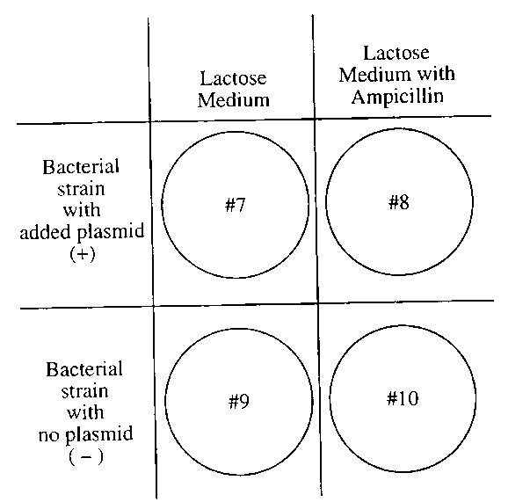
(A) 1 and 2 only
(B) 1 and 4 only
(C) 4 and 5 only
(D) 1, 2, and 3 only
(E) 4, 5, and 6 only

11. If the scientist used the cultures to perform another experiment as shown to the right, using medium that contained lactose as the only energy source, growth would most likely occur on which of the following plates?
(A) 10 only
(B) 7 and 8 only
(C) 7 and 9 only
(D) 8 and 10 only
(E) 9 and 10 only

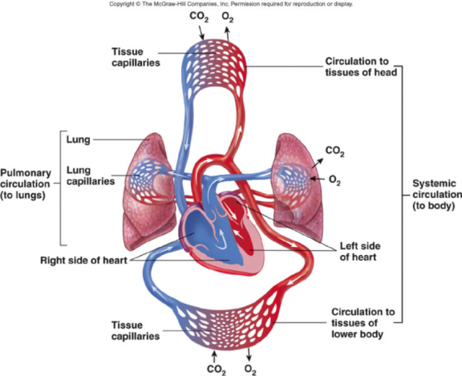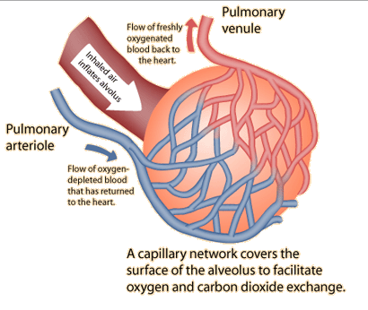
12. In the human body, the respiratory system and circulatory system work together to deliver oxygen to the tissues of the body and remove carbon dioxide from the tissues of the body. Gas exchange between the lungs and the blood vessels occurs at the alveoli, small sacs within the lungs that are covered in a network of capillaries (small blood vessels). If the surface area of the alveoli (the area available for diffusion of gases into and out of the alveoli) is decreased, how will this affect the organism as a whole?
A) The individual will not be able to deliver enough oxygen to the tissues of the body but will still be able to remove carbon dioxide from the bloodstream.
B) The individual will not be able to remove carbon dioxide from the bloodstream but will still be able to deliver enough oxygen to the tissues of the body.
C) The individual will not be able to deliver enough oxygen to the tissues of the body OR remove carbon dioxide from the bloodstream.
D) The individual will have an enhanced ability to deliver oxygen to the tissues of the body and remove carbon dioxide from the bloodstream.

13. We know that plants bend toward light because
(A) the sun stimulates equal cell expansion on both sides of the stem.
(B) cell expansion is greater on the dark side of the stem.
(C) cell expansion is greater on the light side of the stem
(D) auxin is inactive on the dark side of the stem.

14. Plants often use changes in day length (photoperiod) to trigger events such as dormancy and flowering. There are two types of plants based on their photoperiod requirements to induce flowering. These two types of plants are called short-day plants and long-day plants. A long-day plant will flower
(A) in the late fall.
(B) when the night is shorter than a critical value.
(C) only under artificial light in the summer.
(D) during short days with proper fertilization.
(E) regardless of the photoperiod imposed.

15. Imagine that you are designing an experiment aimed at determining whether the initiation of migratory behavior is largely under genetic control. Of the following options, the best way to proceed is to
(A) observe genetically distinct populations in the field and see if they have different migratory habits.
(B) perform within-population matings with birds from different populations that have different migratory habits. Do this in the laboratory and see if offspring display parental migratory behavior.
(C) bring animals into the laboratory and determine the conditions under which they become restless and attempt to migrate.
(D) perform within-population matings with birds from different populations that have different migratory habits. Rear the offspring in the absence of their parents and observe the migratory behavior of offspring.

16. Macrophages are large white blood cells that can engulf foreign substances called antigens. Both macrophages and lymphocytes, such as T cells, appear together at the site of infection. Which statement best explains how macrophages initiate an immune response when a new antigen is first encountered?
A) Macrophages incorporate the antigen into their genetic material and produce a large number of identical macrophages that are programmed to destroy that specific antigen.
B) Macrophages present the antigen directly to a memory B cell that produces antibodies programmed to destroy that specific antigen.
C) Macrophages present the antigen to helper T cells, which activate memory B cells to produce plasma cells, and the plasma cells release antibodies that identify and destroy that specific antigen.
D) Macrophages present fragments of the antigen to other macrophages, which are then able to seek out and destroy the antigen by releasing helper T cells that engulf that specific antigen.

17. What is the main difference between the humoral response and the cell-mediated response?
A) The humoral response is a type of nonspecific immunity, whereas the cell-mediated response is a type of specific immunity.
B) The humoral response is a type of specific immunity, whereas the cell mediated response is a type of nonspecific immunity.
C) The humoral response involves the creation of antibodies to attack pathogens that are free-floating in the body fluids (ex: blood and lymph), whereas the cell mediated response involves the creation of cytotoxic T cells to destroy infected body cells.
D) The humoral response involves the creation of cytotoxic T cells to destroy infected body cells, whereas the cell mediated response involves the creation of antibodies to attack pathogens that are free-floating in the body fluids (ex: blood and lymph).

18. Secondary immune responses upon a second exposure to a pathogen are due to the activation of
A) memory cells (both B cell and T cell varieties)
B) macrophages.
C) stem cells.
D) antigens

19. Secondary immune responses (aka immunological memory) explain
A) a macrophage’s ability to “swallow” an antigen (a foreign particle)
B) the observation that some strains of the pathogen that causes dengue fever cause worse disease than others.
C) the ability of a helper T cell to bind to an antigen-presenting cell
D) the ancient observation that someone who had recovered from the plague could safely care for those newly diseased.

Practice Short Response Questions

1. Describe how recombinant DNA technology can be used to accomplish the following…
A. The creation of human insulin protein to treat diabetes.
B. The creation of golden rice, which is a transgenic plant (meaning it contains DNA from two different organisms) that has been given the gene for beta carotene (vitamin A) production using a bacterial vector.

2. In humans, HIV (human immunodeficiency virus) attacks the helper T lymphocytes of the immune system.
A) Describe how this will affect the nonspecific immune response.
B) Describe how this will affect the specific immune response.
C) Explain why people with HIV typically die of unrelated bacterial / viral infections, not the HIV infection itself.

Practice Long Response Questions

