Name: _______________________________ Date: _________________ Period: ____

Unit 8 Notes: Evolution

Part 1: The History of Life

I. How Did Life Come to Be? –Theories

- Dark Ages: “Life arose from _________ matter.” This process is known as _______________________.

Ex: Rats from dirty clothes, frogs from mud, ________________.

B. Renaissance

- 1668: An Italian doctor named ______________ proposed the theory of __________ “life comes from life”

Redi’s Hypothesis: maggots come from _____, not rotting meat

Control Group (Open) Exp. Group #1 (Lid) Exp. Group #2 (Screen)
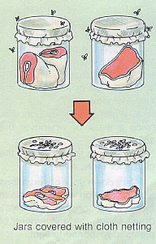
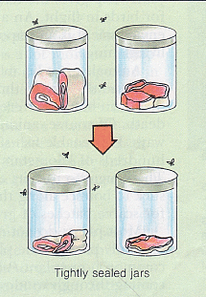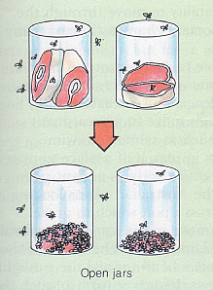
Result: _____________ Result: _____________ Result: _____________

Redi’s conclusion: __________ (life comes from life) is correct!

- 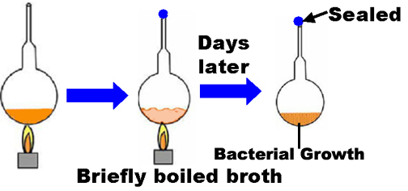1745: _______________ tried to prove that spontaneous generation was correct

Steps to Experiment:
- ___________________
- ___________________
- ___________________

Needham felt this proved that ___________(living) came from _________(non-living) after killing all existing bacteria in the broth.

What was wrong with his experiment? ________________________________________________________

3) 1770: ___________________was an Italian priest who believed Needham did not boil the broth ___________ to kill all existing bacteria
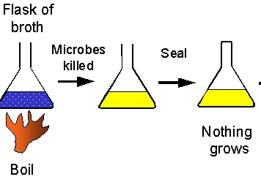
Steps to Experiment:
- ___________________
- ___________________
- ___________________

4) 1862: ______________ did another experiment with broth, which led to the concept of ________________.

Treatment | Description | Picture
Control | Boiled broth in an ______ neck flask…a year later found __________ in flask | 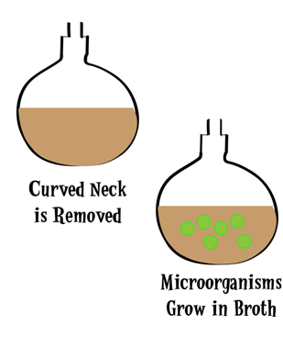  Open Flask
Experimental | boiled broth in a _________neck flask (swan neck keeps bacteria from _________)… a year later found NO ___________ | 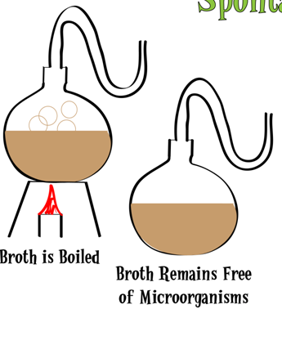  Swan-Neck Flask

Pasteur’s Conclusion: Spontaneous generation is ____________.

II. History of Life on Earth

Age of Earth: ______________
Age of Solar System: ___________
Age of Universe: ________________

III. Earth Before Life

- Formation of the Earth
-_______ billion years ago
-Early Atmosphere: _________, _________, __________, _________, __________, and ____________

- Synthesis of Organic Molecules
- 1924: Alexander _________ hypothesized that conditions in early ______________caused compound to form ___________ (carbon-containing) molecules (ex: ____________)
- 1953: Stanley _________ and Harold Urey set up an experiment to show that the following reaction took place

Label the two missing steps on the picture below:
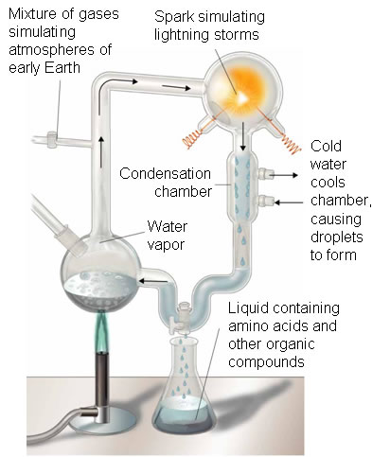

- 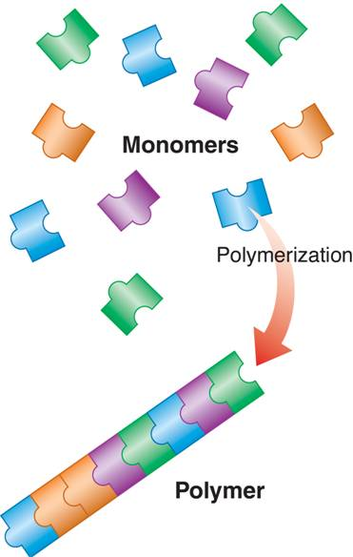Polymerization: __________________small organic molecules to make ____________________

Building Blocks |  | Macromolecules

- First _____________ and “protocells” (early cells) called _____________
Membrane made out of phospholipids. Draw a
microsphere with phospholipids in the box to the
right.

- Heredity and Replication
_____ was the first ________ acid to be used as
genetic material because it could “___________”
(make a copy of itself)

Why would RNA need to be able to self-replicate? _______________________________________________________________

IV: Early Life

- Unicellular Life
________ cells, Prokaryotic = no _________, mostly bacteria
__________ = consumers…can’t make their own food

B. Blue-Green Algae Add ______________ to Atmosphere
First organisms to be able to ______________.
What type of food do they make? (Hint: It’s a sugar) ________________
What gas do they need to take in to make oxygen? _________________

C. Aerobic Respiration
Organisms use glucose to make ______, an energy- rich molecule
What gas do they take in, and what gas do they release? ______________

D. Eukaryotic Cells
Have a _________ and membrane-bound organelles (ex: _______, _______, and ___________) to do specific _______ in the cell.
Endosymbiosis: when a large prokaryote “__________” a small prokaryote, which becomes its __________, ___________, or ___________.

Draw out the process of endosymbiosis in the box below.

E. Multicellular Life
Evolved towards the end of the _____________ era in Earth’s ___________.
Multicellular organisms can ______________ cells to do different jobs (ex: brain cell, blood cell)

- Rapid Diversification of Multi-cellular Life in the Oceans
A bunch of new _______________ (no backbone) body forms showed up
For some reason, there was a massive ______________ at the end of the Precambrian Era, which caused _____________ of species to die off

V. Paleozoic Era

A. The First Complex Multicellular Animals to Evolve - ___________
Fish are _____________, meaning they have a backbone

- The first ___________evolve from seaweed and move to ________

- The dominant animal life are _______________ (another vertebrate)

- A new type of plant – ______________ – evolves
Conifers are better adapted to _________ climates
Conifers are also known as ____________

VI: Mesozoic Era

- Reptiles begin to dominate
Reptiles are better adapted to land than _____________…have ______skin and __________ eggs

- Reptiles called _______________ dominate

- Flowering plants and _____________evolve together
_______________ means that they changed together over time
Insects are needed to pollinate plants…is this cross-pollination or self-pollination? __________________________

- Another mass (major)______________ causes the end of the dinosaurs

VII. Cenozoic Era

A. Evolution of special vertebrates with fur and fat – _________________
Fur and fat help keep mammals warm in _____________ climates
Nourish young with _________

B. Evolution of a special group of mammals – the ________________
Primates are different from other mammals because they live in __________ groups and have _______________ thumbs

C. Evolution of a special group of primates – the _________________
Hominids are more advanced than other primates because they can stand _______________

D. Modern Man (Homo __________________) evolves!

E. Modern man masters ____________ use and builds _________________

F. Last Century -- ___________________ advances lead to rapid changes in society

Part 2: Evidence for Evolution

I. Observable Evidence

A. Early Life Forms: Fossils

Fossil = a trace of a long-dead organism, found in layers of _______________sedimentary rock; hard _____________ replace tissues of organism

Types of Fossils

1) ___________ = imprint in rock
2) ___________ = a mold filled with hard minerals
3) ___________ = signs of life (footprints, burrowing)
4) ___________= organisms that have been preserved nearly perfectly in plant resin (amber)
5) __________ = any living species that is nearly identical to species previously known only from fossils

How do we determine the age of fossils?

1) _____________ age – the approximate age based on the position in ___________ of sedimentary rock
2) _____________ age – the exact age of a fossil based on ________________ dating (ex: Carbon – 14)

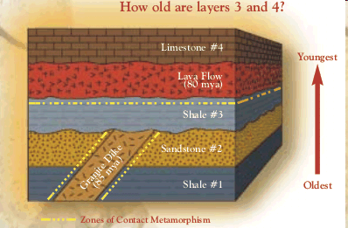Relative Age – Rock Layers: Which is older, a fossil found in layer 2 or 4? How do you know? _____________________________________________

Absolute Age – Radioactive Dating

1) when “isotopes” of atoms in fossils ________ into other “isotopes”
2) Remember: isotopes are the same atom with different numbers of _______
3) _______ = how long it takes for one-half of a sample of an isotope to decay

Ex: Carbon Dating (C14 C12)

4) Practice Problem: Suppose you have found a fossil containing exactly ¼
Of its original amount of C-14 (the rest has decayed into C-12). How old is the
fossil if the half life of C-14 is 5,730 years? ________________________

B. Comparative Anatomy

compare structures found in modern organisms with those from ___________times

- ________________Structures: inherited from a common ____________, changed due to different ________________
Ex: Limb bones of whale, bat, human, etc.

- ________________Structures: similar in _____________, but not inherited from a common _______________
Ex: Wings of insects vs. bird

C. Vestigial Structures

Features/structures that were useful to an ancestor but are no longer useful
Ex: __________ pelvis, human ___________ + ____________

D. Comparative Embryology

Finding similarities in __________ ; organisms sharing a recent ancestor have more similar embryos (discovered by Ernst ____________)

E. Comparative Biochemistry

Finding similarities in ____________ and _________ sequences to look for relatedness
Below is a DNA sequence in several different organisms…which two organisms are the most related? ________________________________

Human | CCA TAG CAC CTA
Pig | CCA TGG AAA CGA
Chimpanzee | CCA TAA CAC CTA
Cricket | CCT AAA GGG ACG

II. Evolutionary Biologists

There are several scientists who observed and predicted the causes behind _______________________
Evolution = change in a _____________ of organisms over a period of time
A population is a group of members of a single _______ living in a particular area

A. Jean Baptiste Lamarck

Theory of Use and __________: “Acquired traits are passed on to the next generation” (AKA Theory of ________________ Characteristics)

1) Organisms constantly try to ___________
2) This effort causes changes in body parts
3) Once a structure is modified, it is passed on to future _______________

Example: _________ neck hypothesis giraffe necks are long because ____________giraffes had to stretch to reach their food

B. Charles Darwin

Geologist and ____________
Sailed to South America and the Galapagos Islands on the H.M.S. ___________
Recorded observations of exotic plants and animals for the Queen
Studied ___________ and their beaks
Concluded that beak shape is related to ________________
Darwin’s Theory of Natural Selection
- There is ______________ in every population
- Some variations are ______________
- More young are produced in each generation than can ____________
- There is ______________ for resources
- Those that are successful go on to _______________
- Overtime, small changes accumulate in a population because the ______ ________continue to be passed on

Is this survival of the fittest?
No! To be fit means more than just to survive…you have to be able to ________
Fitness = a single organism’s ___________contribution to the next generation Over time, a population ____________as the number of favorable traits _______

How do we get variation in a population?
_________________in the DNA create different gene forms
Natural selection “chooses” individuals with favorable mutations to ________
Individuals can’t evolve but populations can. Why is this? _________________
_______________________________________________________________

III. Examples of Natural Selection

A. Peppered Moths
There are two forms of peppered moth, light and dark. Before the Industrial Revolution, light moths survived and reproduced more effectively. After the Industrial Revolution, dark moths survived and reproduced more effectively. Why was this the case? ________________________________________________
_______________________________________________________________

B. Darwin’s Finches: Darwin noticed that different species of finches on different Galapagos Islands had differently shaped beaks. There were also different types of seeds found on each island. Why do the different species have different beak shapes? ______________________________________________
________________________________________________________________

IV. Types of Natural Selection

A. Stabilizing Selection = individuals with the _____________ form of a trait have the highest fitness

B. Directional Selection = one ______________ form of trait is more successful

C. Disruptive Selection = _________ extreme forms are more successful than the average

The graphs below show the three types of natural selection given on the previous page. The dotted line in each graph represents the color distribution of the original mouse population. Label each type of selection.

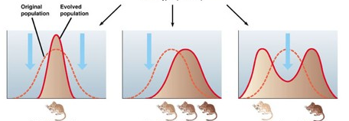
_________________ __________________ ___________________

D. Sexual Selection: Females choose mates based on certain traits
Males with these traits have higher ______________ (reproductive success)

E. Artificial Selection: humans “select” certain ________________ in plants, dogs, etc., that they find ___________________

Note: These organisms may not necessarily survive and reproduce better in nature

V. When does evolution create new species? - Speciation

A. Morphological Species Concept: internal and external ______________ are used to group organisms into species

B. Biological Species Concept– defines a species as a population of organisms that can successfully _____________

C. Speciation: formation of a new ____________

D. Reasons for Speciation: ______________ or ______________ isolation.

E. Models of Speciation (How populations change over time)

Model #1: Gradualism (change happens ____________, and new species are made at a _____________rate)

Model #2: Punctuated Equilibrium (there are times of _________ or no change followed by times of ________ change – often due to major changes in the ____________________) …. This model was designed by Stephen __________

Draw pictures of gradualism and punctuated equilibrium using the GRAPH METHOD and the TREE METHOD

Graph Method Tree Method

VI. Patterns of Evolution

A. Coevolution: change of two or more species in ____________ to one another

Provide TWO examples of coevolution:
1) _________________________________________________________
2) _________________________________________________________

B. Convergent Evolution: organisms with ______________ ancestors become very similar due to ____________ (Ex: sharks and dolphins)

C. Divergent Evolution: two or more ___________populations/species become ______________ (Ex: Darwin’s finches)
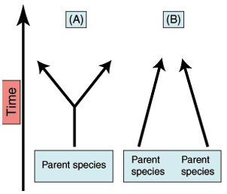
Label each graph to the right as CONVERGENT or DIVERGENT evolution.

D. Adaptive Radiation: an extreme form of _____________evolution where _________ related species evolve from a __________ ancestor species

