Name: _____________________________________________ Date: ____________________________ Period: ______

AP Biology Exam Review: Ecology (Unit 3)

Helpful Videos and Animations:

- Bozeman Biology: Ecosystems
- Bozeman Biology: Ecosystem Change
- Bozeman Biology: Ecological Succession
- Bozeman Biology: Populations
- Bozeman Biology: R and K Selection
- Bozeman Biology: Cooperative Interactions
- Bozeman Biology: Communities
- Bozeman Biology: Niche
- Bozeman Biology: Environmental Matter Exchange

Topic Outline: (Thank you to Megan Chirby and Amy Litz!)

Unit 3, Part 1 Notes: Population Ecology

- Populations
- Population Growth
- density dependent limiting factors (competition for resources, parasites & diseases, waste products, stress, predation)
- density independent limiting factors (climate = temperature & rainfall, natural disaster)
- exponential growth (J-shaped, unlimited) vs. logistic growth curve (S-shaped, limited)
- carrying capacity = maximum population supported by habitat
- Using age structure to study human populations
- Population ability to respond to changes in the environment is affected by genetic diversity. Species and populations with little genetic diversity are at risk for extinction.
- Communication within populations
- Cooperative behavior (ex: predator warnings)
- Behaviors to enhance reproductive success (ex: territory marking)
- Different types of behaviors and reasons for behaviors: Animals use visual, audible, tactile, electrical and chemical signals to indicate dominance, find food, establish territory and ensure reproductive success. (ex: bee dances)

Unit 3, Part 2 Notes: Community Ecology

- Communities
- Niche (fundamental vs. realized)
- Be able to analyze food chains and food webs / identify trophic levels
- Location of decomposers on a food chain
- Primary productivity (gross vs. net)
- Trophic Efficiency: energy pyramids vs. pyramids of biomass vs. pyramids of numbers
- The importance of species diversity in a community (determined by species richness and relative abundance)
- Types of symbiosis: mutualism, commensalism, predation, parasitism, competition
- The effect of removing a dominant or keystone species

Unit 3, Part 3 Notes: Ecosystem Ecology

- Ecosystems
- Levels of ecology: population, community, ecosystem, biosphere
- Abiotic vs. biotic factors
- Effect of human activities on ecosystems (ex: invasive species)
- Effect of geological / meteorological events on ecosystems (ex: meteor causing extinction of dinosaurs)
- Free Energy
- Reproduction and rearing of offspring require free energy beyond that used for maintenance and growth. Different organisms use various reproductive strategies in response to energy availability.
- There is a relationship between metabolic rate per unit body mass and the size of multicellular organisms — generally, the smaller the organism, the higher the metabolic rate.
- Excess acquired free energy versus required free energy expenditure results in energy storage or growth.
- Insufficient acquired free energy versus required free energy expenditure results in loss of mass and, ultimately, the death of an organism.

Unit 3, Part 4 Notes: Biogeochemical Cycles

- Molecules and atoms from the environment are necessary to build new molecules
- C,H,N,O,P, and S are the most common elements in living organisms
- Carbon (know where it is found in the four macromolecules and how it cycles between the environment and living organisms via the Carbon Cycle)
- Nitrogen (know where it is found in proteins and nucleic acids and how it cycles between the environment and living organisms via the Nitrogen Cycle)
- Phosphorus (know where it is found in lipids and nucleic acids and how it cycles between he environment and living organisms via the Phosphorus Cycle)
- Know where/how carbon, hydrogen, nitrogen, oxygen, phosphorus, and sulfur are used in the macromolecules

Practice Multiple Choice Questions

1. Long–term studies of Belding's ground squirrels show that immigrants move nearly 2 km from where they are born and become 1% –8% of the males and 0.7% –6% of the females in other populations. On an evolutionary scale, why is this significant?
a. | These immigrants make up for the deaths of individuals, keeping the other populations' size stable.
b. | Young reproductive males tend to stay in their home population and are not driven out by other territorial males.
c. | These immigrants provide a source of genetic diversity for the other populations.
d. | Those individuals that emigrate to these new populations are looking for less crowded conditions with more resources.
e. | Gradually, the populations of ground squirrels will move from a clumped to a uniform population pattern of dispersion.

2. Which of the following graphs illustrates the REALISTIC growth curve of a small population of rodents that has grown to reach a static carrying capacity?
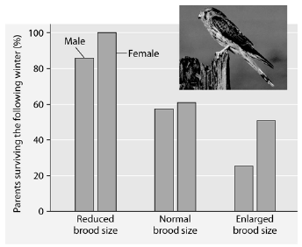
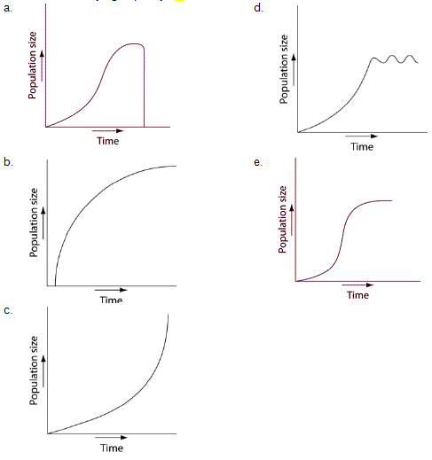

Researchers in the Netherlands studied the effects of parental care given in European kestrels over five years. The researchers transferred chicks among nests to produce reduced broods (three or four chicks), normal broods (five or six chicks), and enlarged broods (seven or eight chicks). They then measured the percentage of male and female parent birds that survived the following winter. (Both males and females provide care for chicks.)

3. Which of the following is a conclusion that can be drawn from this graph?
a. | Female survivability is more negatively affected by larger brood size than is male survivability.
b. | Male survivability decreased by 50% between reduced and enlarged brood treatments.
c. | Both males and females had increases in daily hunting with the enlarged brood size.
d. | There appears to be a negative correlation between brood enlargements and parental survival.
e. | Chicks in reduced brood treatment received more food, weight gain, and reduced mortality.

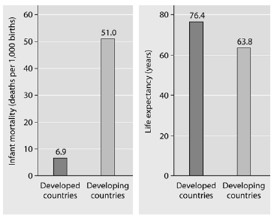

4. What is a logical conclusion that can be drawn from the graphs above?
a. | Developed countries have lower infant mortality rates and lower life expectancy than developing countries.
b. | Developed countries have higher infant mortality rates and lower life expectancy than developing countries.
c. | Developed countries have lower infant mortality rates and higher life expectancy than developing countries.
d. | Developed countries have higher infant mortality rates and higher life expectancy than developing countries.
e. | Developed countries have a life expectancy that is about 42 years more than life expectancy in developing countries.

5. Approximately how many kg of carnivore (secondary consumer) biomass can be supported by a field plot containing 1,000 kg of plant material?
a. | 10,000
b. | 1,000
c. | 100
d. | 10
e. | 1

6. Elephants are not the most dominant species in African grasslands, yet they influence community structure. The grasslands contain scattered woody plants, but they are kept in check by the uprooting activities of the elephants. Take away the elephants, and the grasslands convert to forests or to shrublands. The newly growing forests support fewer species than the previous grasslands. Which of the following describes why elephants are the keystone species in this scenario?
a. | Essentially all of the other species depend on the presence of the elephants to maintain the community.
b. | Grazing animals depend upon the elephants to convert forests to grassland.
c. | Elephants prevent drought in African grasslands.
d. | Elephants are the biggest herbivore in this community.
e. | Elephants help other populations survive by keeping out many of the large African predators.

7. Food chains are sometimes short because
a. | only a single species of herbivore feeds on each plant species.
b. | local extinction of a species causes extinction of the other species in its food chain.
c. | most of the energy in a trophic level is lost as it passes to the next higher level.
d. | predator species tend to be less diverse and less abundant than prey species.
e. | most producers are inedible.

8. Why is net primary production (NPP) a more useful measurement to an ecosystem ecologist than gross primary production (GPP)?
a. | NPP can be expressed in energy/unit of area/unit of time.
b. | NPP can be expressed in terms of carbon fixed by photosynthesis for an entire ecosystem.
c. | NPP represents the stored chemical energy that is available to consumers in the ecosystem.
d. | NPP is the same as the standing crop.
e. | NPP shows the rate at which the standing crop is utilized by consumers.

9. Consider the food chain grass  grasshopper  mouse  snake  hawk. How much of the chemical energy fixed by photosynthesis of the grass (100%) is available to the hawk?
a. | 0.01%
b. | 0.1%
c. | 1%
d. | 10%
e. | 60%
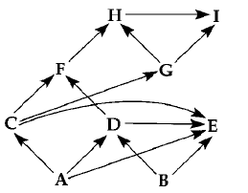
10. If the figure above represents a terrestrial food web, the combined biomass of C + D would probably be
a. | greater than the biomass of A.
b. | less than the biomass of H.
c. | greater than the biomass of B.
d. | less than the biomass of A + B.
e. | less than the biomass of E.

Use the graph and information provided in the paragraph below to answer the following questions.
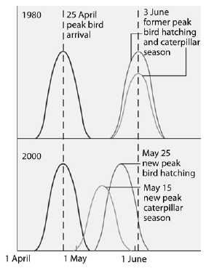
Flycatcher birds that migrate from Africa to Europe feed their nestlings a diet that is almost exclusively moth caterpillars. The graph below shows the mean dates of arrival, bird hatching, and peak caterpillar season for the years 1980 and 2000.
11. Why were ecologists concerned about the shift in the peak caterpillar season from June 3, 1980, to May 15, 2000?
a. | The caterpillars would have eaten much of the foliage of the trees where flycatchers would have nested, rendering their nests more open to predation.
b. | The earlier hatching of caterpillars would compete with other insect larval forms which the flycatchers would also use to feed their young.
c. | The 2000 flycatcher nestlings would miss the peak caterpillar season and might not be as well fed.
d. | The flycatchers would have to migrate sooner to match their brood–rearing to the time of peak caterpillar season.
e. | Pesticides, which have a negative effect on the ecosystem, would have to be used to control the earlier outbreak of caterpillar hatching.

Practice Short Response Questions

