**Ms. Chirby’s AP Biology Review Packet**

Thank you Ms. Chirby!

**\*\*\*Note: The unit #’s and order are different for this packet than they are in our curriculum. Also, enzymes are included in the biochemistry unit on this packet, but we included them in the enzymes and cell respiration unit for our curriculum. OH WELL, WE CAN DEAL.\*\*\***

**Unit 1: Evolution and Classification**

***Thinking Practice Questions***

1. As a field researcher you are sent to the Arizona desert to study the prairie dog species C. ludivincianus to determine if the population is in Hardy-Weinberg equilibrium. Specifically, you are studying this population with respect to the gene that determines the coat color in C. ludivincianus. This trait is coded for by a single gene (the NDY6 gene) with two alleles (N, n) and is passed down from one generation to the next. After sampling 170 of these prairie dogs, you find that 36% of the C. ludivincianus population is homozygous recessive for coat color. Assuming that the population is in Hardy-Weinberg equilibrium…
2. What is the allele frequency of the N allele?
3. What is the frequency of homozygous dominant prairie dogs?
4. What is the frequency of heterozygous prairie dogs?
5. What conditions must be being satisfied for this population to be in HW equilibrium?
6. Sixty flowering plants are planted in a flowerbed. Forty of the plants are red-flowering homozygous dominant. Twenty of the plants are white-flowering homozygous recessive. The plants naturally pollinate and reseed themselves for several years. In a subsequent year, 178 red-flowered plants, 190 pink-flowered plants, and 52 white-flowered plants are found in the flowerbed. Use a chi-square analysis to determine if the population is in Hardy-Weinberg equilibrium.
7. For the past 10 to 25 years, farmers have planted crop seeds that have been genetically modified to withstand treatment with a common weed killer called Roundup®. This allows the farmers to spray their fields to get rid of weeds without harming their crops. Recently, more and more farmers have discovered that their fields have Roundup-resistant pigweed growing along with their crop. Describe what has most likely happened over time to lead to this.
8. Peppered moths have wings that vary in color, ranging from white to dark gray. During the Industrial Revolution through the mid-20th century, factories and power plants, which burned coal, produced large quantities of soot and smog. Near industrialized areas, black powder covered surfaces, including the moth habitat.
9. Use this information to explain the changes seen in light and dark peppered moths from 1800-1950, as shown in the graph below.

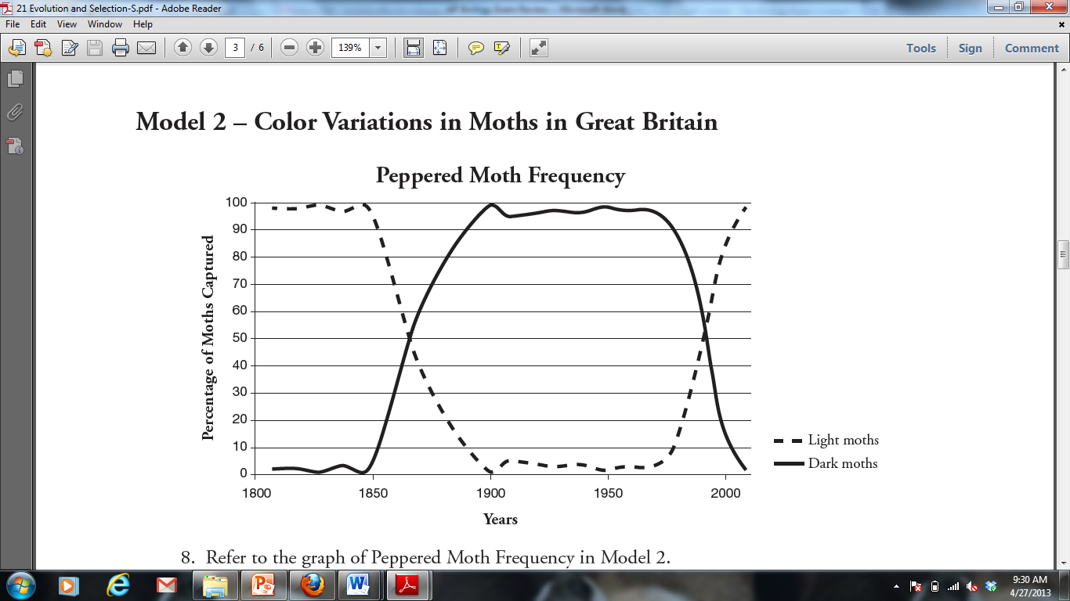

1. Propose an explanation for the return of the peppered moth population to more light than dark moths by the year 2000.
2. Five new species of bacteria were discovered in Antarctic ice core samples. The nucleotide (base) sequences of rRNA subunits were determined for the new species. The table below shows the number of nucleotide differences between the species. Draw a phylogenetic tree indicating the relatedness of these 5 species.

|  |  |  |  |  |  |
| --- | --- | --- | --- | --- | --- |
| Species | 1 | 2 | 3 | 4 | 5 |
| 1 | - | 2 | 23 | 19 | 17 |
| 2 |  | - | 24 | 19 | 18 |
| 3 |  |  | - | 23 | 23 |
| 4 |  |  |  | - | 1 |
| 5 |  |  |  |  | - |

***Long Response Question***

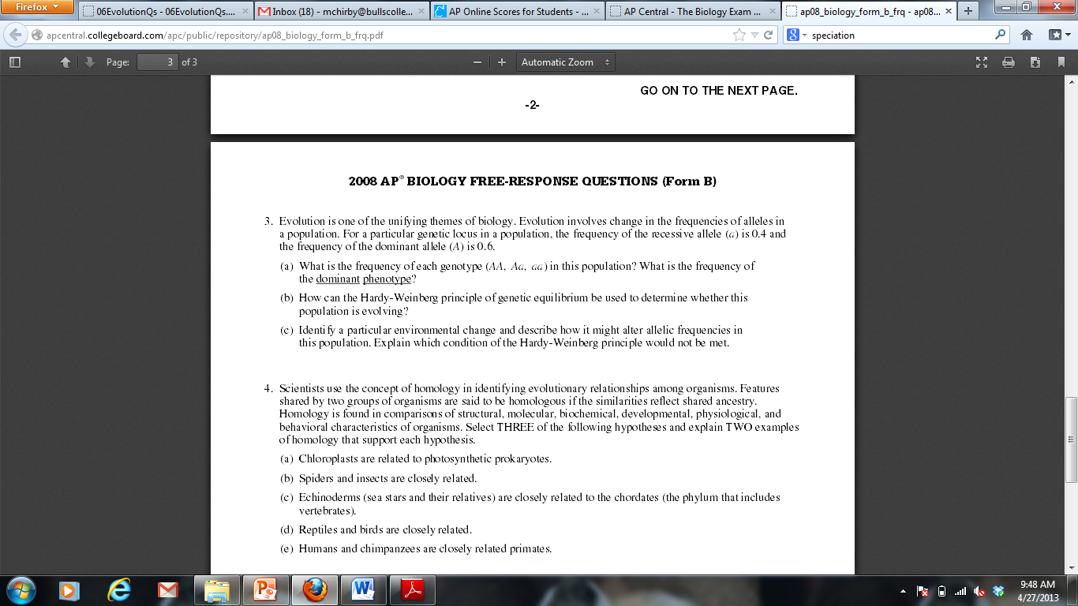

**Unit 2: Biochemistry**

***Thinking Practice Questions***

1. If the following molecules were to undergo a dehydration synthesis reaction, what molecules would result? **Circle** the parts of each amino acid that will interact and **draw** the resulting molecule.

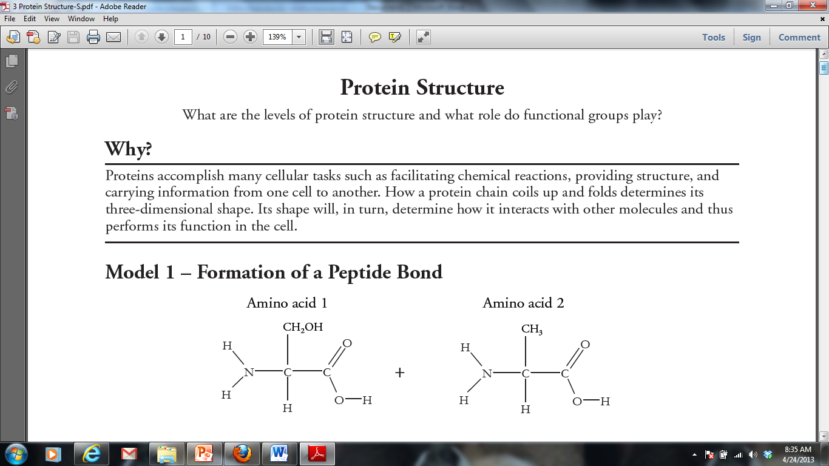

1. Identify which of the six main elements (CHNOPS) are found in each of the four macromolecules (carbohydrates, lipids, proteins, and nucleic acids).
2. Describe the relationship between substrate concentration and reaction rate shown in the graph below and propose an explanation for it.

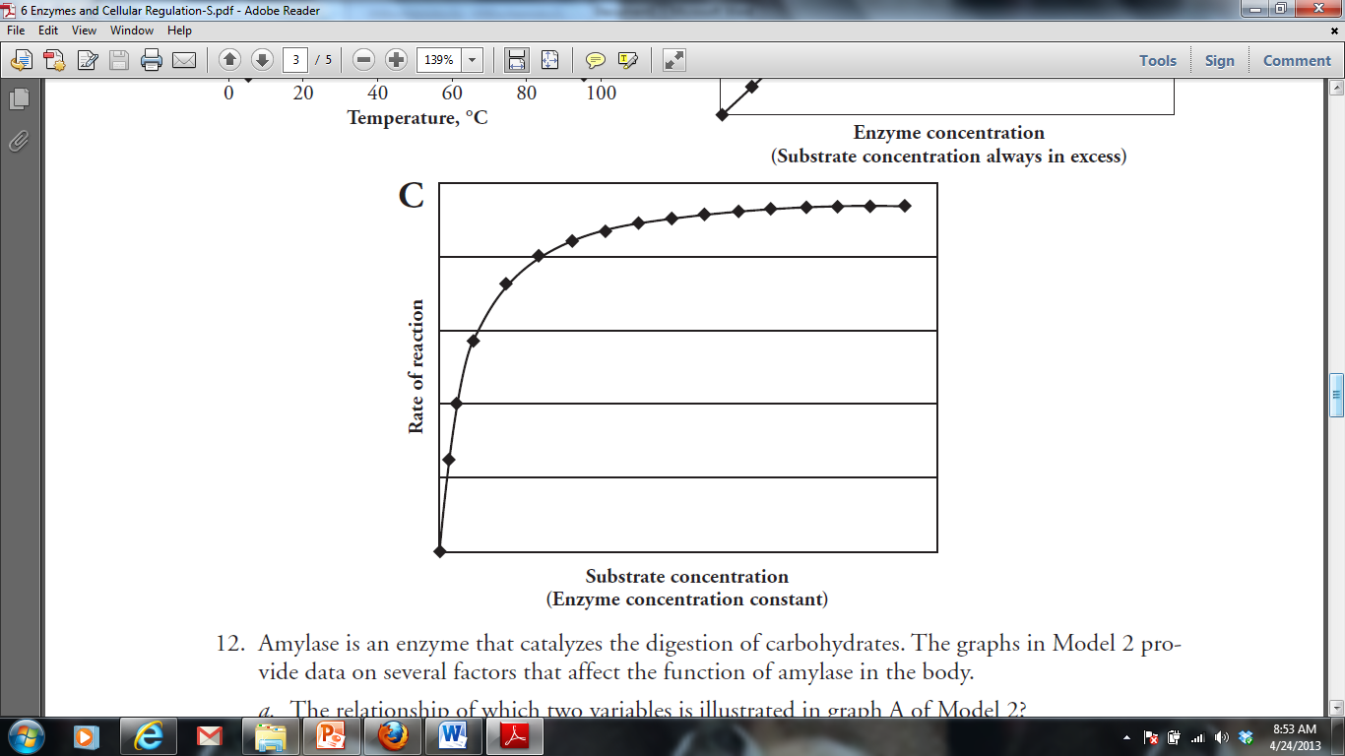

1. DNA polymerase from *T. aquaticus (Taq)* is used in PCR (polymerase chain reaction). PCR is a technique where millions of copies of DNA can be made from one original copy. In this method, the target DNA molecule is subjected to temperatures over 95 °C to make the double-stranded DNA separate. The temperature is then lowered slightly to allow primers to anneal before the *Taq* polymerase catalyzes the reactions to incorporate new nucleotides into the complementary strands. The cycle is then repeated over and over until there are millions of copies of the target DNA.
2. Predict why this bacterial polymerase is used instead of a human polymerase.
3. What would happen if you used a human polymerase in a series of PCR reactions?

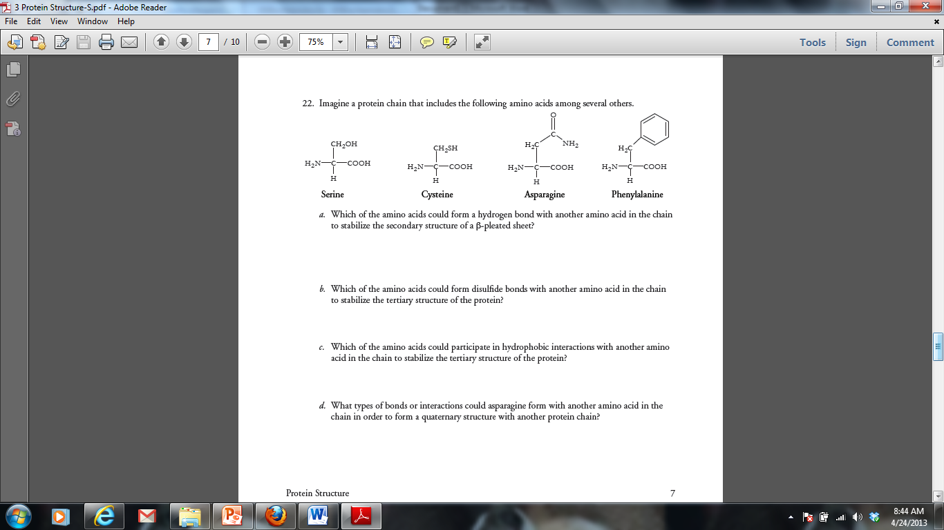

5.

***Short Response Question***

Water is important for all living organisms. The functions of water are directly related to its physical properties. Describe how the properties of water contribute to TWO of the following:

* Transpiration
* thermoregulation in endotherms
* plasma membrane structure

**Unit 3: Cell Structure and Transport**

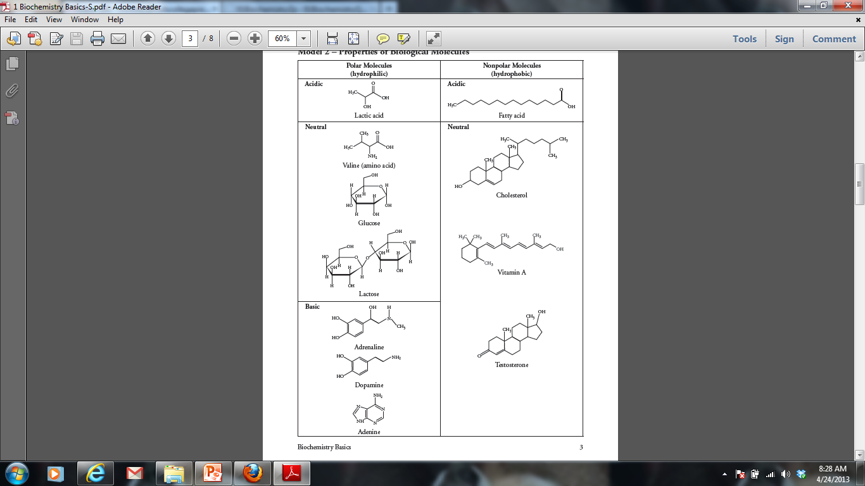***Thinking Practice Questions***

1. For each molecule shown to the right, answer the following, providing justifications for each:
2. Is it polar or nonpolar?
3. Is it hydrophobic or hydrophilic?
4. In order to be transferred into a cell, would the molecule require a protein channel?

‘

1. Biological systems rely heavily on the properties of water movement. Excretion, digestion, and blood pressure are just a few examples of situations where water balance is important. Suppose you have a semi-permeable membrane that ONLY water can pass. On one side of the membrane you have 0.1 M CaCl2. On the other side of the membrane, you have 0.1 M Glucose. CaCl2 ionizes in water to produce 3 ions. Glucose does not ionize in water.

|  |  |
| --- | --- |
| 0.1 M CaCl2 | 0.1 M Glucose |

1. Calculate the water potential for each side of the membrane. Assume room temperature (25 degrees Celsius or 298 Kelvin)
2. Describe which way water will move and explain your answer.

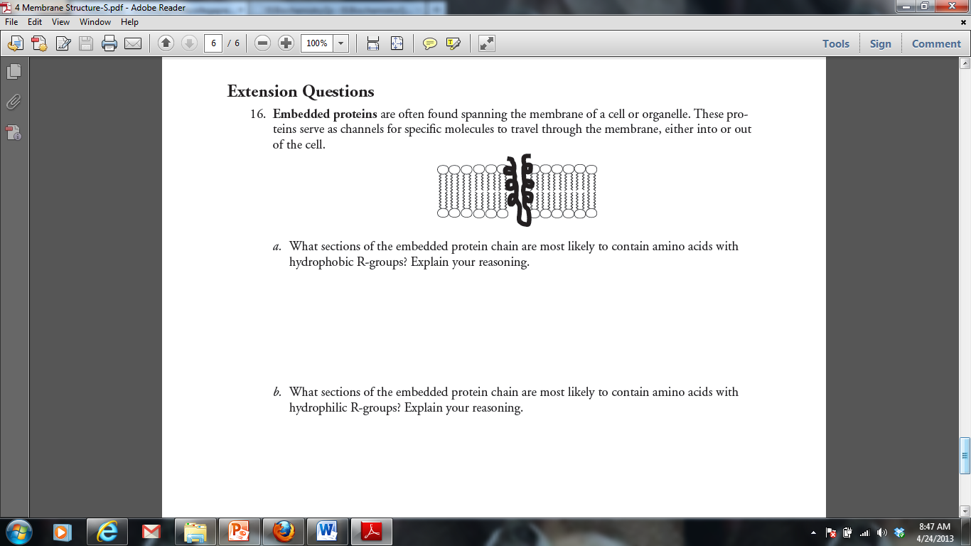

3.

4. Tay-Sachs disease is a human genetic abnormality that results in cells accumulating and becoming clogged with very large and complex lipids. Which cellular organelle must be involved in this condition?

**Units 4 and 5: Cell Energy (Cellular Respiration and Photosynthesis)**

***Thinking Practice Questions***

1. The figure below outlines the process of cellular respiration. Glucose and oxygen are both reactants in this process.
2. Describe the journey of a single carbon atom from glucose in cellular respiration
3. Describe the journey of a single hydrogen atom from glucose in cellular respiration
4. Describe the function of the oxygen molecules in cellular respiration

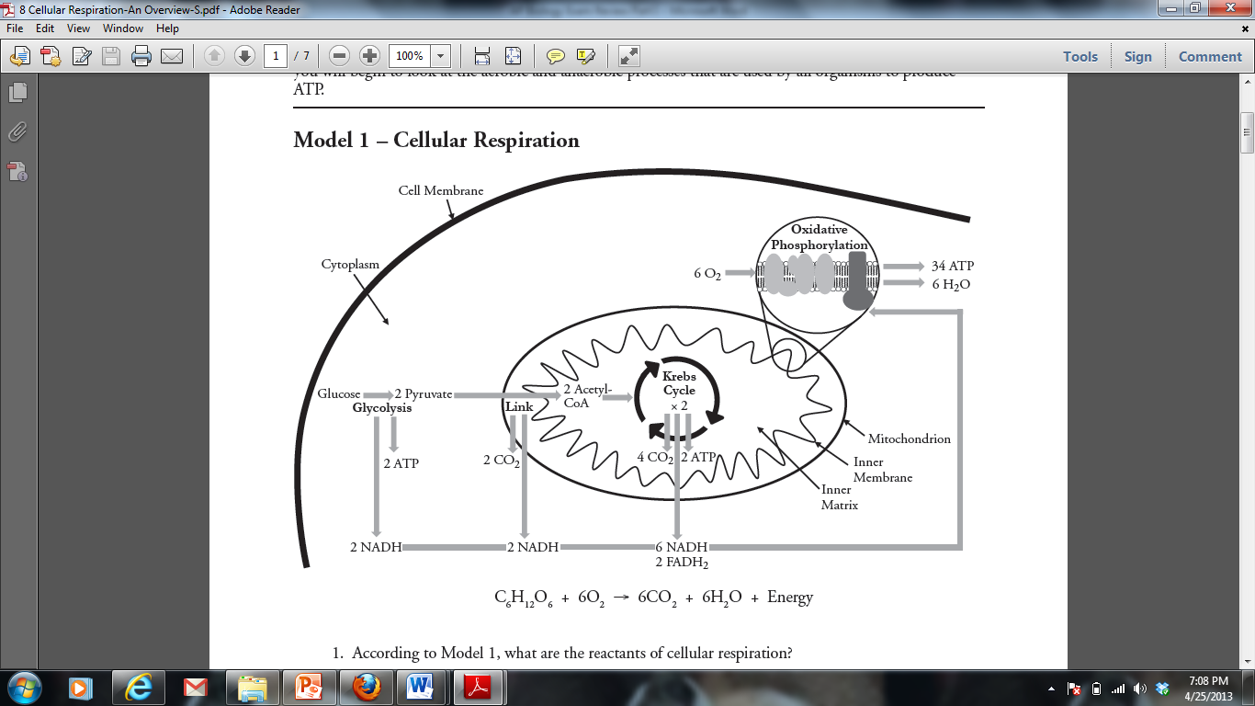

1. The figure below outlines the process of photosynthesis. Carbon dioxide and water are both reactants in this process.
2. Describe the journey of a single hydrogen atom from water in photosynthesis.
3. Describe the journey of a single oxygen atom from water in photosynthesis.
4. Describe the journey of a carbon dioxide molecule in photosynthesis.

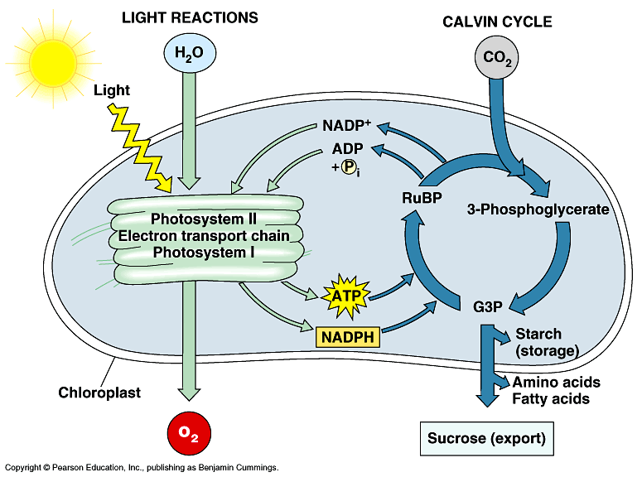

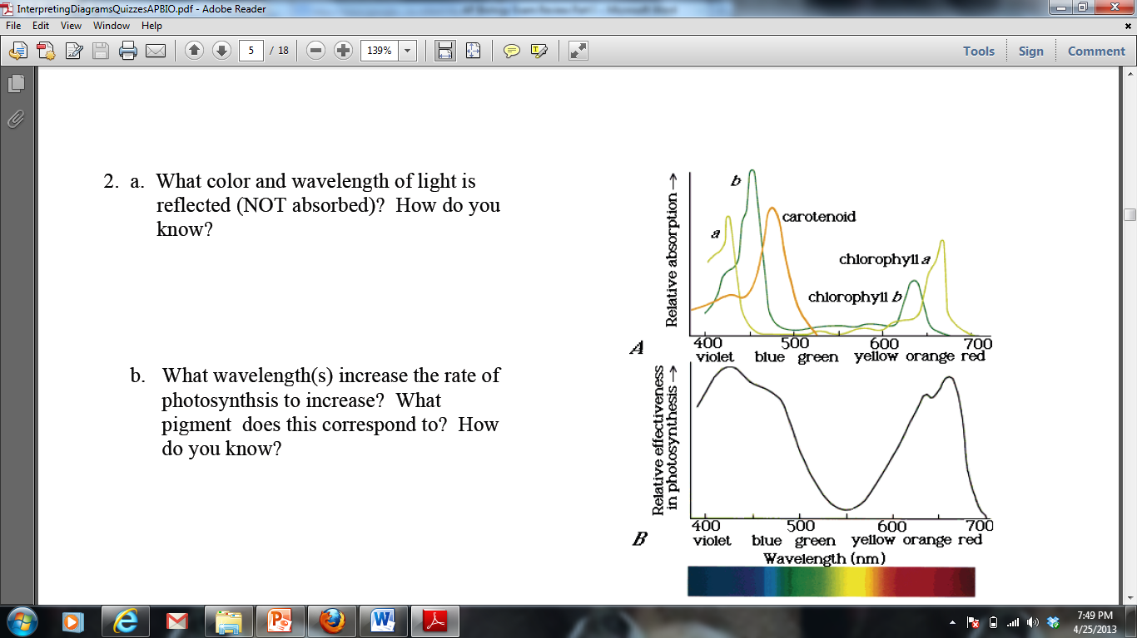

1. The figures to the right display the absorption range for several different pigments found in plants (top) and the rate of photosynthesis at varying conditions of wavelength in one plant species (bottom):
2. What color and wavelength of light is reflected by the plant species tested? How do you know?
3. What wavelength(s) increase the rate of photosynthesis in the plant species tested? What pigment does this correspond to? How do you know?

***Short Response Question***

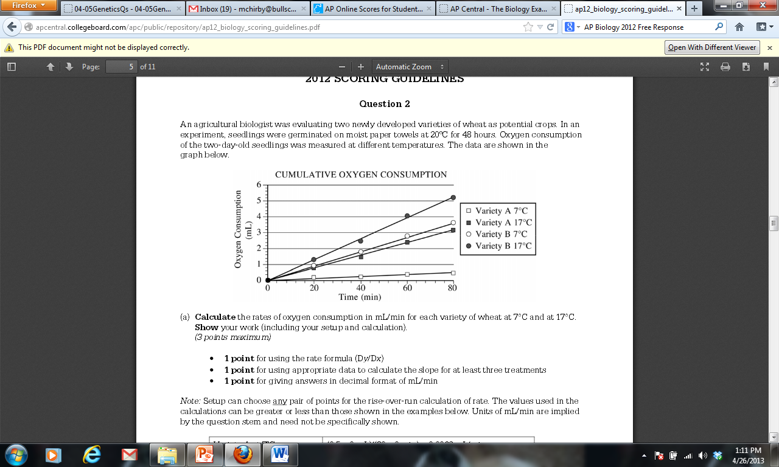

In a second experiment, Variety A seedlings at 17oC were treated with a chemical that prevents NADH from being oxidized to NAD+. **Predict** the most likely effect of the chemical on metabolism and oxygen consumption of the treated seedlings. **Explain** your prediction.

**Units 6 and 7: Cell Division and Signaling**

***Thinking Practice Questions***

1. Refer to the figure to the right.
2. What process is being shown in this picture?
3. What type of organism are these cells from? How do you know?
4. Identify a numbered cell for each of the four major stages of mitosis.
5. In what stage are most of the cells in this image? What does this indicate about the amount of time spent in each phase of the cell cycle?
6. Paclitaxel is a chemotherapy drug used to treat a variety of cancers. Paclitaxel inhibits both assembly and disassembly of microtubules.
7. Which phases in the cell cycle are affected by Paclitaxel? How does this drug inhibit the growth of cancer?
8. Paclitaxel affects not only cancer cells, but normal cells as well. Would the effects of Paclitaxel be seen first in organs that have quickly dividing cells (like the intestine and hair follicles) or in organs that have slow or nondividing cells (like muscles and the nervous system). Justify your reasoning.
9. Two students debate about proteins that regulate the cell cycle. One argues that MPF triggers the production of cyclin, while the other argues that cyclin triggers the production of MPF.
10. Based on the figure on the previous page, which statement is correct and why?
11. Propose a possible function of MPF, based on when it is produced in the cell cycle.
12. The following diagram shows an action potential of a neuron. For each question, you can answer with one letter or multiple letters.
13. At which letter would you find Na+ voltage gated channel OPEN?



1. At which letter(s) would you find the Na+/K+

pump WORKING?

1. At which letter(s) would you find K+ voltage gated channels OPEN?
2. At point F, would there be a more positive charge on the INSIDE or OUTSIDE of the neuron?
3. At point B, would you find more Na+ on the INSIDE or OUTSIDE of the neuron?
4. 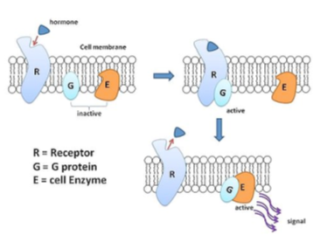Tetrodotoxin is a neurotoxin that blocks Na+ voltage gated channels. How would the function of the neuron be altered by the presence of this toxin?
5. Refer to the diagram at the right to respond to the following questions.
6. Is the hormone hydrophobic or hydrophilic? How do you know?
7. Explain how the action of the hormone might be different if it could move through the cell membrane.
8. Explain what is happening in this picture and make a prediction about what will be the end result in the cell to which this hormone has bound.
9. One student described an action potential in a neuron by saying “As more gates open the concentration of sodium inside the cell increases and this causes even more gates to open.” Is this an example of a positive or negative feedback loop? Justify your reasoning.



1. The figure to the right shows the feedback mechanism for regulating blood glucose.
2. Is this a positive or negative feedback loop? Explain your answer.
3. Individuals that suffer from Type I diabetes do not have functional insulin-producing cells. Describe how their blood will differ from that of a healthy individual after a glucose-rich meal.

***Short Response Question***

Meiosis reduces chromosome number and rearranges genetic information. **Explain** how the reduction and rearrangement are accomplished in meiosis.

**Units 8 and 9: Classical and Molecular Genetics**

***Thinking Practice Questions***

1. You have performed a dihybrid cross of plants and got the following data: 206 purple tall, 65 white tall, 83 purple short, 30 white short. Perform a chi-square analysis to test the null hypothesis that both parents were heterozygous for the traits of color and height. Purple (A) is dominant to white (a), and tall (B) is dominant to short (b).
2. Compare the two DNA sequences shown below. Transcribe them into mRNA and translate them into an amino acid sequence.

GTG CAC CTC ACA CCA GAG GAG (Normal Hemoglobin)

mRNA 🡪

amino acids 🡪

GTG CAC CAC ACA CCA GTG GAG (Sickle Cell Hemoglobin)

mRNA 🡪

amino acids 🡪

1. Circle any differences there are in the DNA, RNA and amino acid sequences that might exist between these two sequences.
2. Identify the type of mutation that is represented AND EXPLAIN, IN DETAIL, what effect this would have on the protein/pigment.

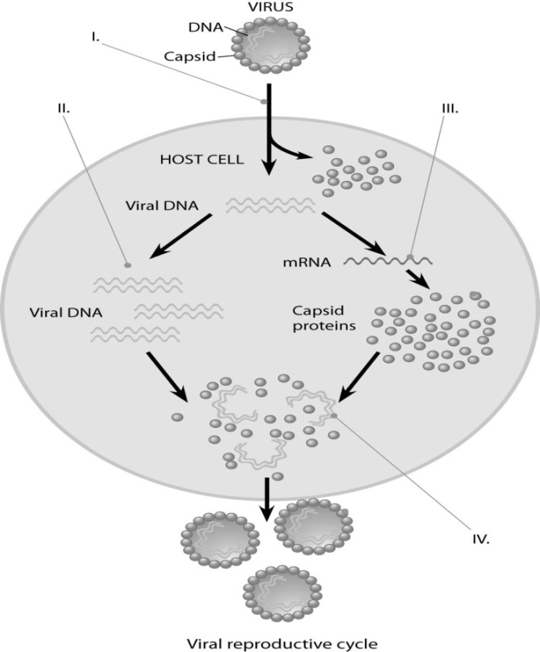

1. In prokaryotic cells, translation begins before transcription is finished. Give two reasons why this would not be possible in eukaryotic cells.
2. Describe the processes occurring at each of the numbered positions (I, II, III, and IV) in the diagram to the right.

***Short Response Question***

When DNA replicates, each strand of the original DNA molecule is used as a template for the synthesis of a second, complementary strand. Compare and contrast the replication of the two new strands, **listing** and **explaining** at least one similarity and one difference in the methods of synthesis. You may draw a diagram to help answer the question, but be sure to explain your diagram in your answer.

**Units 10 and 11: Gene Regulation / Biotechnology and Organism Form / Function**

***Thinking Practice Questions***

1. In a molecular biology laboratory, a student obtained competent *E. coli* cells and used a common transformation procedure to induce the uptake of plasmid DNA with a gene for resistance to the antibiotic kanamycin. The results below were obtained.

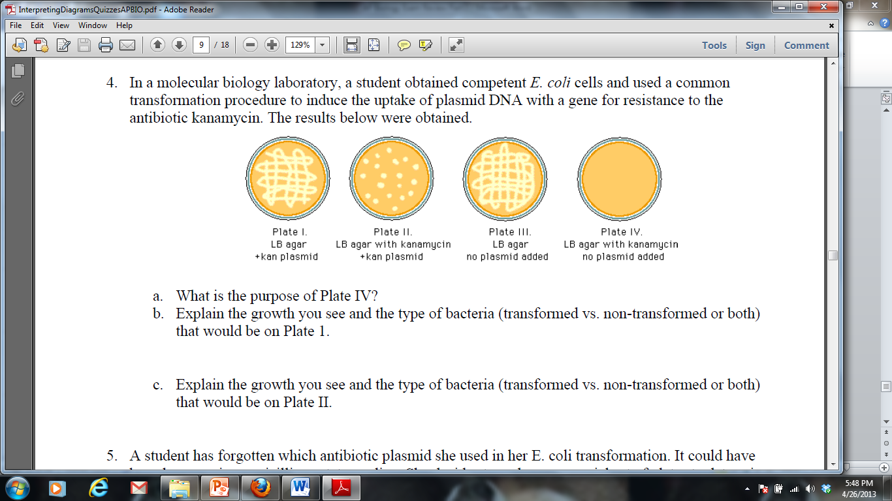

1. What is the purpose of Plate IV?
2. Explain the growth you see and the type of bacteria (transformed vs. non-transformed or both) that would be on Plate 1.
3. Explain the growth you see and the type of bacteria (transformed vs. non-transformed or both) that would be on Plate II.
4. If the student repeated the experiment, but the heat shock was unsuccessful and the plasmid was unable to be transformed, for which plates would growth be expected? Explain your answer.
5. The restriction enzyme EcoRI cleaves double-stranded DNA at the sequence 5'-GAATTC-3' and the restriction enzyme HindIII cleaves at 5'-AAGCTT-3'. A 20 kb circular plasmid is digested with each enzyme individually and then in combination, and the resulting fragment sizes are determined by means of electrophoresis. The results are as follows:

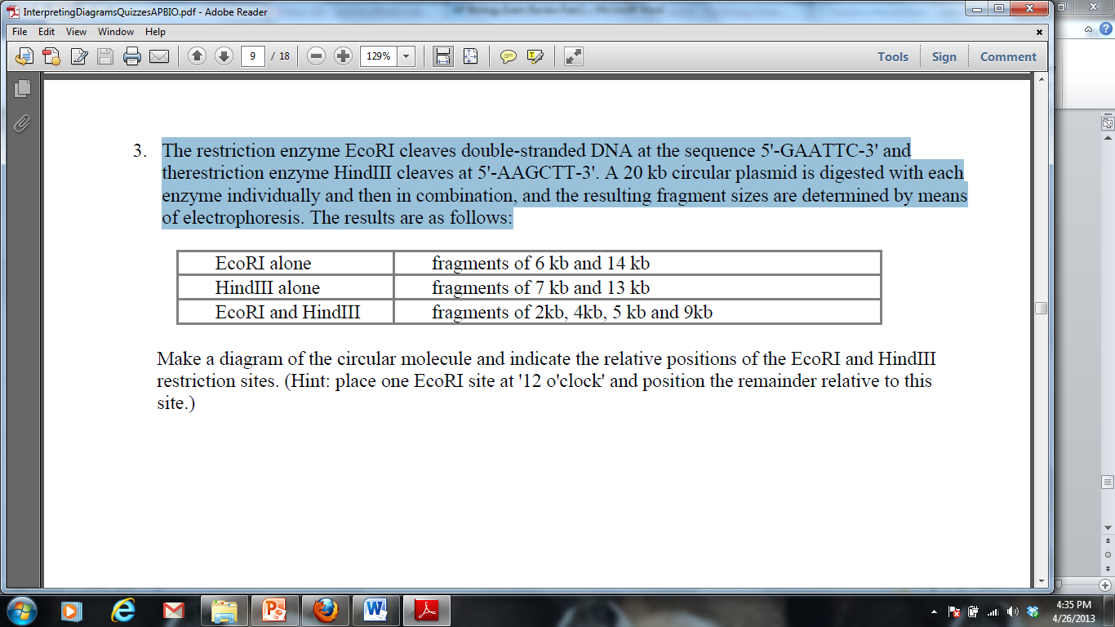

Make a diagram of the circular molecule and indicate the relative positions of the EcoRI and HindIII restriction sites. (Hint: place one EcoRI site at '12 o'clock' and position the remainder relative to this site.)



1. Refer to the images at the right to answer the following:
2. Which immune response in shown: cell mediated or humoral? Explain how you know.
3. What are the “Y” shaped molecules called? What is their role in the immune response?



1. Describe how the “Y” shaped molecules relate to the graph displayed.

**Unit 12: Ecology**

***Thinking Practice Questions***

1. Invasive species are species that are introduced into an environment but are not naturally found in that environment. One example of an invasive species is the American gray squirrel, introduced into Britain at the end of the 18th century. Until 1876 the only native squirrel in Britain was the European red squirrel, which was found in deciduous and coniferous forests. By 1940 the gray squirrel had displaced the red squirrel across most of the British Isles, and by 1984 the red squirrel was only found in isolated coniferous woodland areas. After its initial introduction, the gray squirrel population increased rapidly; however, in recent years population sizes within specific environments have become stable.
2. Explain why the newly-introduced gray squirrel initially showed rapid population growth and why the native red squirrel showed a population decline.
3. Why has the population size of the gray squirrel become stable in recent years?
4. The first age structure graph below for country X shows the percent of the population in each age group for the year 2000. The remaining three graphs are projections of how the age structure of country X will change. From these age structure diagrams construct a graph of population size vs. time for 2000-2080 and justify your prediction.

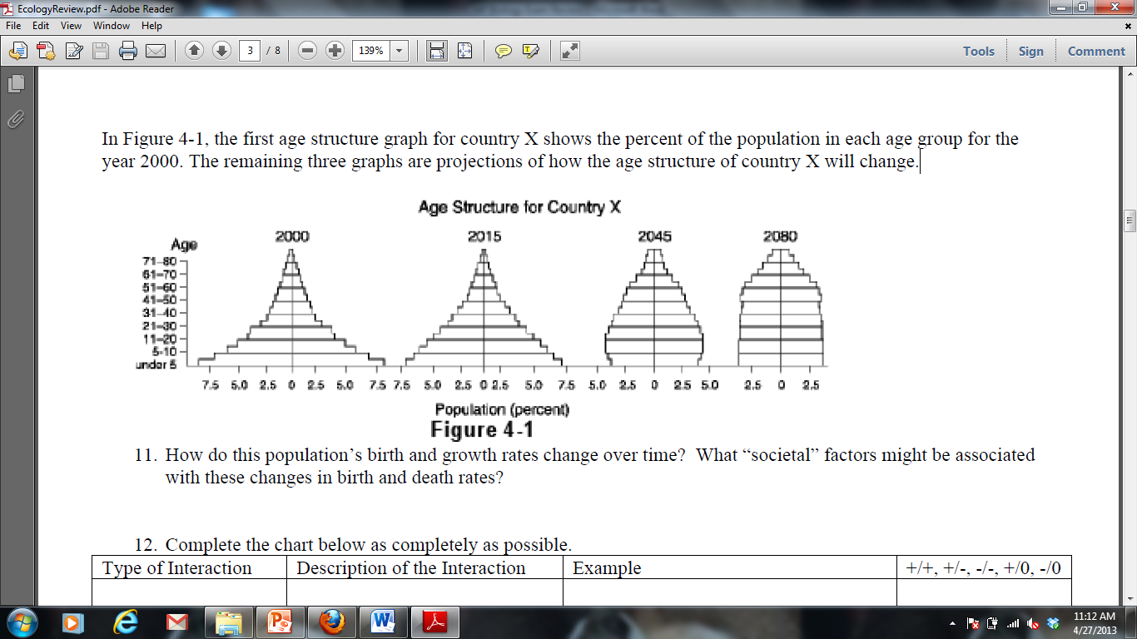

1. The graphs below display the growth rate for two species of bacteria when grown separately and together.

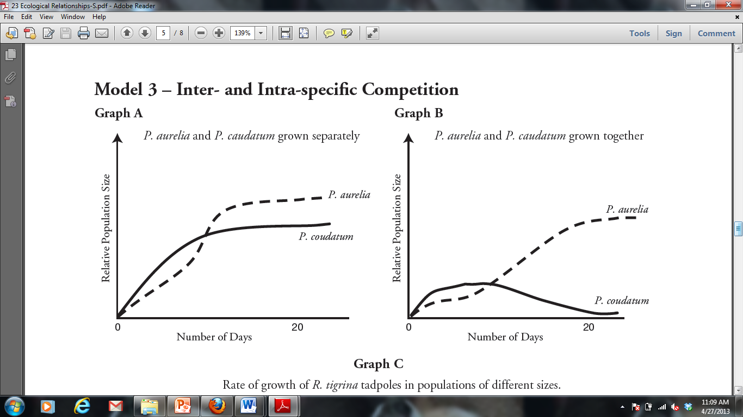

1. The population growth of which bacteria is more affected by growing conditions? Explain how you know.
2. Using the information provided in the graphs, make a prediction as to why the bacteria identified in part a is more affected by growing conditions than the other bacteria.
3. Interdependence in nature is illustrated by the transfer of energy through trophic levels. The diagram below depicts the transfer of energy in a food web of an Arctic lake located in Alaska.

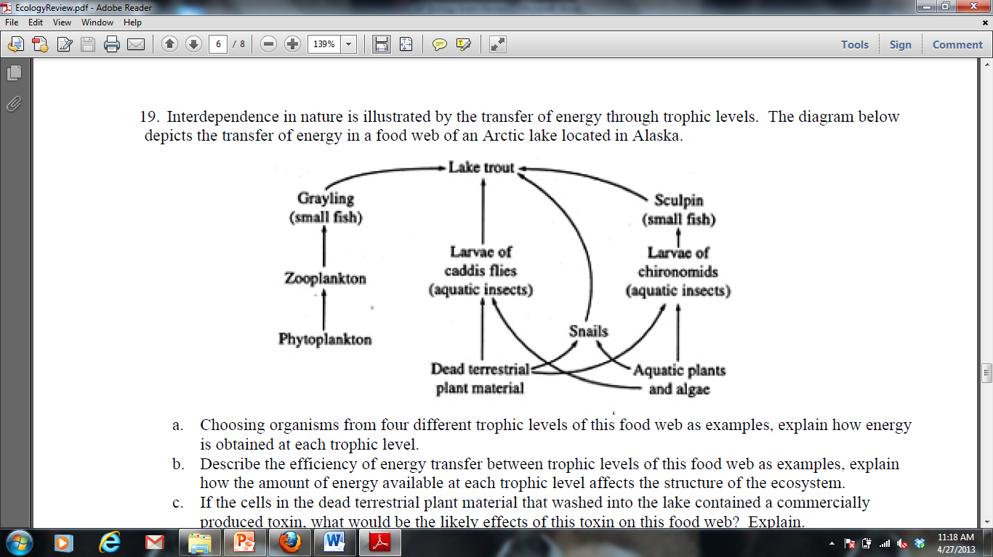

1. Identify an organism from each of the 5 trophic levels (producer, primary consumer, secondary consumer, teritiary consumer and decomposer) and explain how energy is obtained at each level.
2. Describe the efficiency of energy transfer between trophic levels of this food web.
3. Explain how the amount of energy available at each trophic level affects the size of each population.
4. If all of the Sculpin in this ecosystem were removed, predict how it would impact the following and explain each prediction:

* The population of lake trout
* The population of snails
* The population of algae
* The amount of oxygen produced in the ecosystem
* The amount of light energy absorbed by the ecosystem

***Long Response Question***

