Name: _____________________________________________ Date: ____________________________ Period: ______

**AP Biology Exam Review: Classical Genetics (Unit 10) and Molecular Genetics (Unit 11)**

**Helpful Videos and Animations:**

1. [Bozeman Biology: Mendelian Genetics](https://www.youtube.com/watch?v=NWqgZUnJdAY&feature=BFa&list=PLFCE4D99C4124A27A)
2. [Bozeman Biology: Chromosomal Genetics](https://www.youtube.com/watch?v=rIe7mPXkYhs&list=PL7A750281106CD067&index=52&feature=plpp_video)
3. [Bozeman Biology: A Beginner's Guide To Punnett Squares](https://www.youtube.com/watch?v=Y1PCwxUDTl8&feature=BFa&list=PL7A750281106CD067)
4. [Bozeman Biology: Probability in Genetics - Multiplication and Addition Rules](https://www.youtube.com/watch?v=y4Ne9DXk_Jc&feature=BFa&list=PL7A750281106CD067)
5. [Bozeman Biology: Linked Genes](https://www.youtube.com/watch?v=-_UcDhzjOio&feature=BFa&list=PL7A750281106CD067)
6. [Bozeman Biology: The Genetics of Blood Types](https://www.youtube.com/watch?v=KXTF7WehgM8&feature=BFa&list=PL7A750281106CD067)
7. [Andrew Douch: Pedigree Analysis 1](http://www.youtube.com/watch?v=HbIHjsn5cHo)
8. [Andrew Douch: Pedigree Analysis 2](http://www.youtube.com/watch?v=ej2hFc8u_zQ&feature=channel&list=UL)
9. Bozeman Biology: DNA Replication
10. Bozeman Biology: DNA and RNA - Part 1
11. Bozeman Biology: DNA and RNA - Part 2
12. McGraw-Hill Animation: DNA Replication
13. Cold Spring Harbor Lab Animation: Griffith / Avery, McCarty, and Macleod Experiments
14. McGraw-Hill Animation: Hershey Chase Experiment
15. Bozeman Biology: Transcription and Translation
16. McGraw-Hill Animation: Transcription
17. McGraw-Hill Animation: Translation
18. McGraw-Hill Animation: Intron Removal by Spliceosomes containing snRNP's (small nuclear riboproteins)
19. McGraw-Hill Animation: Mechanism of Viral Infection (Lytic)
20. McGraw-Hill Animation: Lytic vs. Lysogenic Cycle of Viral Infection
21. Sumanas Animation: Life Cycle of HIV, a Retrovirus
22. McGraw-Hill Animation: Bacterial Transduction Using a Temperate Phage
23. Bozeman Biology: Mechanisms of Genetic Variation in Prokaryotic vs. Eukaryotic Cells

**Topic Outline: (Thank you to Megan Chirby and Amy Litz!)**

***Unit 10, Part 1 Notes: The Basics of Mendelian Genetics***

1. Mendel’s experiments

* Pea plants with distinct dominant vs. recessive traits
* Know what happens in the P 🡪 F1 🡪 F2 generations

1. Basic Genetics Vocabulary

* Gene vs. allele
* Homozygous vs. heterozygous
* Genotype vs. Phenotype
* Monohybrid Cross vs. Dihybrid Cross
* Testcross

1. Setting up / analyzing genetic crosses with Punnett squares

* Know how to set up monohybrid and dihybrid crosses given information regarding parent genotypes and phenotypes and analyze offspring genotype / phenotype ratios
* Understand the rules of probability in Punnett Square analysis

1. Rule of Multiplication: when calculating the probability that two or more independent events will occur together in a specific combination, multiply the probabilities of each of the two events

For example, the probability of a coin landing face up two times in two flips is ½ X ½ = ¼

In genetics, if you cross two organisms with the genotypes AABbCc and AaBbCc, the probability of an offspring having the genotype AaBbcc is ½ X ½ X ¼ = 1/16

1. Rule of Addition: when calculating the probability that any of two or more mutually exclusive events will occur, you need to add together their individual probabilities. For example, if you are tossing a die, what is the probability that it will land on either the side with four spots or the side with five spots? (1/6 + 1/6 = 1/3)
2. Non-Mendelian Patterns of Inheritance

* Explain how sex-linkage is different from autosomal patterns of inheritance and be able to set up a sex-linked Punnett square
* Codominance and Incomplete Dominance (be able to complete Punnett squares for these two patterns of inheritance)

***Unit 10, Part 2 Notes: Human Genetics***

1. Non-Mendelian Patterns of Inheritance (continued)

* Multiple Alleles (blood type Punnett squares! Use the alleles i, IA, and IB)
* Pleiotropy
* Polygenic Inheritance
* Nonnuclear inheritance (traits determined by DNA in mitochondria or chloroplasts, not DNA in the nucleus)
* Traits influenced by the environment (ex: human height)

1. Analyzing a pedigree of a human inherited condition

* Be able to describe the methods of fetal testing for inherited genetic conditions (amniocentesis and chorionic villi sampling)
* Be able to determine the type of inheritance shown in a pedigree (autosomal dominant, autosomal recessive, sex-linked dominant, and sex-linked recessive) Here are a couple hints:

1. If there are significantly more males with a condition than females, the trait is sex-linked (be able to explain why sex-linked recessive conditions are found more often in males)
2. With an autosomal trait, if a child has a trait but the parents don’t, the trait is recessive (both parents are carriers)

***Unit 10, Part 3 Notes: Chromosomal Genetics***

1. Mendel’s Laws

* Law of Dominance
* Law of Segregation (and explain how disorders caused by nondisjunction – ex. Trisomy 21 / Down Syndrome – are related to this law ; be able to define aneuploidy, monosomy, and trisomy)
* Law of Independent Assortment

1. Linked Genes (found on the same chromosome and inherited together during cell division)

* Crossing over between homologous chromosomes during Prophase I of meiosis may separate linked genes onto different chromosomes. The frequency of recombination of linked genes due to crossing over increases if two genes are farther apart on the chromosome
* We can create a linkage map shown the location of genes on a chromosome. The distance between genes is measured in map units. 1 map unit = 1% recombination frequency 🡪 those genes are close together!

***Unit 11, Part 1 Notes: DNA***

1. DNA History

* Be able to describe the experiments leading to the discovery of DNA as the cell’s genetic material. Key scientists include

1. Franklin, Watson, Crick, Wilkins
2. Griffith
3. Hershey / Chase
4. Avery-MacLeod-McCarty
5. Structure of DNA

* Deoxyribose nucleic acid
* Double helix (two twisted stsrands) made of nucleotides (monomers)
* Nucleotide = phosphate + 5C deoxyribose sugar + nitrogen base
* Antiparallel strands- one runs 3’ to 5’ the other runs 5’ to 3’,sides of phosphates and sugars
* (backbone), rungs of paired bases with hydrogen bonds in between
* Purines (adenine,guanine; double rings) pair with Pyrimidines (cytosine, uracil, thymine; single ring)
* A - T- double H bond
* C – G- triple H bond

1. Location of DNA

* In eukaryotes DNA is found in nucleus on multiple linear chromosomes (a chromosome IS a strand of DNA with proteins etc. associated).
* In prokaryotes DNA is not in a nucleus and is usually a single circular chromosome
* Prokaryotes, viruses, and eukaryotes (yeast) can contain plasmids (small extra-chromosomal DNA that is double stranded DNA)

1. DNA replication

* Process of making exact copies of DNA (i.e. for mitosis or meiosis)
* Process is semi conservative (original strand is copied)
* Steps

1. Enzyme (helicase) unzip strands by breaking hydrogen bonds
2. “Spare” nucleotides are added bidirectionally to bond complementarily with use of DNA polymerases (DNA pol)
3. DNA pol only can add to the 3’ to 5’ side and new DNA is made in the 5’ to 3’direction
4. Replication bubbles open up and a replication fork is created because bubble is in half and it has one side 3/5 and one 5/3
5. RNA primers must be laid down to start process (RNA primase makes primers)
6. Leading strand makes DNA continuously (3/5)
7. Lagging strand makes DNA discontinuously (5/3), Okazaki fragments
8. Lagging strand requires enzyme (ligase) to fuse fragments

***Unit 11, Part 2 Notes: From Gene to Protein***

1. RNA

* Ribonucleic acid
* Single stranded, different sugar called ribose, different base called uracil INSTEAD of thymine
* Base pair rules in RNA, A-U and C-G
* messenger RNA or mRNA carries information from DNA to the ribosome
* transfer RNA or tRNA bind amino acids and are used in translation at ribosome

1. Transcription

* making mRNA in nucleus
* enzyme RNA pol reads the DNA in 3’ to 5’ direction and synthesizes complementary mRNA
* Ex. 3’ to 5’ DNA is ATG CAT then the 5’ to 3’ mRNA made will be UAC GUA
* Steps

1. Promoter is where RNA pol binds and begins
2. Elongation (adding of RNA nucleotides- does not stay attached to DNA)
3. Termination, ends when RNA pol reaches a termination sequence
4. mRNA editing

* introns spliced out (cut out) using spliceosomes (snRNP’s)
* add polyA tail to 3’
* add GTP cap to 5’
* each 3 are called a codon
* go to ribosome (free or in rough ER)

1. Translation

* mRNA code is read and matched with tRNA (brings amino acids) to construct a polypeptide using the ribosome
* Ex. mRNA codon is AAA then tRNA anticodon will be UUU and will have a corresponding amino acid for that codon of mRNA
* 3 steps: Initiation, Elongation, Termination (see notes)
* If in ER then: polypeptide is released into ER, then to Golgi complex, vesicle to cell membrane, then exocytosis (may be given signals for exit/destination)
* Free ribosomes typically make products for the cell and are not exported

1. Mutations and Increasing Genetic Diversity

* Changes to the DNA sequence are not all harmful…some can increase genetic variability 🡪 more possible forms of traits so that not all organisms can be killed off by any one factor (ex: a disease that kills all tall people)
* They can be spontaneous errors in replication or they can be caused by mutagens (environmental factors like radiation, chemicals, cigarette smoke, etc.)
* If a mutagen causes changes in genes that regulate the cell cycle / cell division it is considered a carcinogen (a cancer-causing factor)
* Some mutations are neutral (happen in introns that do not code for proteins)
* Some mutations are harmful (change protein function in a negative way)
* Types of Mutations:

1. Point mutation: change in one base pair of a gene (substitution: replace one base with another)
2. Silent – changes one base, but codes for the same amino acid (due to redundancy)
3. Missense – codes for another amino acid (changes protein sequence and usually function)

Example: sickle cell disease… one T substituted for A in the gene coding for hemoglobin protein

* Nonsense – code changes to a stop codon (makes a nonfunctional protein that is terminated early)
* Frameshift mutation: the mutation effects all nucleotides / codon groupings farther along the DNA / RNA code
* Insertion – adding extra nucleotides (causes a frameshift if you are not adding exactly three extra bases)
* Deletion – removing nucleotides (causes a frameshift if you are not removing exactly three bases)

Example: O blood type allele involves a deletion in the A blood type code

***Unit 11, Part 3 Notes: Viral and Bacterial Genetics***

1. Viruses

Replication

* Viruses inject DNA or RNA into host cell
* Viruses have highly efficient replicative capabilities that allow for rapid evolution
* Viruses replicate via the lytic cycle, allowing one virus to produce many progeny simultaneously
* Virus replication allows for mutations to occur through usual host pathways.
* RNA viruses lack replication error-checking mechanisms, and thus have higher rates of mutation.
* Related viruses can combine/recombine information if they infect the same host cell.
* Some viruses are able to integrate into the host DNA and establish a latent (lysogenic) infection
* HIV is a well-studied system where the rapid evolution of a virus within the host contributes to the pathogenicity of viral infection.
* Genetic information in retroviruses is a special case and has an alternate flow of information: from RNA to DNA, made possible by reverse transcriptase, an enzyme that copies the viral RNA genome into DNA. This DNA integrates into the host genome and becomes transcribed and translated for the assembly of new viral progeny.

1. Bacterial Reproduction and Genetic Recombination

* Transformation
* Transduction
* Conjugation
* Transposition

**Practice Multiple Choice Questions**

1. In garden peas, a single gene controls stem length. The recessive allele (*t*) produces short stems when homozygous. The dominant allele (*T*) produces long stems. A short-stemmed plant is crossed with a heterozygous long-stemmed plant. Which of the following represents the expected phenotypes of the offspring and the ratio in which they will occur?

(A) 3 long-stemmed plants: 1 short-stemmed plant

(B) 1 long-stemmed plant: 1 short-stemmed plant

(C) 1 long-stemmed plant: 3 short-stemmed plants

(D) Long-stemmed plants only

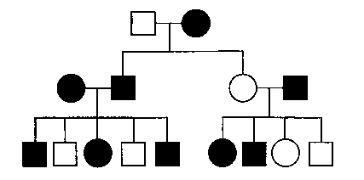2. In the pedigree below, squares represent males and circles represent females. Individuals who express a particular trait are represented by shaded figures. Which of the following patterns of inheritance best explains the transmission of the trait?

(A) Sex‑linked dominant

(B) Sex‑linked recessive

(C) Autosomal recessive

(D) Autosomal dominant

3. In humans, red-green color blindness is a sexlinked recessive trait. If a man and a woman produce a color-blind son, which of the following must be true?

(A) The father is color-blind.

(B) Both parents carry the allele for color blindness.

(C) Neither parent carries the allele for color blindness.

(D) The mother carries the allele for color blindness.

4. Assume that genes *A* and *B* are not linked. If the probability of allele A in a gamete is 1/2 and the probability of allele *B* in a gamete is 1/2, then the probability that both *A* and *B* are in the same gamete is

(A) 1/2 x 1/2

(B) 1/2 + l/2

(C) 1/2 ÷ 1/2

(D) 1/2

5. In corn, the trait for tall plants *(T)* is dominant to the trait for dwarf plants *(r)* and the trait for colored kernels *(C)* is dominant to the trait for white kernels *(c).* In a particular cross of corn plants, the probability of an offspring being tall is 1/2 and the probability of a kernel being colored is 3/4. Which of the following most probably represents the parental genotypes?

(A) *TtCc* x *ttCc*

(B) *TtCc* x *TtCc*

(C) *TtCc* x *ttcc*

1. *TTCc* x *ttCc*

6. A form of vitamin D-resistant rickets, known as hypophosphatemia, is inherited as an X-linked dominant trait. If a male with hypophosphatemia marries a normal female, which of the following predictions concerning their potential progeny would be true?

(A) All of their sons would inherit the disease.

(B) All of their daughters would inherit the disease.

(C) About 50% of their sons would inherit the disease.

1. About 50% of their daughters would inherit the disease.

7. In fruit flies, vermilion eyes are a sex-linked recessive characteristic. If a vermilion-eyed female is crossed with a wild-type male, what proportion of the male offspring should have vermilion eyes?

(A) 0%

(B) 25%

(C) 50%

(D) 100%

8. If red hair, blue eyes, and freckles were consistently inherited together, the best explanation would be that

(A) these traits are recessive characteristics

(B) both parents have red hair, blue eyes, and freckles

(C) the genes for these traits are linked on the same chromosome

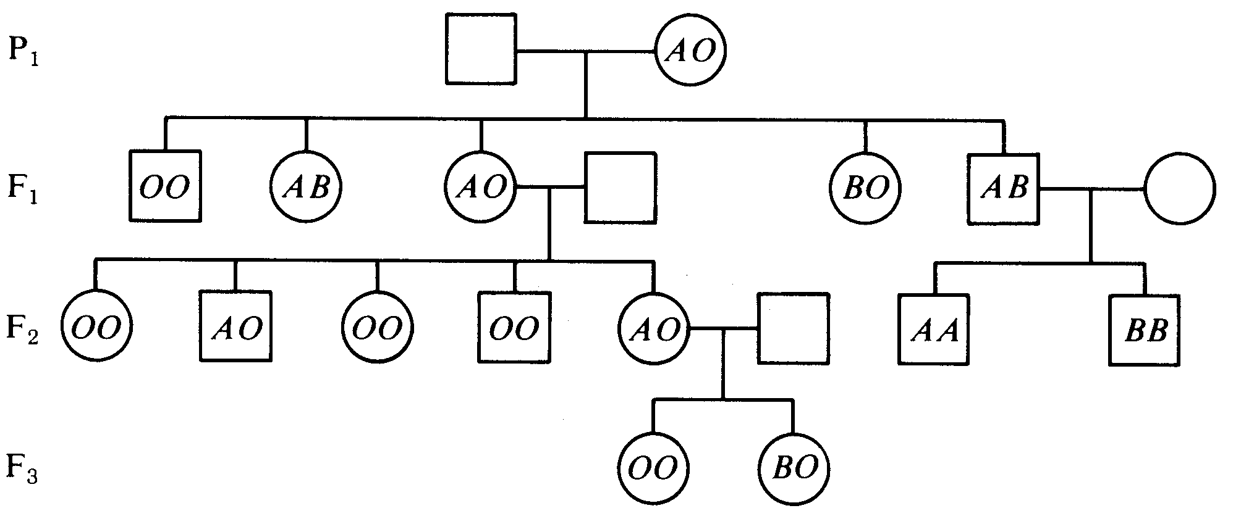 (D) gene duplications have occurred

9. The genotype of the P1 male must be

(A) *OO*

(B) *AO*

(C) *BO*

(D) *AB*

10. The only other possible genotype for children of the F1 *AB* male would be

(A) *OO*

(B) *BO*

(C) *AO*

(D) AB

11. The most likely genotype of the mate of the F1 *AO* female is

(A) *AB*

(B) *BB*

(C) *OO*

(D) *AA*

**12. When DNA replicates, each strand of the original DNA molecule is used as a template for the synthesis of a second, complementary strand. Which of the following figures most accurately illustrates enzyme-mediated synthesis of new DNA at a replication fork?** 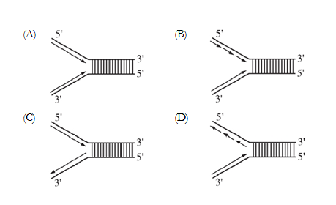

13. Actinomycin D is an antibiotic drug that inhibits protein synthesis by blocking transcription. In some cells, the application of the drug does not affect the synthesis of certain proteins. Which of the following best explains such an occurrence?

(A) Not all proteins need tRNA molecules for their synthesis.

(B) The proteins that are made are using mRNA synthesized before application of the drug.

(C) Nuclear proteins do not require the cytoplasmic machinery of ribosomes.

(D) Protein synthesis is blocked in the cytoplasm at the ribosome level.

. . . glycine-serine-glycine . . .

14. Which of the following DNA strands will code for the amino acid sequence shown above?

(A) . . . ACTCCTTCT . . .

(B) . . . TCTCCGTCG . . .

(C) . . . CCGTCGACT . . .

(D) . . . CCTTCGCCT . . .

Sickle cell disease is an inherited disorder that affects red blood cells. Sickle cell disease affects more than 72,000 Americans, primarily those of African heritage, but also those of Arabian, Asian, Caribbean, Indian, Mediterranean, and South and Central American ancestry.

The maps below show both the frequency of HbS (sickle cell) allele and the areas where Malaria is prevalent.

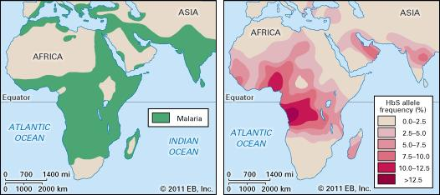

15. Why is the HbS allele more commonly found in people (or their descendants) from parts of tropical and sub-tropical sub-saharan regions where malaria is or was common?

(A) In areas where malaria is common, there is a fitness benefit in carrying only a single sickle-cell gene

(B) Because the individuals homozygous for the HbS allele die shortly after birth

(C) Those with only one of the two alleles of the sickle-cell disease, are more tolerant to the infection and thus show more severe symptoms when infected

(D) The genotype is influenced by natural selection, resulting in more individuals who are homozygous dominant than heterozygous.

16. If malaria spreads to more of Northern Asia what would you predict would happen the HbS allele frequency in that area?

(A) The occurrence of the HbS allele would remain low due to decreased fitness

(B) The occurrence of the HbS allele would increase due to being carried by the malaria

(C) The occurrence of the HbS allele would increase as the heterozygous advantage increased

(D) The occurrence of the HbS allele woulddecrease due to the malaria killing individuals.

17. The genetic variations in organisms

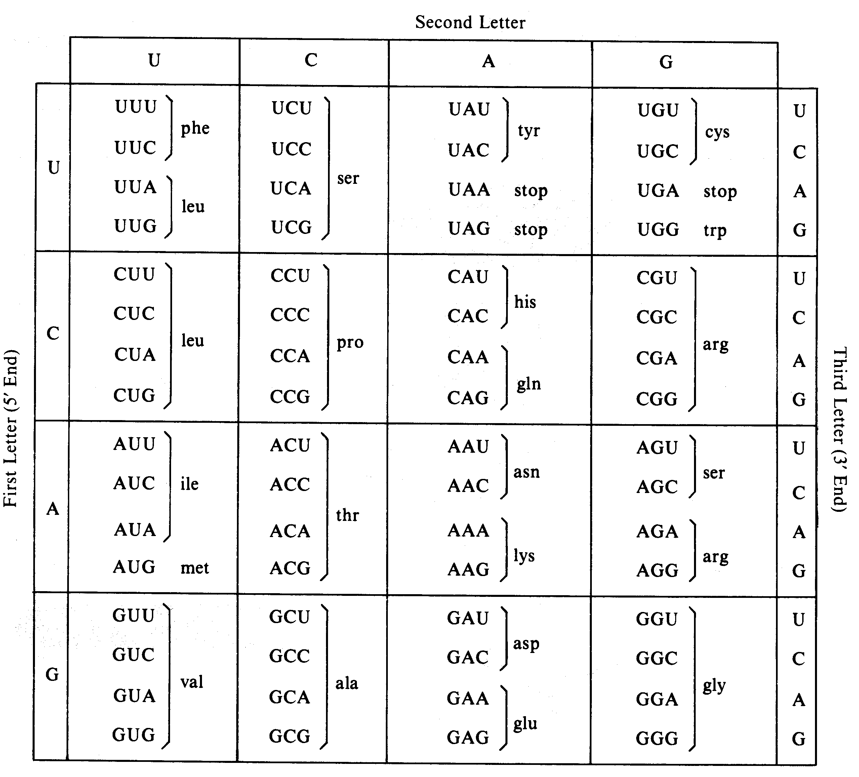(A) can be less than the phenotypic variations in populations due to missense mutations(B) can be more than the phenotypic variations in populations due to silent mutations

(C) is generally more than the phenotypic variations in populations due to nonsense mutations

(D) is always less than the phenotypic variations in populations due to point mutations

18. A single substitution in the third position would have the greatest probability of mutational effect on the codon

(A) GUU

(B) AUU

(C) CGU

(D) AUG

(E) CCC

19. Which amino acid has the greatest number of codons?

(A) Leucine (leu)

(B) Proline (pro)

(C) Tryptophan (trp) *

(D) Glutamic acid (glu)

(E) Aspartic acid (asp)



20. The figure above shows several steps in the process of bacteriophage transduction in bacteria. Which of the following explains how genetic variation in a population of bacteria results from this process?

(A) Bacterial proteins transferred from the donor bacterium by the phage to the recipient bacterium recombine with genes on the recipient’s chromosome.

(B) The recipient bacterium incorporates the transduced genetic material coding for phage proteins into its chromosome and synthesizes the corresponding proteins.

(C) The phage infection of the recipient bacterium and the introduction of DNA carried by the phage cause increased random point mutations of the bacterial chromosome.

(D) DNA of the recipient bacterial chromosome undergoes recombination with DNA introduced by the phage from the donor bacterium, leading to a change in the recipient’s genotype.

21. During the infection cycle for a typical retrovirus, such as HIV, which uses RNA as genetic material, the genetic variation in the resulting population of new virus particles is very high because of

(A) damage to the virus particle from envelope loss during infection

(B) errors introduced in the DNA molecule through reverse transcription

(C) errors in the protein molecules produced in translation

(D) recombination of the genomes of free virus particles

**Practice Long Response Questions**

In fruit flies, the phenotype for eye color is determined by a certain locus. ***E*** indicates the

dominant allele and ***e*** indicates the recessive allele. The cross between a male wild-type fruit fly

and a female white-eyed fruit fly produced the following offspring.

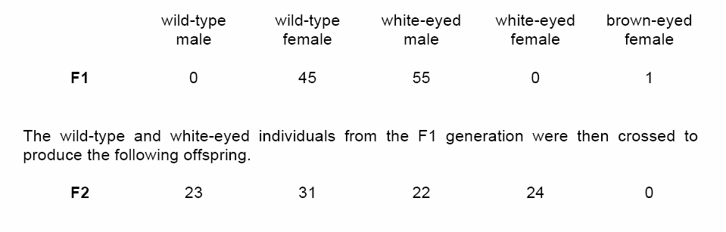

a. **Determine** the genotypes of the original parents (P generation) and **explain** your

reasoning. You may use Punnett squares to enhance your description, but the results

from the Punnett squares must be discussed in your answer.

b. Use a Chi-squared test on the F2 generation data to analyze your prediction of the

parental genotypes. **Show** all your work and **explain** the importance of your final answer.

c. The brown-eyed female in the F1 generation resulted from a mutational change. **Explain**

what a mutation is, and **discuss** two types of mutations that might have produced the

brown-eyed female in the F1 generation.

