Name: _____________________________________________ Date: ____________________________ Period: ______

AP Biology Exam Review: Cell Structure and Transport (Unit 5)

Helpful Videos and Animations:
- Bozeman Biology: Cell Membranes
- Bozeman Biology: Transport Across Cell Membranes
- Bozeman Biology: Compartmentalization
- Bozeman Biology: Cellular Organelles

Topic Outline:

Unit 5, Part 1 Notes: Cell Membrane and Transport
- Structure of the Cell Membrane (understand the fluid mosaic model and identify the structure and function of molecules found within it – phospholipids, integral proteins, peripheral proteins, glycolipids, and glycoproteins)
- Semi/Selective Permeability – which molecules can move through the phospholipid bilayer and which molecules must move with the help of a transport protein?
- Passive Transport vs. Active Transport – up vs. down concentration gradient, use of energy?
- Types of Passive Transport
- Simple Diffusion
- Facilitated Diffusion using channel or carrier proteins (what is the difference between these two types transport proteins?)
- Osmosis (hypertonic, hypotonic, isotonic) – be able to predict the movement of water across a semi-permeable membrane based on solute OR water concentration (Hint: you must know how to analyze a “U-tube” problem)
Associated Vocabulary: lysis (animal cells), flaccid (plant cell), plasmolyzed (plant cell), turgid / turgo pressure (plant cell)
- Types of Active Transport
- Protein pumps (know how the sodium (Na+) / potassium (K+) pump works!)
- Co-transport
- Bulk Transport: Exocytosis vs. Endocytosis (3 Types: phagocytosis, pinocytosis, and receptor-mediated endocytosis)
- Importance of having a large membrane surface area efficient transport of materials into and out of the cell (Note: this is why cells of the small intestine—an organ used for absorption—have many membrane folds called microvilli)
- Be able to perform cell surface area to volume ratio calculations to compare the efficiency of membrane transport in cells of various shapes and sizes

Unit 5, Part 2 Notes: Cell Structure and Function
- The Difference between Prokaryotic and Eukaryotic Cells (organelles present, size, organization of DNA, etc.)
- Structures and Functions of Eukaryotic Organelles (make sure you understand how the structure and molecular composition of each cell part gives it its unique functions)
- Nucleus (with nuclear membrane, nuclear pores, nucleolus, and chromatin)
- Ribosomes (free vs. bound… what kinds of proteins does each type create?)
- Endoplasmic Reticulum (smooth vs. rough)
- Golgi Apparatus
- Vacuoles (compare plant vs. animal vacuoles)
- Mitochondria
- Chloroplasts
- Cytoskeleton
- Centrosomes + Centrioles
- Cilia and Flagella
- Extracellular Matrix
- Intercellular Junctions: three types in animal cells (tight junctions, desmosomes, and gap junctions) ; one type in plant cells (plasmodesmata)
- Identify which organelles are found in plant vs. animal cells and identify each in an image
- Describe the function of the endomembrane system in protein synthesis and secretion (be able to list / sequence all structures and processes involved)
- Be able to describe how eukaryotic cells and the mitochondria / chloroplasts within them arose by endosymbiosis

Practice Multiple Choice Questions

1. Celery stalks that are immersed in fresh water for several hours become stiff and hard. Similar stalks left in a 0.15 M salt solution become limp and soft. From this we can deduce that the cells of the celery stalks are
a. | hypotonic to both fresh water and the salt solution.
b. | hypertonic to both fresh water and the salt solution.
c. | hypertonic to fresh water but hypotonic to the salt solution.
d. | hypotonic to fresh water but hypertonic to the salt solution.
e. | isotonic with fresh water but hypotonic to the salt solution.

2. Mammalian blood contains the equivalent of 0.15 M NaCl. Seawater contains the equivalent of 0.45 M NaCl. What will happen if red blood cells are transferred to seawater?
a. | Water will leave the cells, causing them to shrivel and collapse.
b. | NaCl will be exported from the red blood cells by facilitated diffusion.
c. | The blood cells will take up water, swell, and eventually burst.
d. | NaCl will passively diffuse into the red blood cells.
e. | The blood cells will expend ATP for active transport of NaCl into the cytoplasm.

The solutions in the arms of a U-tube are separated at the bottom of the tube by a selectively permeable membrane. The membrane is permeable to sodium chloride and water but not to glucose. Side A is filled with a solution of 0.4 M glucose and 0.5 M sodium chloride (NaCl), and side B is filled with a solution containing 0.8 M glucose and 0.4 M sodium chloride. Initially, the volume in both arms is the same. Refer to the figure to answer the following questions.

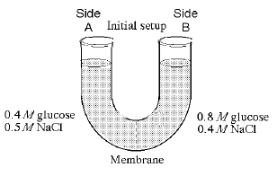
3. At the beginning of the experiment,
a. | side A is hypertonic to side
b. | side A is hypotonic to side B.
c. | side A is isotonic to side B.
d. | side A is hypertonic to side B with respect to glucose.
e. | side A is hypotonic to side B with respect to sodium chloride.

4. If you examine side A after three days, you should find
a. | a decrease in the concentration of NaCl and glucose and an increase in the water level.
b. | a decrease in the concentration of NaCl, an increase in water level, and no change in the concentration of glucose.
c. | no net change in the system.
d. | a decrease in the concentration of NaCl and a decrease in the water level.
e. | no change in the concentration of NaCl and glucose and an increase in the water level.

5. A patient has had a serious accident and lost a lot of blood. In an attempt to replenish body fluids, distilled water–equal to the volume of blood lost–is transferred directly into one of his veins. What will be the most probable result of this transfusion?
a. | It will have no unfavorable effect as long as the water is free of viruses and bacteria.
b. | The patient's red blood cells will shrivel up because the blood fluid has become hypotonic compared to the cells.
c. | The patient's red blood cells will swell because the blood fluid has become hypotonic compared to the cells.
d. | The patient's red blood cells will shrivel up because the blood fluid has become hypertonic compared to the cells.
e. | The patient's red blood cells will burst because the blood fluid has become hypertonic compared to the cells.

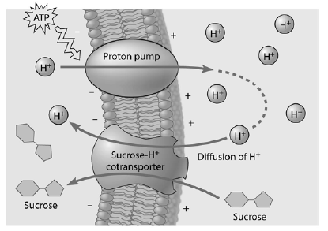
6. Based on the figure to the right, which of these experimental treatments would increase the rate of sucrose transport into the cell?
a. | decreasing extracellular sucrose concentration
b. | decreasing extracellular pH
c. | decreasing cytoplasmic pH
d. | adding an inhibitor that blocks the regeneration of ATP
e. | adding a substance that makes the membrane more permeable to hydrogen ions

Read the following information and refer to Figure 7.4 to answer the following question.

Five dialysis bags, constructed from a semi-permeable membrane that is impermeable to sucrose, were filled with various concentrations of sucrose and then placed in separate beakers containing an initial concentration of 0.6 M sucrose solution. At 10-minute intervals, the bags were massed (weighed) and the percent change in mass of each bag was graphed.

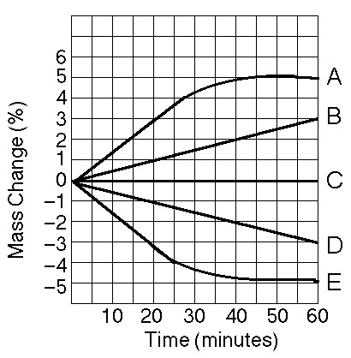

Figure 7.4

7. Which line represents the bag that contained a solution isotonic to the 0.6 molar solution at the beginning of the experiment?
A, B, C, D, E

8. Cells of the pancreas will incorporate radioactively labeled amino acids into proteins. This "tagging" of newly synthesized proteins enables a researcher to track their location. In this case, we are tracking an enzyme secreted by pancreatic cells. What is its most likely pathway?
a. | ER  Golgi  nucleus
b. | Golgi  ER  lysosome
c. | nucleus  ER  Golgi
d. | ER  Golgi  vesicles that fuse with plasma membrane
e. | ER  lysosomes  vesicles that fuse with plasma membrane

9. Which of the following is one of the ways that the membranes of winter wheat are able to remain fluid when it is extremely cold?
a. | by increasing the percentage of unsaturated phospholipids in the membrane
b. | by increasing the percentage of cholesterol molecules in the membrane
c. | by decreasing the number of hydrophobic proteins in the membrane
d. | by co-transport of glucose and hydrogen
e. | by using active transport

10. Tay–Sachs disease is a human genetic abnormality that results in cells accumulating and becoming clogged with very large, complex, and undigested lipids. Which cellular organelle must be involved in this condition?
a. | the endoplasmic reticulum
b. | the Golgi apparatus
c. | the lysosome
d. | mitochondrion
e. | membrane–bound ribosomes

11. A cell has the following molecules and structures: enzymes, DNA, ribosomes, plasma membrane, and mitochondria. It could be from:
  - A bacterium.
  - An animal, but not a plant.
  - A plant, but not an animal.
  - A plant or an animal.
  - Any kind of organism.
12. In a plant cell, DNA may be found
- only in the nucleus.
- only in the nucleus and mitochondria.
- only in the nucleus and chloroplasts.
- in the nucleus, mitochondria, and chloroplasts.

13. All of the following are part of a prokaryotic cell except
- DNA.
- a cell wall.
- a plasma membrane.
- ribosomes.
- an endoplasmic reticulum.

14. A gland cell capable of producing large quantities of a protein hormone would have well-developed:
  - Cilia.
  - Centrioles.
  - Rough Endoplasmic Reticulum.
  - Smooth Endoplasmic Reticulum

Practice Short Response Questions

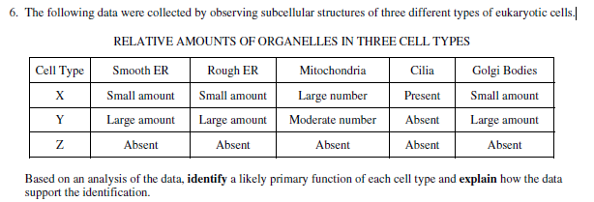

Practice Long Response Questions

A laboratory assistant prepared solution of 0.8 M, 0.6 M, 0.4 M, and 0.2 M sucrose, but forgot to label them. After realizing the error, the assistant randomly labeled the flasks containing these four unknown solutions as flask A, flask B, flask C, and flask D.
Design an experiment, based on the principles of diffusion and osmosis, that the assistant could use to determine which of the flasks contains each of the four unknown solutions. Include in your answer
(a) a description of how you would set up and perform the experiment
(b) the results you would expect from your experiments
(c) an explanation of those results

