Name: _____________________________________________ Date: ____________________________ Period: ______

AP Biology Exam Review: Cell Division (Unit 8) and Cell Signaling (Unit 9)

Helpful Videos and Animations:
- Bozeman Biology: Cell Communication
- Bozeman Biology: Signal Transduction Pathways
- Bozeman Biology: Signal Transmission and Gene Expression
- Bozeman Biology: Effects of Changes in Pathways
- Bozeman Biology: Evolutionary Significance of Cell Communication
- Bozeman Biology: The Cell Cycle, Mitosis, and Meiosis

Topic Outline:

Unit 8 Notes, Part 1: The Cell Cycle and Mitosis

- The Cell Cycle
- Reason for division- as cells increase in volume, the surface area decreases and demand for material resources increases which limits cell size
- Smaller cells have a more favorable surface area-to-volume ratio for exchange of materials with the environment (diffusion, etc.). High SA:V ratio is favorable. Ex. 6:1 is better than 6:5
- Mitosis = creation of new body cells (somatic cells) with 46 chromosomes each (diploid cells / 2n = two sets of chromosomes
- Organization of DNA in eukaryotic cells = multiple linear chromosomes vs. organization of DNA in prokaryotic cells = single circular chromosome
- Interphase (normal life of the cell, 90% of cell’s life)… : growth (G1), synthesis of DNA (S) and preparation for mitosis (G2).
- Be able to describe the events that take place in the following steps of mitosis: prophase, prometaphase, metaphase, anaphase and telophase (+ cytokinesis, division of the cytoplasm by a cleavage furrow in animals or cell plate in plants)
- Be able to explain how/why eukaryotic cell division is different from binary fission
- Vocabulary: chromosome, sister chromatids, centromere, nuclear envelope, mitotic spindle, microtubules, kinetochore, centrioles / centrosome, metaphase plate, cleavage furrow, cell plate

Unit 8 Notes, Part 2: Meiosis and Sexual Reproduction

- Meiosis
- Cell division to create gametes (sex cells) with half the number of chromosomes (23) of a somatic cell (haploid cell / n = one set of chromosomes)
- Understand the difference between sexual vs. asexual reproduction
- There are 23 pairs of homologous chromosomes in a body cell (what are homologous chromosomes?) that divide during meiosis
- 22 pairs are autosomes and 1 pair consists of sex chromosomes (XX for females and XY for males)
- Fertilization = the fusion of haploid gametes (egg + sperm) to create a diploid zygote
- Meiosis includes two rounds of division to produce four daughter cells
- Be able to explain how Meiosis I is different from Meiosis II and describe what occurs in each of the stages of meiosis: Prophase I, Metaphase I, Anaphase I, Telophase I / Cytokinesis, Prophase II, Metaphase II, Anaphase II, Telophase II / Cytokinesis
- During meiosis, homologous chromosomes are paired (one from mom and one from dad) and line up in the center of the cell randomly. The homologues are pulled apart and separated in meiosis I. A second division occurs in which the duplicated chromosomes are pulled apart.
- Variation occurs in gametes during “crossing over,” and fertilization because of all possible combinations of homologous chromosomes aligning during metaphase I (independent assortment)

Unit 8 Notes, Part 3: Cell Cycle Regulation

- Control of the Cell Cycle
- There are internal checkpoints that tell the cell to continue dividing or stop dividing
- Major checkpoints = G1 phase checkpoint (after G1 phase), G2 phase checkpoint, and M phase checkpoint
- If the cell does not receive the “go ahead” signal at the G1 checkpoint, it enters the “G0 phase,” a state of semi-dormancy where no cell division is occurring (ex: mature nerve cells)
- Example: if cyclin molecules bind to Cdk molecules (cyclin dependent kinases), they produce MPF (mitosis / maturation promoting factor)… enough MPF can allow the cell to pass the G2 checkpoint and enter mitosis… to bring mitosis to a close, MPF switches itself off by starting a process that degrades cyclin
- If checkpoints are normal… cells will show density-dependent inhibition (stop dividing when they are crowded) and anchorage dependency (must be attached to a substrate to divide)
- If cells divide two frequently, they will not show density-dependent inhibition or anchorage dependency tumors (know the difference between benign and malignant tumors and be able to define metastasis)

Unit 9 Notes, Part 1: The Basics of Cell Signaling

- There are three main steps in cell signaling
- Reception (target cell’s detection of a signal molecule)
- Transduction (conversion of the signal to a form that can bring about a particular cell response)
- Response (the specific cellular response to the signal molecule)
- Reception
- Ligand (signal molecule) binds to receptor
- Intracellular receptors (for hydrophobic molecules like steroids that can pass through the cell membrane)
- Plasma membrane receptors (for hydrophilic molecules that cannot pass through the cell membrane)
Ex: G protein coupled receptor or receptor tyrosine kinase (see notes to recall how these work)
- Tranduction
- Tranduction involves amplifying the signal (making it stronger) and converting it to a form the cell can respond to
- Second messengers (ex: calcium ions – Ca2+ -- or cyclic AMP) carry the signal from the receptor and may be used to activate protein kinases or other key molecules in the transduction process… second messengers amplify the signal because multiple second messengers are created from one ligand received and these second messengers can activate multiple kinases
- Phosphorylation cascade (protein kinases activate molecules by adding a phosphate group, these molecules then activate other molecules, and ultimately you activate a molecule that causes the specific cell response)
- Response
- Regulating Synthesis of Proteins: Transduction may activate transcription factors that initiate transcription of particular genes in the nucleus (by enabling the binding of RNA polymerase to start creating mRNA from DNA)
- Regulating Activity of Proteins: ex: In the epiphrine pathway in liver cells that initiates breakdown of glycogen to produce blood glucose to fuel the fight or flight response, protein kinases activate the enzyme phosphorylase, which chops apart glycogen

Unit 9 Notes, Part 2: The Nervous System

- The Nervous System
- function: sensory input, motor function, regulation
- structure: neuron, axon, dendrites, synapse
- Polarized neuron: Na⁺ outside, K⁺ and Cl⁻ inside
- Depolarization moves Na into neuron, generating an action potential
- Repolarization exchanges Na⁺ and K⁺ through the sodium-potassium pump
- At synapse, calcium channels open to allow calcium to rush in, stimulating release of neurotransmitters
- Neurotransmitters released into synapse to generate action potential for motor neuron or muscle cell
- A typical neuron has a cell body, axon and dendrites. Many axons have a myelin sheath that acts as an electrical insulator.
- The structure of the neuron allows for the detection, generation, transmission and integration of signal information.
- Schwann cells, which form the myelin sheath, are separated by gaps of unsheathed axon over which the impulse travels as the signal propagates along the neuron.

Unit 9 Notes, Part 3: The Endocrine System

- The Endocrine System
- Negative feedback mechanisms maintain dynamic homeostasis for a particular condition (variable) by regulating physiological processes, returning the changing condition back to its target set point.
- Positive feedback mechanisms amplify responses and processes in biological organisms. The condition initiating the response is moved farther away from the initial set-point. Amplification occurs when the stimulus is further activated which, in turn, initiates an additional response that produces system change.
- Be able to describe the basic mechanism of action of the endocrine system – secretion of hormones into the bloodstream and travel to different target cells
- Be able to describe the advantages and disadvantages of using the endocrine system – one signal molecule can have multiple target cells / tissues / organs but it is a slow method of signaling
- Be able to distinguish between the different types of hormone molecules—steroid, amine, and peptide—and the different types of receptors—plasma membrane and intracellular.

Practice Multiple Choice Questions

1. Let’s say a toxin destroys adenylyl cyclase, the enzyme responsible for creating cyclic AMP—a second messenger molecule in the cell. What will be the final effect on the signaling pathway?
- The initial messenger molecule (ex: epinephrine) will be unable to bind to its plasma membrane receptor.
- The initial messenger molecule (ex: epinephrine) will bind more easily to the plasma membrane receptor.
- The transduction step will be inhibited, resulting in a smaller response.
- The transduction step will be more efficient, resulting in a larger response.

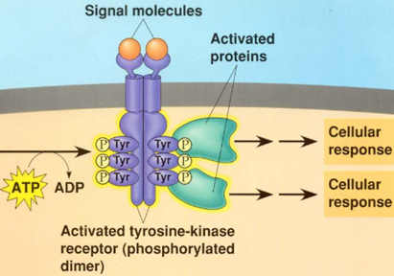
2. If ATP is not present in the cell pictured to the right, what would be the most immediate effect on the receptor tyrosine kinase pathway?
- The signal molecules will not be able to bind to the receptor.
- The tyrosine molecules will be unable to detach from the receptor.
- The tyrosine molecules will not be able to “steal” phosphate groups from ATP and use these phosphate groups to activate other proteins.
- The two parts to the receptor will not be able to come together as a dimer.

3. The pathway below shows the effect of insulin, a hormone released in response to high blood glucose, on liver cells. In Type 1 diabetes, cells in the pancreas cannot create and secrete insulin. How will this affect blood glucose levels?
- Blood glucose levels will remain high because glucose will not be removed from the blood by the GLUT channels in liver cells.
- Blood glucose levels will decrease because glucose will be successfully removed from the blood by the GLUT channels in liver cells.
- Blood glucose levels will remain high because the pancreas will never receive the signal to create insulin.
- Blood glucose levels will decrease because the receptor will be activated by another hormone.
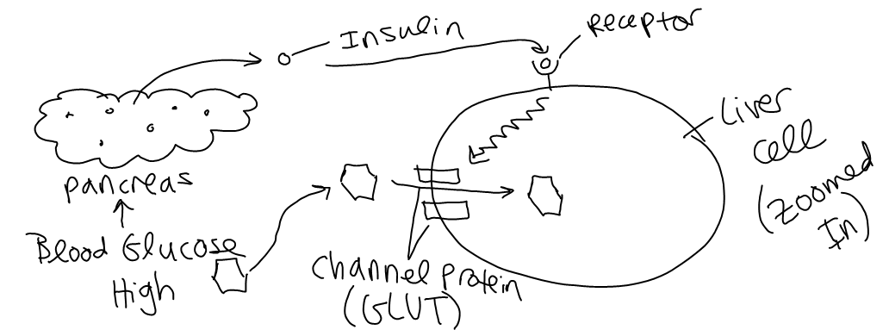

4. Of the following, a receptor protein in a membrane that recognizes a chemical signal is most similar to
A) the active site of an enzyme in the cytoplasm that binds to a specific substrate.
B) RNA specifying the amino acids in a polypeptide.
C) a particular metabolic pathway operating within a specific organelle.
D) an enzyme with an optimum pH and temperature for activity.
E) genes making up a chromosome.

5. At puberty, an adolescent female body changes in both structure and function of several organ systems, primarily under the influence of changing concentrations of estrogens and other steroid hormones. How can one hormone, such as estrogen, mediate so many effects?
A) Estrogen is produced in very large concentration and therefore diffuses widely.
B) Estrogen has specific receptors inside several cell types, but each cell responds in the same way to its
binding.
C) Estrogen is kept away from the surface of any cells not able to bind it at the surface.
D) Estrogen binds to specific receptors inside many kinds of cells, each of which have different
responses to its binding.
E) Estrogen has different shaped receptors for each of several cell types.

6. Nerve cells communicate with one another via chemical messengers called neurotransmitters. GABA is a neurotransmitter that causes the opening of channels on the post-synaptic neuron that let negatively charged chloride ions (Cl-) into the cell or positively charged potassium ions (K+) out of the cell. Is GABA an excitatory or inhibitory neurotransmitter and how do you know?
  - Excitatory; It causes the influx of positive charge to bring the postsynaptic neuron to threshold.
  - Excitatory; It prevents the influx of positive charge to prevent the postsynaptic neuron from reaching threshold.
  - Inhibitory; It causes the influx of positive charge to bring the postsynaptic neuron to threshold.
  - Inhibitory; It prevents the influx of positive charge to prevent the postsynaptic neuron from reaching threshold.

7. Suppose there is a drug that increases the number of Schwann cells on the axon of a neuron. How will this affect signaling down the length of this axon?
- Nerve signaling will increase in speed.
- Nerve signaling will decrease in speed.
- Nerve signaling will require a smaller stimulus to trigger an action potential.
- Nerve signaling will require a larger stimulus to trigger an action potential.

8. A toxin that binds specifically to voltage-gated potassium channels in axons and prevents them from opening would be expected to
A. prevent the repolarization and hyperpolarization (aka undershoot) phase of the action potential.
B. prevent the depolarization phase of the action potential.
C. enable the axon to reach threshold potential more rapidly.
D. prevent the axon from reaching threshold potential

9. Let’s say a toxin binds to voltage-gated calcium channels on the axon terminal membrane of a presynaptic cell and prevents them from opening in response to the wave of positive charge (depolarization) passing down the presynaptic cell’s axon. What will be the most immediate effect on transmission of the signal across a synapse from the presynaptic cell to the post-synaptic cell?
- Neurotransmitter molecules cannot diffuse across the synapse.
- Neurotransmitter molecules cannot bind to ligand-gated Na+ channels on the postsynaptic cell’s dendrite membrane.
- Ligand-gated Na+ channels on the postsynaptic cell’s dendrite membrane will not open, allowing Na+ to enter the cell and bring the postsynaptic cell to threshold potential.
- Calcium cannot come into the pre-synaptic cell and cause vesicles filled with neurotransmitter molecules to fuse with the presynaptic cell’s axon terminal membrane.

10. When the concentration of solutes in the blood (blood osmolarity) is high, the pituitary gland releases antidiuretic hormone (ADH). ADH stimulates the kidneys to reabsorb water in order to increase blood volume and decrease blood osmolarity. When the kidneys reabsorb water, this causes the urine to be extremely concentrated (i.e. have a low water content).
Ms. Ottolini overhydrates in preparation for a big race (yeah right, she is far too lazy for this!). How will her body respond to this massive intake of water, which results in a high blood volume?
- The high blood volume (low blood osmolarity) will inhibit the secretion of ADH from the pituitary, the kidney will not reabsorb water, and the urine will be very dilute (i.e. have a high water content)
- The high blood volume (low blood osmolarity) will inhibit the secretion of ADH from the pituitary, the kidney will reabsorb water, and the urine will be very concentrated (i.e. have a low water content)
- The high blood volume (low blood osmolarity) will stimulate the secretion of ADH from the pituitary, the kidney will not reabsorb water, and the urine will be very dilute (i.e. have a high water content)
- The high blood volume (low blood osmolarity) will stimulate the secretion of ADH from the pituitary, the kidney will reabsorb water, and the urine will be very concentrated (i.e. have a low water content)

11. High blood glucose triggers cells in the pancreas to release the hormone insulin, which lowers blood glucose levels. Type 1 diabetes occurs when the pancreas cannot produce insulin. In an experiment, the blood glucose levels of several diabetic rats are measured and the rats are then fed a high carbohydrate meal. Which statement explains how a rat’s blood glucose levels will most likely be affected by the high-carbohydrate meal?
  - The rat’s blood glucose level will increase after eating, which will cause insulin levels to rise until blood glucose decreases below the pre-meal level.
  - The rat’s blood glucose level will increase after eating and, after the rat is given an insulin injection, will quickly decrease to the pre-meal level.
  - The rat’s blood glucose level will increase for several hours after eating, and then will gradually decrease over several hours to the pre-meal level.
  - The rat’s blood glucose level will increase after eating and, even after the rat is given an insulin injection, will remain higher than the pre-meal level.

12. The hormone ethylene causes ripening in fruits. As fruits ripen, they produce more ethylene, which causes fruits in the nearby vicinity to ripen as well and produce ethylene. This is why all the apples in a barrel ripen at approximately the same time. This system is an example of…
- Positive feedback because the plant’s response (i.e. ripening) increases the stimulus (i.e. release of ethylene)
- Positive feedback because the plant’s response (i.e. ripening) removes the stimulus (i.e. release of ethylene)
- Negative feedback because the plant’s response (i.e. ripening) increases the stimulus (i.e. release of ethylene)
- Negative feedback because the plant’s response (i.e. ripening) removes the stimulus (i.e. release of ethylene)

13. Many hormones are involved in maintaining homeostasis in the body. For example, insulin and glucagon hormone have opposing effects that keep blood glucose levels within a set range. If blood glucose levels are too high, the pancreas releases insulin to promote the uptake of glucose from the blood into the liver cells to be stored as glycogen. If blood glucose levels are too low, the pancreas releases glucagon to promote the breakdown of glycogen in the liver cells and the release of glucose into the bloodstream. This system is an example of…
  - Positive feedback because the body’s response (ex: release of glucagon) increases the stimulus (ex: low blood glucose)
  - Positive feedback because the body’s response (ex: release of glucagon) removes the stimulus (ex: low blood glucose)
  - Negative feedback because the body’s response (ex: release of glucagon) increases the stimulus (ex: low blood glucose)
  - Negative feedback because the body’s response (ex: release of glucagon) removes the stimulus (ex: low blood glucose)

14. How would you expect the length of interphase to differ in a skin cell (which has to be continuously replaced) vs. a mature nerve cell (which is never replaced)?
- Interphase is longer in the skin cell because a long interphase corresponds to a faster rate of cell division.
- Interphase is shorter in the skin cell because a short interphase corresponds to a faster rate of cell division.
- Interphase is longer in the skin cell because a long interphase corresponds to a slower rate of cell division.
- Interphase is shorter in the skin cell because a short interphase corresponds to a slower rate of cell division.

15. In some organisms such as certain fungi and algae, cells undergo mitosis repeatedly without subsequently undergoing cytokinesis. What would result from this?
(A) A rapid rate of sexual reproduction
(B) A decrease in chromosome number
(C) Division of the organism into many cells, most
lacking nuclei
(D) Large cells containing many nuclei
16. A cell containing 92 chromatids at metaphase of mitosis would, at its completion, produce two nuclei each containing how many chromosomes?
A) 12
B) 16
C) 23
D) 46
E) 92

17. The karyotype of one species of primate has 48 chromosomes. In a particular female, cell division goes awry and she produces one of her eggs with an extra chromosome (25). The most probable source of this error would be a mistake in which of the following?
A) Mitosis in her ovary
B) Metaphase I of one meiotic event
C) Telophase II of one meiotic event
D) Telophase I of one meiotic event
E) Either anaphase I or II

18. Which of the steps below take place in both mitosis and meiosis?
1. Formation of four new nuclei, each with half the chromosomes present in the parental nucleus
2. Alignment of tetrads at the metaphase plate
3. Separation of sister chromatids
4. Separation of the homologues; no uncoupling of the centromere
5. Synapsis; chromosomes moving to the middle of the cell in pairs
A) 2
B) 3
C) 5
D) 2 and 3 only
E) 2, 3, and 5

19. How do cells at the completion of meiosis compare with cells that have replicated their DNA and are just about to begin meiosis?
A) They have twice the amount of cytoplasm and half the amount of DNA.
B) They have half the number of chromosomes and half the amount of DNA.
C) They have the same number of chromosomes and half the amount of DNA.
D) They have half the number of chromosomes and one-fourth the amount of DNA.
E) They have half the amount of cytoplasm and twice the amount of DNA.
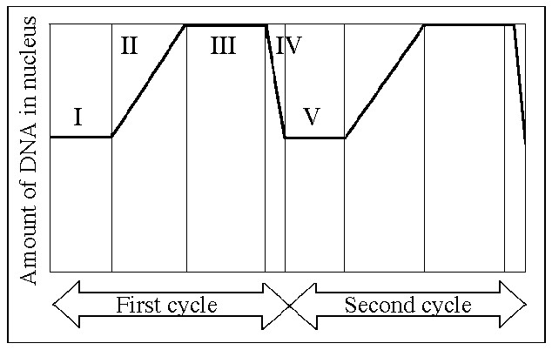
20. Which number above represents the point in the cell cycle during which the chromosomes are replicated?
A) I
B) II
C) III
D) IV
E) V

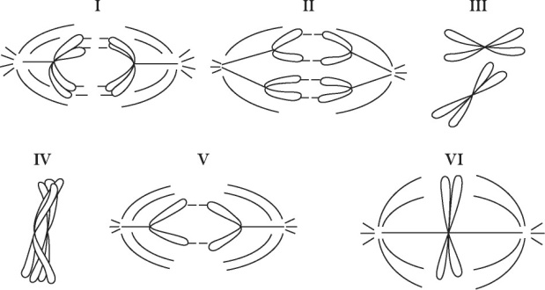
21. Which diagram represents prophase I of meiosis?
A) I
B) II
C) IV
D) V
E) VI

22. In multicellular organisms, mitosis is
- the means of tissue growth and repair.
- a way of generating increasing genetic variation in members of the next generation
- the means of sexual reproduction.
- able to occur in only a few cells of specialized tissues.

23. A research team used the setup to study the incorporation of labeled nucleotides into a culture of lymphocytes and found that the lymphocytes incorporated the labeled nucleotide at a significantly higher level after a pathogen was introduced into the culture. They concluded that
A) the presence of the pathogen made the experiment too contaminated
to trust the results.
B) their tissue culture methods needed to be relearned.
C) infection causes lymphocytes to divide more rapidly.
D) infection causes cell cultures in general to reproduce more
rapidly.
E) infection causes lymphocyte cultures to skip some parts of the
cell cycle.

24. Natural selection and recombination due to crossing over during meiosis I are related in which of the following ways?
A) Recombinants are usually selected against.
B) Non-recombinant organisms are usually favored by natural selection if there is environmental change.
C) Most recombinants reproduce less frequently than do non-recombinants.
D) Recombinants may have combinations of traits that are favored by natural selection.
E) Recombination does not affect natural selection.
25. A research team began a study of a cultured cell line. Their preliminary observations showed them that the cell line did not exhibit either density-dependent inhibition or anchorage dependence. What could they conclude right away?
- The cells originated in the nervous system.
- The cells are unable to form spindle microtubules.
- They have altered order of cell cycle phases.
- The cells show characteristics of tumors.
- They were originally taken from an elderly organism.

26. For a chemotherapeutic drug to be useful for treating cancer cells, which of the following is most desirable?
- It only attacks cells that are large in size.
- It only attacks cells that are highly specialized.
- It interferes with cells entering G0.
- It interferes with rapidly dividing cells.

Practice Long Response Questions

1. Communication occurs among the cells in a multicellular organism. Choose THREE of the following examples of cell-to-cell communication, and for each example, describe the communication that occurs and the types of responses that result from this communication.
- communication between two plant cells
- communication between two immune-system cells
- communication either between a neuron and another neuron, or between a neuron and a muscle cell
- communication between a specific endocrine-gland cell and its target cell

***Note: We discussed the immune system in our Organism Form and Function Unit (#11)***

