Cell Membrane Condensed Notes

Lipid Bilayer Structure
The lipid bilayer is a universal component of all cell membranes. Its role is critical because its structural components provide the barrier that marks the boundaries of a cell. The structure is called a "lipid bilayer" because it is composed of two layers of fat cells organized in two sheets. The lipid bilayer is typically about five nanometers thick and surrounds all cells providing the cell membrane structure.

Lipids and Phospholipids
The structure of the lipid bilayer explains its function as a barrier. Lipids are fats, like oil, that are insoluble in water. There are two important regions of a lipid that provide the structure of the lipid bilayer. Each lipid molecule contains a hydrophilic region, also called a polar head region, and a hydrophobic, or nonpolar tail region.
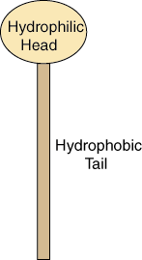
Figure %: Basic Lipid Structure
The hydrophilic region is attracted to aqueous water conditions while the hydrophobic region is repelled from such conditions. Since a lipid molecule contains regions that are both polar and nonpolar, they are called amphipathic molecules.
The most abundant class of lipid molecule found in cell membranes is the phospholipid. The phospholipid molecule's polar head group contains a phosphate group. It also sports two nonpolar fatty acid chain groups as its tail.
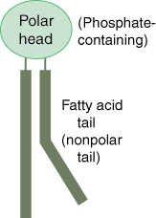
Figure %: Phospholipid Structure
The fatty acid tail is composed of a string of carbons and hydrogens. It has a kink in one of the chains because of its double-bond structure.

The Bilayer
The phospholipids organize themselves in a bilayer to hide their hydrophobic tail regions and expose the hydrophilic regions to water. This organization is spontaneous, meaning it is a natural process and does not require energy. This structure forms the layer that is the wall between the inside and outside of the cell.
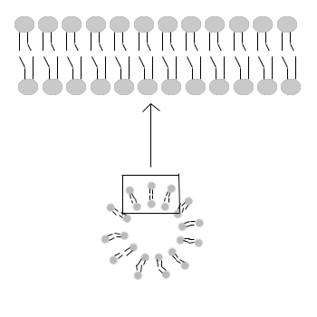
Figure %: Lipid Bilayer

Properties of the Lipid Bilayer
As we have already mentioned, the most important property of the lipid bilayer is that it is a highly impermeable structure. Impermeable simply means that it does not allow molecules to freely pass across it. Only water and gases can easily pass through the bilayer. This property means that large molecules and small polar molecules cannot cross the bilayer, and thus the cell membrane, without the assistance of other structures.
Another important property of the lipid bilayer is its fluidity. The lipid bilayer contains lipid molecules, and, as we will discuss later, it also contains proteins. The bilayer's fluidity allows these structures mobility within the lipid bilayer. This fluidity is biologically important, influencing membrane transport. Fluidity is dependent on both the specific structure of the fatty acid chains and temperature (fluidity increases at lower temperatures).
Structurally, the lipid bilayer is asymmetrical: the lipid and protein composition in each of the two layers is different.

Membrane Proteins

In addition to the lipid bilayer, the cell membrane also contains a number of proteins. We have already mentioned the presence of certain proteins in the cell membrane. In this section we will discuss the different classes of proteins found there. While the lipid bilayer provides the structure for the cell membrane, membrane proteins allow for many of the interactions that occur between cells. As we discussed in the previous section, membrane proteins are free to move within the lipid bilayer as a result of its fluidity. Although this is true for most proteins, they can also be confined to certain areas of the bilayer with enzymes. Membrane proteins perform various functions, and this diversity is reflected in the significantly different types of proteins associated with the lipid bilayer.

Classifications of Membrane Proteins
Proteins are generally broken down into the smaller classifications of integral proteins, peripheral proteins, and lipid-bound proteins.

Integral Proteins
Integral proteins are embedded within the lipid bilayer. They cannot easily be removed from the cell membrane without the use of harsh detergents that destroy the lipid bilayer. Integral proteins float rather freely within the bilayer, much like oceans in the sea. In addition, integral proteins are usually transmembrane proteins, extending through the lipid bilayer so that one end contacts the interior of the cell and the other touches the exterior. The stretch of the integral protein within the hydrophobic interior of the bilayer is also hydrophobic, made up of non-polar amino acids. Like the lipid bilayer, the exposed ends of the integral protein are hydrophilic.
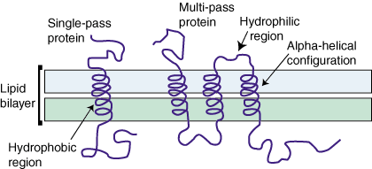
Figure %: Membrane Proteins
When a protein crosses the lipid bilayer it adopts an alpha-helical configuration. Transmembrane proteins can either cross the lipid bilayer one or multiple times. The former are referred to as single-pass proteins and the later as multi-pass proteins. As a result of their structure, transmembrane proteins are the only class of proteins that can perform functions both inside and outside of the cell.

Peripheral Proteins
Peripheral proteins are attached to the exterior of the lipid bilayer. They are easily separable from the lipid bilayer, able to be removed without harming the bilayer in any way. Peripheral proteins are less mobile within the lipid bilayer.

Lipid-Bound Proteins
Lipid-bound proteins are located entirely within the boundaries of the lipid bilayer.

The Cell Surface
The protein and lipid cell membrane is covered with a layer of carbohydrate chains on its outer surface. This layer is called a cell coat or glycocalyx. The exact composition and distribution of these chains is very diverse. The chains are thought to provide the cell with protection against damage. Glycocalyx are only found on the surface of the cells of higher organism's.
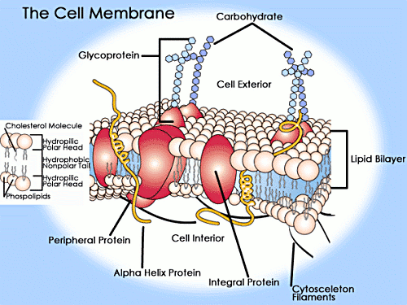
Figure %: A detailed view of a Cell Membrane (phospholipid bilayer and associated proteins)

Structures Responsible for Membrane Transport

We have discussed how the lipid bilayer acts as an efficient barrier by only allowing a very small number of non-polar molecules to freely enter or exit a cell. While for the most part this selectivity is a valuable function and allows the cell to maintain its integrity, cells do need to move certain large, polar molecules such as amino acids, sugars, and nucleotides across their membranes. As a result, cell membranes require specific structures that allow for the transport of certain molecules.

Membrane Transport
There are a number of different ways that molecules can pass from one side of a cell membrane to the other. Some such means, like diffusion and osmosis, are natural processes that require no expenditure of energy from the cell and are called passive transport. Other methods of transport do require cellular energy and are called active transport. In addition to these two forms of transport, there exist other forms of transport such as endocytosis and exocytosis, which will be discuss later and do not require the same set of membrane proteins for their function.

Passive Transport
Diffusion is the natural phenomenon in which nonpolar molecules naturally flow from an area of higher concentration to an area of lower concentration. Osmosis is a similar process, but refers specifically to water molecules. Both of these classes of molecules we have already discussed as capable of crossing the lipid bilayer. As seen in , neither diffusion nor osmosis require the expenditure of energy.

Active Transport
Active transport occurs when a cell actively pumps a molecule across its membrane, against the natural direction dictated by diffusion, osmosis, or polarity. As seen in , such transport requires energy.
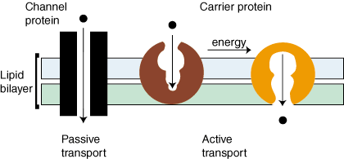
Figure %: Active and Passive Transport Proteins

Transport Proteins
Both of passive and active transport are mediated with the help of transmembrane proteins that act as transporters. shows the two main classes of transport proteins: carrier proteins and channel proteins. For the most part, carrier proteins mediate active transport while channel proteins mediate passive transport. Carrier proteins create an opening in the lipid bilayer by undergoing a conformational change upon the binding of the molecule. Channel proteins form hydrophilic pores across the lipid bilayer. When open, these pores allow specific molecules to pass through. There is one other class of transport proteins called ionophores. These are small, hydrophobic proteins that increase bilayer permeability for specific ions.
Transport proteins are critical to cell life and cell interactions. They allow for the proper distribution of ions and molecules in multicellular organisms. Additionally, they can help to maintain proper intra- and extra-cellular pH levels, facilitate communication between cells, and are involved numerous other essential functions including protein synthesis.

