Name: _____________________________________________ Date: ____________________________ Period: ______

AP Biology Exam Review: Cell Energy – Enzymes and Cellular Respiration (Unit 6) and Photosynthesis (Unit 7)

Helpful Videos and Animations:
- Bozeman Biology: Photosynthesis and Respiration
- Bozeman Biology: Photosynthesis
- Bozeman Biology: Cellular Respiration
- Bozeman Biology: Gibbs Free Energy
- Bozeman Biology: Life Requires Free Energy
- Bozeman Biology: Coupled Reactions
- Bozeman Biology: Enzymes

Topic Outline:

Unit 6 Notes: Enzymes and Cell Respiration

- Enzymes
- Biological catalysts (made of protein) that speed up rate of chemical reactions by lowering activation energy required for reaction to occur
- Enzyme has active site (exposed R groups) where reaction occurs
- Enzymes can break down substance (catabolic reaction) or build up substances (anabolic)
- Enzyme/substrate complex is formed
- Substrate is what enzyme acts on
- Rate is determined by collisions between substrate and enzyme
- Ends in –ase, named after substrate often
- Enzyme is specific to substrate; the substrate must be complementary to the surface properties (shape and charge) of the active site (which is made up of R groups with specific chemistry, i.e. hydrophobic).
- Enzyme rate is affected by:
- pH (optimal for each enzyme),
- temperature (optimal for each enzyme but in general increased temp means increased collisions so rate goes up initially; too much heat can denature enzyme), enzyme concentration (more enzyme faster rate or vice versa)
- substrate concentration (more substrate = faster rate, until the point of enzyme saturation)
- Know the difference between an endergonic and exergonic reaction and be able to analyze their reaction curves ; be able to explain energy coupling and provide examples
- Inhibition-competitive inhibition (something competes for active site; can be overcome with more substrate)
- Non-competitive inhibition- attaches at allosteric site and changes shape of enzyme so it is not functional; can not be overcome with more substrate
- Coenzymes (organic; NAD and vitamin B etc.) and cofactors (inorganic; zinc, magnesium etc.) interact with enzymes to put them into the right structure to do work.

- Cellular Respiration
- Explain the difference between aerobic cellular respiration and anaerobic cellular respiration (aka fermentation)
- Write the full balanced chemical equation for cellular respiration
- Cell Respiration = Exergonic
- A Series of Redox Reactions: Oxidation (loss of electrons / energy) ; reduction (gain of electrons / energy)
- Gycolysis
- In cytosol
- Glucose 2 Pyruvate (electrons and H+ taken from glucose to reduce 2 NAD+ 2NADH ; 2 net ATP gained)
- Oxidation of Pyruvate
- Transport protein moves pyruvate from cytosol to matrix of mitochondrion
- 2 Pyruvate 2 Acetyl CoA (an enzyme removes CO2, takes away electrons to reduce NAD+ NADH, and adds coenzyme A)
- Citric Acid Cycle
- 2 turns of the cycle (1 per acetyl CoA) one molecule of glucose is fully oxidized to CO2
- A series of oxidation / reduction reactions produces 2CO2, 3NADH, 1FADH2 (another electron / hydrogen carrier) and 1 ATP per turn of the cycle (Total = X2)
- Electron Transport Chain + Chemiosmosis
- ETC NADH and FADH2 “dump” electrons off to the inner mitochondrial membrane’s electron transport chain proteins use energy from electrons passed between them to “pump” H+ across the inner mitochondrial membrane into the intermembrane space
The final electron acceptor is O2 H2O
- Chemiosmosis H+ flow back down their gradient (proton motive force) through a channel in ATP synthase into the matrix ATP synthase turns and creates ATP from ADP and Pi
Chemiosmosis is an energy-coupling mechanism that uses energy stored in the form of an H+ gradient across a membrane to drive cellular work (creation of ATP by ATP synthase)
This method of making ATP is known as oxidative phosphorylation (ADP is phosphorylated and oxygen is necessary to keep the electrons flowing)
Oxidative phosphorylation accounts for 26-28 of the 30-32 total ATP created during cellular respiration
- Fermentation / Anaerobic Respiration (creating ATP without oxygen)
- An expansion of glycolysis (the Kreb’s / Citric Acid Cycle and Electron Transport Chain are not used)
- Glycolysis 2 ATP
- Reactions that regenerate NAD+ to act as an electron acceptor for electrons released during the breakdown of glucose to pyruvate
2 Types of Fermentation = alcohol fermentation and lactic acid fermentation
Alcohol Fermentation pyruvate is converted to ethanol, releasing CO2 and regenerating NAD+ from NADH
Lactic Acid Fermentation pyruvate is reduced by NADH (NAD+ is formed in the process), and lactate is formed as a waste product
- Facultative anaerobes can use aerobic respiration if oxygen is present but can switch to fermentation under anaerobic conditions ; obligate anaerobes cannot survive in the presence of oxygen

Unit 7 Notes: Photosynthesis

- Photosynthesis
- Know the difference between autotrophs and heterotrophs
- Know the structure of a chloroplast and the location of cells with high concentrations of chloroplasts (mesophyll tissue of leaf) ; Be able to identify the following structures within a chloroplast – stroma, thylakoid,granum, thylakoid space
- Know the location of stomata on a leaf’s surface (bottom surface) and their function in transpiration and gas exchange (How do stomata open and close?)
- Know the full balanced chemical equation for photosynthesis
- Summary of the two steps in photosynthesis: Light Reactions and Calvin Cycle
- Light Reactions (in thylakoid membrane)
-Light is absorbed by chlorophyll and drives the transfer of electrons from water to NADP+ NADPH
-Water is split when electrons are removed, and O2 is released from the stomata
-ATP is generated, using chemiosmosis to power the addition of a phosphate group to ADP ATP in a process called photophosphorylation
-Vocabulary: photons, pigments, chlorophyll, carotenoids / accessory pigments, absorption spectrum of a pigment, action spectrum for photosynthesis, photosystems (I and II), reaction centers, primary electron acceptor
-Key Skills: Explain the difference between linear (noncyclic) electron flow and cyclic electron flow
- Calvin Cycle
-electrons and H+ from NADPH and energy from ATP are used to reduce CO2 into organic molecules (Glyceraldehyde-3 Phosphate / G3P… the precursor molecule to glucose) in a process called carbon fixation
-Vocabulary: ribulose bisphosphate (RuBP), rubisco, glyceraldehydes 3-phosphate (G3P)
-Key Skills: Describe the role of the rubisco enzyme in carbon fixation
- Understand how C4 and CAM plants fix carbon in hot, arid climates where stomata must remain closed at times ; know the difference between spatial and temporal separation (Remember, normal plants = C3 plants)
Vocabulary: photorespiration, bundle-sheath cells, mesophyll cells

Practice Multiple Choice Questions

1. An airtight, temperature-controlled glass box containing actively growing tomato plants was placed under a light source. Plastic wrapping that only transmits green light was placed over the box, and two days later air samples from inside the box were collected and analyzed. The most likely change in air quality is
(A) an increase in nitrogen (N2)
(B) an increase in carbon dioxide (CO2)
(C) an increase in oxygen (O2)
(D) a decrease in carbon dioxide (CO2)

The chemical reaction for photosynthesis is 6 CO₂ + 12 H₂O + light energy --> C₆H₁₂O₆ + 6 O₂ + 6 H₂O
2. If the input water is labeled with a radioactive isotope of oxygen, ₁₈O, then the oxygen gas released as the reaction proceeds is also labeled with ₁₈O. Which of the following is the most likely explanation?
(A) During the light reactions of photosynthesis, water is split, the hydrogen atoms combine with the CO2, and oxygen gas is released.
(B) During the light reactions of photosynthesis, water is split, removing electrons and protons, and oxygen gas is released.
(C) During the Calvin cycle, water is split, regenerating NADPH from NADP+, and oxygen gas is released.
(D) During the Calvin cycle, water is split, the hydrogen atoms are added to intermediates of sugar synthesis, and oxygen gas is released.

3. During aerobic cellular respiration, oxygen gas is consumed at the same rate as carbon dioxide gas is produced. In order to provide accurate volumetric measurements of oxygen gas consumption, the experimental setup should include which of the following?
(A) A substance that removes carbon dioxide gas
(B) A plant to produce oxygen
(C) A glucose reserve
(D) A valve to release excess water

Frogs of three different species are weighed and the amount of oxygen consumed by each species is determined by placing them in a respirometer for 1 hour. The results of this experiment are listed below.
Average Total Cubic Centimeters of Oxygen
Species Weight in Grams Consumed in 1 Hour

1 15 0.75
2 11 0.55
3 21 1.05

4. From the information in the table, it is most reasonable to conclude that
- since all frogs respire through their skin, smaller frogs with smaller surface areas will consume less oxygen per gram of body weight than larger frogs with larger surface areas
- frogs placed in a warm environment will respire more rapidly than frogs placed in a colder environment
- each species of frog has its own unique rate of respiration
- the amount of oxygen consumed per gram of body weight for each species is the same

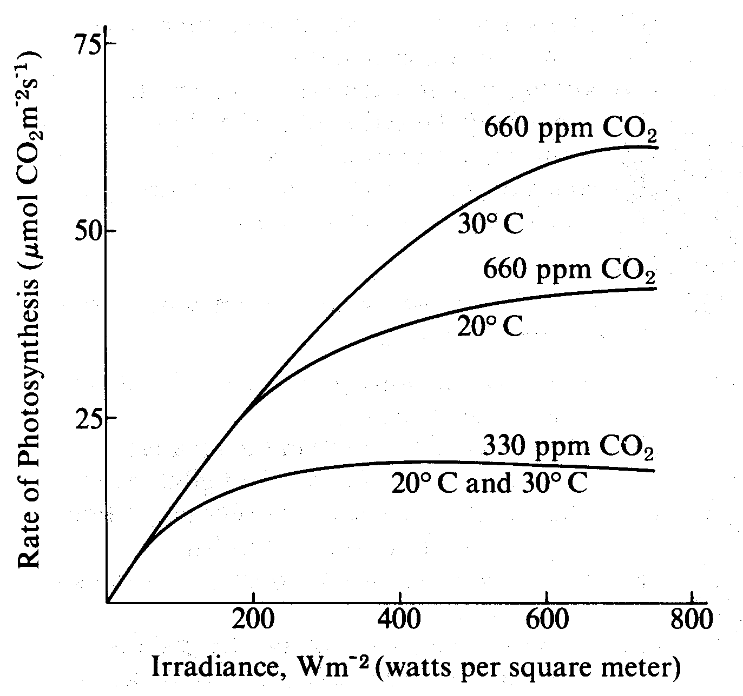
The graph shows the relationship of photosynthetic rate and irradiance (light intensity) influenced by both temperature and carbon dioxide level.

5. According to the graph, the greatest rate of photosynthesis occurs when CO₂ is present at
- high concentrations and low temperatures
- low concentrations and high temperatures
- high concentrations and low irradiance levels
- high concentrations and high irradiance levels

6. From the data in the graph, which of the following conclusions is most reasonable?
- The rate of photosynthesis is inversely proportional to light intensity.
- The rate of photosynthesis at 660 ppm CO₂ is more dependent on temperature than the rate at 330 ppm CO₂.
- There is no theoretical maximum for the rate of photosynthesis.
- Attempts to increase the photosynthetic yield in field crops should involve the lowering of CO₂ levels.

7. Which of the following seems most likely from the data?
- Light produces heat, which causes increases in the rates of photosynthesis.
- Light causes the saturation of cytochrome oxidase, which then limits the use of CO₂.
- The photosynthetic rate could be increased further by decreasing the CO₂ concentration.
- Increasing irradiance levels above 800 Wm^{–2} would have less effect on the rate of photosynthesis than would increasing the CO₂ concentration.

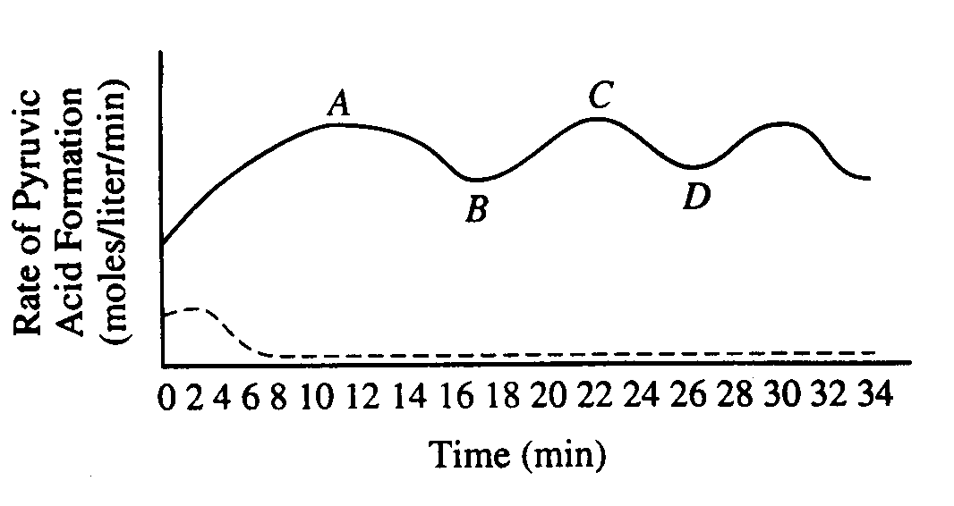
A tissue culture of vertebrate muscle was provided with a constant excess supply of glucose under anaerobic conditions starting at time zero and the amounts of pyruvic acid and ATP produced were measured. The solid line in the graph above represents the pyruvic acid produced in moles per liter per minute. ATP levels were also found to be highest at points A and C, lowest at B and D. A second culture was set up under the same conditions, except that substance X was added, and the results are indicated by the dotted line.

8. The rate of pyruvic acid formation fluctuates because
- all glucose has reacted
- all enzymes have been used up
- the reaction is accelerated by positive feedback
- the reaction is affected by negative feedback

9. Which of the following best accounts for the shape of the solid line between points A and D?
- After ten minutes the cellular enzymes became ineffective.
- Respiration became uncontrolled.
- ATP acted as an allosteric inhibitor on one or more of the enzymes.
- The measurements of pyruvic acid were unreliable.

10. It is most reasonable to hypothesize that, in the breakdown of glucose, substance X is
- an activator
- an inhibitor
- a substrate
- a coenzyme

11. Which of the following is most likely to result if oxygen is added to the tissue culture?
- Lactic acid formation will increase.
- For each glucose molecule consumed, more ATP will be formed.
- The levels of ATP produced will decrease.
- Ethyl alcohol will be produced.

Practice Long Response Questions

A controlled experiment was conducted to analyze the effects of darkness and boiling on photosynthetic rate of incubated chloroplast suspension. The dye reduction technique was used. Each chloroplast suspension was mixed with DPIP, an electron acceptor that changes from blue to clear when it is reduced. Each sample was placed in individually in a spectrophotometer and the percent transmittance was recorded. (Hint: The percent transmittance is higher through clear liquid than blue liquid!) The three samples used were prepared as follows:
- Sample 1 – chloroplast suspension + DPIP
- Sample 2 – chloroplast suspension surrounded by foil wrap to provide a dark environment + DPIP
- Sample 3 – chloroplast suspension that has been boiled + DPIP

Time (min) | Light, unboiled  % Transmittance  Sample 1 | Dark, Unboiled  % Transmittance  Sample 2 | Light, Boiled  % Transmittance  Sample 3
0 | 28.8 | 29.2 | 28.8
5 | 48.7 | 30.1 | 29.2
10 | 57.8 | 31.2 | 29.4
15 | 62.5 | 32.4 | 28.7
20 | 66.7 | 31.8 | 28.5

- Construct and label a graph showing the results of the three samples
- Identify and explain the control OR controls for this experiment
- The differences in the curves of the graphed data indicate that there were differences in the number of electrons produced in the three samples during the experiment. Discuss how electrons are generated in photosynthesis and why the three samples gave different transmittance results.

