Cell Division, Mitosis, and Meiosis

Cell Division Functions in Reproduction, Growth, and Repair
Cell division involves the distribution of identical genetic material, DNA, to two daughters cells. What is most remarkable is the fidelity with which the DNA is passed along, without dilution or error, from one generation to the next.

Core Concepts:
- All Organisms Consist of Cells and Arise from Preexisting Cells
  - Mitosis is the process by which new cells are generated.
  - Meiosis is the process by which gametes are generated for reproduction.
- The Cell Cycle Represents All Phases in the Life of a Cell
  - DNA replication (S phase) must precede mitosis, so that all daughter cells receive the same complement of chromosomes as the parent cell.
  - The gap phases separate mitosis from S phase. This is the time when molecular signals mediate the switch in cellular activity.
  - Mitosis involves the separation of copied chromosomes into separate cells
- Unregulated Cell Division Can Lead to Cancer
  - Cell-cycle checkpoints normally ensure that DNA replication and mitosis occur only when conditions are favorable and the process is working correctly.
  - Mutations in genes that encode cell-cycle proteins can lead to unregulated growth, resulting in tumor formation and ultimately invasion of cancerous cells to other organs.

In order to better understand the concept of cell division and genetics, some basic definitions are in order:
- gene - basic unit of heredity; codes for a specific trait
- locus - the specific location of a gene on a chromosome (locus - plural loci)
- genome - the total hereditary endowment of DNA of a cell or organism
- somatic cell - all body cells except reproductive cells
- gamete - reproductive cells (i.e. sperm & eggs)
- chromosome - elongate cellular structure composed of DNA and protein - they are the vehicles which carry DNA in cells
- diploid (2n) - cellular condition where each chromosome type is represented by two homologous chromosomes
- haploid (n) - cellular condition where each chromosome type is represented by only one chromosome
- homologous chromosome - chromosome of the same size and shape which carry the same type of genes
- chromatid - one of two duplicated chromosomes connected at the centromere
- centromere - region of chromosome where microtubules attach during mitosis and meiosis

Chromosome structure
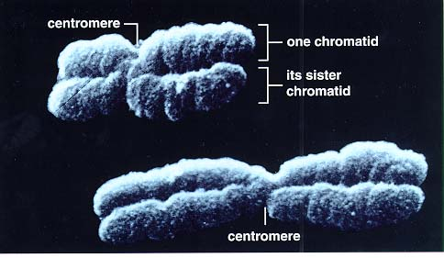 | - composed of DNA and protein (histones) all tightly wrapped up in one package  - duplicated chromosomes are connected by a centromere
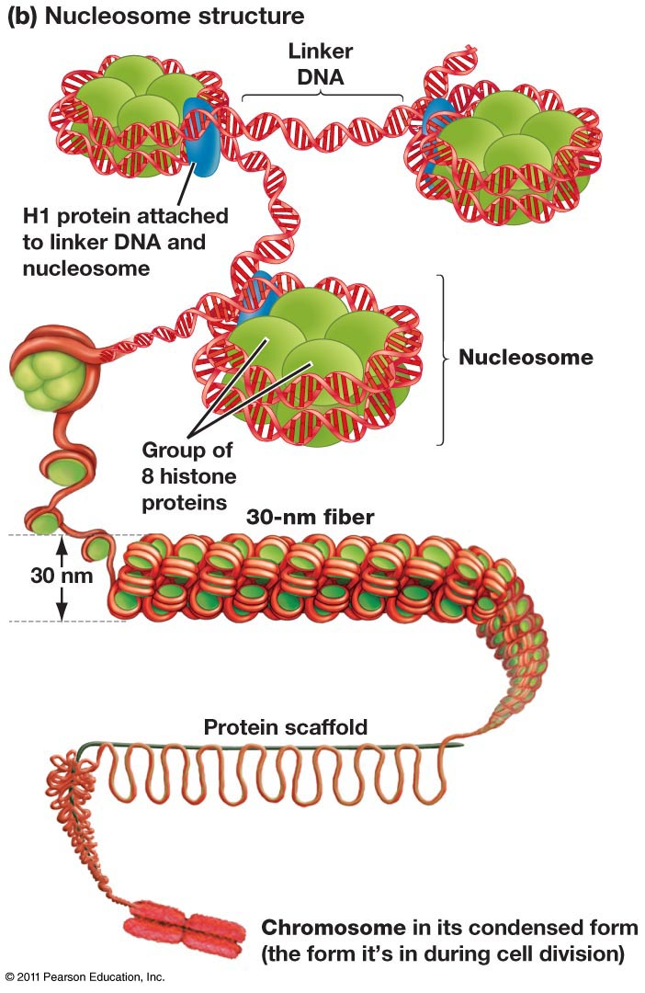 | - The relationship between DNA and chromosomes is illustrated here

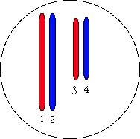 | Example - an organism is 2n = 4.  - Chromosomes 1 & 2 are homologous chromosomes  - Chromosomes 3 & 4 are homologous chromosomes  - Chromosomes 1 & 3 came from the mother  - Chromosomes 2 & 4 came from the father

Typical Animal Life Cycle
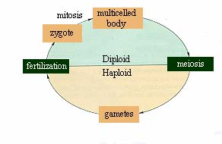

The Cell Cycle
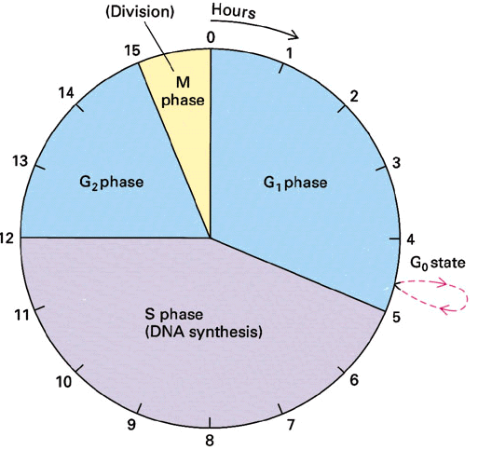 | G1 - first gap  S - DNA synthesis (replication)  G2 - second gap  M - mitosis
- mitosis - nuclear/chemical events resulting in two daughter nuclei which have identical genetic material to each other and to the mother cell
- cytokinesis - division of the cytoplasm. This usually occurs with mitosis, but in some organisms this is not so

Mitosis in a Nutshell
- The stages of the cell cycle can be broken down into six stages:
  - Interphase, Prophase, Metaphase, Anaphase, Telophase
Interphase
- is the "resting" or non-mitotic portion of the cell cycle.
- It is comprised of G1, S, and G2 stages of the cell cycle.
- DNA is replicated during the S phase of Interphase

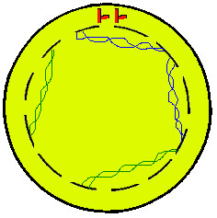 | 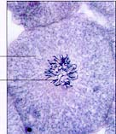 | Prophase - the first stage of mitosis.  - The chromosomes condense and become visible  - The mitotic spindle forms (from the centrioles in animal cells)  Prometaphase  - The centrioles form and move toward opposite ends of the cell ("the poles")  - The nuclear membrane dissolves  - Spindle fibers from each centriole attach to each sister chromatid at the kinetochore  Compare Prophase to the Prophase I and to the Prophase II stages of mitosis.

Metaphase  - The Centrioles complete their migration to the poles  - The chromosomes line up in the middle of the cell ("the equator")  Compare Metaphase to the Metaphase I and to the Metaphase II stages of mitosis. | 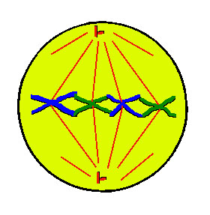 | 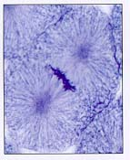

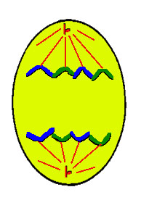 | 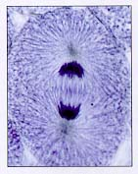 | Anaphase  - Spindles attached to kinetochores begin to shorten.  - This exerts a force on the sister chromatids that pulls them apart.  - Spindle fibers continue to shorten, pulling chromatids to opposite poles.  - This ensures that each daughter cell gets identical sets of chromosomes  Compare Anaphase to the Anaphase I and to the Anaphase II stages of mitosis.

Telophase  - The chromosomes decondense  - The nuclear envelope forms  - Cytokinesis reaches completion, creating two daughter cells  Compare Telophase to the Telophase I and to the Telophase II stages of mitosis. | 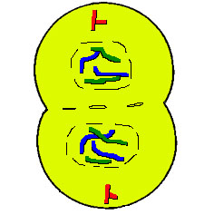 | 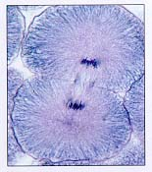

Cytokinesis Divides the Cytoplasm
In animal cells, cytokinesis occurs by a process known as cleavage
- First, a cleavage furrow appears
  - cleavage furrow = shallow groove near the location of the old metaphase plate
- A contractile ring of actin microfilaments in association with myosin, a protein
  - Actin and myosin are also involved in muscle contraction and other movement functions
- The contraction of a the dividing cell's ring of microfilaments is like the pulling of drawstrings
  - The cell is pinched in two
- Cytokinesis in plant cells is different because plant cells have cell walls.
- There is no cleavage furrow
- During telophase, vesicles from the Golgi apparatus move along microtubules to the middle of the cell (where the cell plate was) and coalesce, producing the cell plate
  - Cell-wall construction materials are carried in the vesicles and are continually deposited until a complete cell wall forms between the two daughter cells

Chromosome Separation Is the Key Event of Mitosis
- Mitotic spindle fibers are the railroad tracks for chromosome movement.
  - Spindle fibers are made of microtubules.
  - Microtubules are lengthened and shortened by the addition and loss of tubulin subunits.
  - Mitotic spindle shortening during anaphase is a result of the loss of tubulin subunits.
- A kinetochore motor is the engine that drives chromosome movement.
  - Multiple studies have shown that the kinetochore contains motor proteins that can �walk� along the spindle fiber during anaphase.
  - These proteins presumably remove tubulin subunits, shortening spindle fibers and facilitating the chromosome movement.

Regulation of the Cell Cycle
The cell cycle is controlled by a cyclically operating set of reaction sequences that both trigger and coordinate key events in the cell cycle
- The cell-cycle control system is driven by a built-in clock that can be adjusted by external stimuli (chemical messages)
- Checkpoint - a critical control point in the cell cycle where stop and go-ahead signals can regulate the cell cycle
  - Animal cells have built-in stop signals that halt the cell cycles and checkpoints until overridden by go-ahead signals.
  - Three Major checkpoints are found in the G1, G2, and M phases of the cell cycle
- The G1 checkpoint - the Restriction Point
  - The G1 checkpoint ensures that the cell is large enough to divide, that enough nutrients are available to support the resulting daughter cells, and that growth factors from other cells have been received
- If a cell receives a go-ahead signal at the G1 checkpoint, it will usually continue with the cell cycle
- If the cell does not receive the go-ahead signal, it will exit the cell cycle and switch to a non-dividing state called G0
- Actually, most cells in the human body are in the G0 phase
- The G2 checkpoint ensures that DNA replication in S phase has been completed successfully.
- The metaphase checkpoint ensures that all of the chromosomes are attached to the mitotic spindle by a kinetochore.
Cyclins and Cyclin-Dependent Kinases - The Cell-Cycle Clock
Rhythmic fluctuations in the abundance and activity of cell-cycle control molecules pace the events of the cell cycle.
- Kinase - a protein which activates or deactivates another protein by phosphorylating them.
- Kinases give the go-ahead signals at the G1 and G2 checkpoints (see the animation below)
- The kinases that drive these checkpoints must themselves be activated
  - The activating molecule is a cyclin, a protein that derives its name from its cyclically fluctuating concentration in the cell
  - Because of this requirement, these kinases are called cyclin-dependent kinases, or Cdk's
MPF - Maturation Promoting Factor (M-phase promoting factor)
- Cyclins accumulate during the G1and G2 phases of the cell cycle.
- By the G2 checkpoint (the red bar in the figure), enough cyclin is available to form MPF complexes (aggregations of Cdk and cyclin) which initiate mitosis
  - MPF apparently functions by phosphorylating key proteins in the mitotic sequence
- Later in mitosis, MPF switches itself off by initiating a process which leads to the destruction of cyclin
  - Cdk, the non-cyclin part of MPF, persists in the cell as an inactive form until it associates with new cyclin molecules synthesized during interphase of the next round of the cell cycle
PDGF - Platelet-Derived Growth Factors - An Example of an External Signal for Cell Division
PDGF is required for the division of fibroblasts which are essential in wound healing
- When injury occurs, platelets (blood cells important in blood clotting) release PDGF
- Fibroblasts are a connective tissue cells which possess PDGF receptors on their plasma membranes
- The binding of PDGF activates a signal-transduction pathway that leads to a proliferation of fibroblasts and a healing of the wound
Density Dependent Inhibition
- Cells grown in culture will rapidly divide until a single layer of cells is spread over the area of the petri dish, after which they will stop dividing
- If cells are removed, those bordering the open space will begin dividing again and continue to do so until the gap is filled - this is known as contact inhibition
- Apparently, when a cell population reaches a certain density, the amount of required growth factors and nutrients available to each cell becomes insufficient to allow continued cell growth
Anchorage Dependence
- For most animal cells to divide, they must be attached to a substratum, such as the extracellular matrix of a tissue or the inside of the culture jar
- Anchorage is signaled to the cell-cycle control system via pathways involving membrane proteins and the cytoskeleton
Cells Which No Longer Respond to Cell-Cycle Controls - Cancer Cells
- Cancer cells do not respond normally to the body's control mechanism.
  - They divide excessively and invade other tissues
  - If left unchecked, they can kill the organism
- Cancer cells do not exhibit contact inhibition
  - If cultured, they continue to grow on top of each other when the total area of the petri dish has been covered
  - They may produce required external growth factor (or override factors) themselves or possess abnormal signal transduction sequences which falsely convey growth signals thereby bypassing normal growth checks
- Cancer cells exhibit irregular growth sequences
  - If growth of cancer cells does cease, it does so at random points of the cell cycle
  - Cancer cells can go on dividing indefinitely if they are given a continual supply of nutrients
    - Normal mammalian cells growing in culture only divide 20-50 times before they stop dividing

Meiosis

More definitions:
- Allele - alternate forms of the same gene
- Homozygous - having two identical alleles for a given gene
- Heterozygous - having two different alleles for a given gene
- Genotype - genetic makeup of an organism
- Phenotype - the expressed traits of an organism

Meiosis in a Nutshell
- Meiosis Is a Special Type of Cell Division That Occurs in Sexually Reproducing Organisms
  - Meiosis reduces the chromosome number by half, enabling sexual recombination to occur.
    - Meiosis of diploid cells produces haploid daughter cells, which may function as gametes.
    - Gametes undergo fertilization, restoring the diploid number of chromosomes in the zygote
  - Meiosis and fertilization introduce genetic variation in three ways:
    - Crossing over between homologous chromosomes at prophase I.
    - Independent assortment of homologous pairs at metaphase I:
      - Each homologous pair can orient in either of two ways at the plane of cell division.
      - The total number of possible outcomes = 2n (n = number of haploid chromosomes).
    - Random chance fertilization between any one female gamete with any other male gamete.
- The Role of Sexual Reproduction in Evolution
  - Sexual reproduction in a population should decline in frequency relative to asexual reproduction.
    - Asexual reproduction�No males are needed, all individuals can produce offspring.
    - Sexual reproduction�Only females can produce offspring, therefore fewer are produced.
  - Sexual reproduction may exist because it provides genetic variability that reduces susceptibility of a population to pathogen attack.

The stages of meiosis can be broken down into two main stages, Meiosis I and Meiosis II
- Meiosis I can be broken down into four substages: Prophase I, Metaphase I, Anaphase I and Telophase I
- Meiosis II can be broken down into four substages: Prophase II, Metaphase II, Anaphase II and Telophase II

Meiosis I
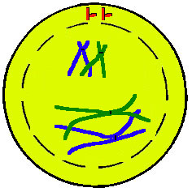 | Prophase I - most of the significant processes of Meiosis occur during Prophase I  - The chromosomes condense and become visible  - The centrioles form and move toward the poles  - The nuclear membrane begins to dissolve  - The homologs pair up, forming a tetrad  - Each tetrad is comprised of four chromotids - the two homologs, each with their sister chromatid  - Homologous chromosomes will swap genetic material in a process known as crossing over (abbreviated as XO)  - Crossing over serves to increase genetic diversity by creating four unique chromatids  Compare Prophase I to Prophase II and to the Prophase stage of mitosis.

Crossing Over
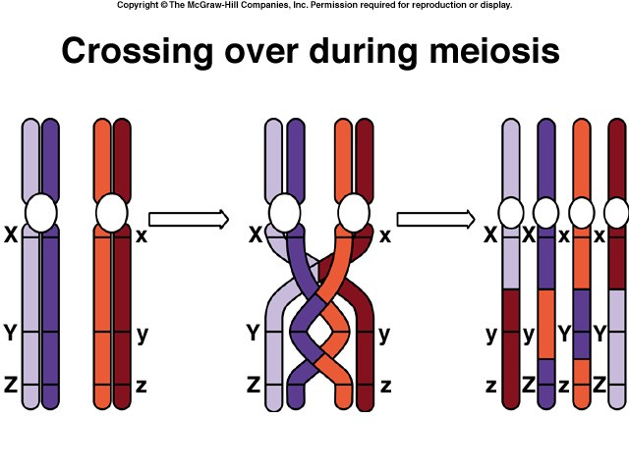 | - Genetic material from the homologous chromosomes is randomly swapped  - This creates four unique chromatids  - Since each chromatid is unique, the overall genetic diversity of the gametes is greatly increased

Metaphase I  - Microtubules grow from the centrioles and attach to the centromeres  - The tetrads line up along the cell equator  Compare Metaphase I to Metaphase II and to the Metaphase stage of mitosis. | 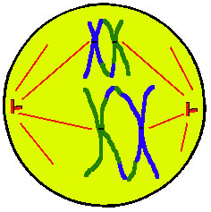

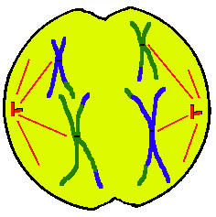 | Anaphase I  - The centromeres break and homologous chromosomes separate (note that the sister chromatids are still attached)  - Cytokinesis begins  Compare Anaphase I to Anaphase II and to the Anaphase stage of mitosis.

Telophase I  - The chromosomes may decondense (depends on species)  - Cytokinesis reaches completion, creating two haploid daughter cells  Compare Telophase I to Telophase II and to the Telophase stage of mitosis. | 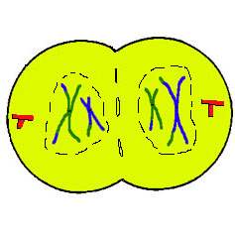

Meiosis II
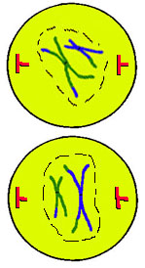 | Prophase II  - Centrioles form and move toward the poles  - The nuclear membrane dissolves  Compare Prophase II to Prophase I and to the Prophase stage of mitosis.

Metaphase II  - Microtubules grow from the centrioles and attach to the centromeres  - The sister chromatids line up along the cell equator  Compare Metaphase II to Metaphase I and to the Metaphase stage of mitosis. | 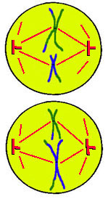

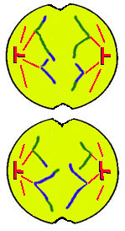 | Anaphase II  - The centromeres break and sister chromatids separate  - Cytokinesis begins  Compare Anaphase II to Anaphase I and to the Anaphase stage of mitosis.

Telophase II  - The chromosomes may decondense (depends on species)  - Cytokinesis reaches completion, creating four haploid daughter cells  Compare Telophase II to Telophase I and to the Telophase stage of mitosis. | 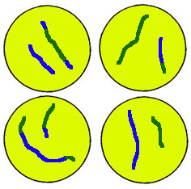

A Comparison between Mitosis and Meiosis
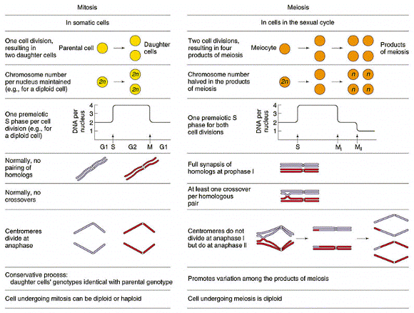

Some questions to ponder
- How does the number of daughter cells produced from mitosis and meiosis differ?
- How does the ploidy of the daughter cells produced from mitosis and meiosis differ?
- Do the daughter cells produced from mitosis contain identical genetic complements?
- Do any of the daughter cells produced from meiosis contain identical genetic complements?
- When do the homologous chromosomes separate during mitosis?
- When do the homologous chromosomes separate during meiosis?
- When do sister chromatids separate during mitosis?
- When do sister chromatids separate during meiosis?
- Click the cockroach below to view the answers to these questions.
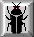

The Consequences of Meiotic Mistakes
Nondisjunctions occur when homologous chromosomes fail to separate at meiosis I or when chromatids fail to separate at meiosis II.
- Fertilization can result in embryos that are 2n + 1 (a "trisomy") or 2n � 1.
- Abnormal copy numbers of one or more chromosomes is usually, but not always, fatal (Example: Down syndrome)
- Increase in frequency of Down Syndrome increases with age
Polyploidy can occur when whole sets of chromosomes fail to separate at meiosis I or II.
- The resulting 2n gametes, if fertilized by normal sperm, create 3n zygotes (triploid).
- Organisms with an odd number of chromosome sets cannot produce viable gametes (Example: seedless fruits).

Animations
- Cell Cycle
- Mitosis - this is a cartoon showing the movement of the chromosomes
  - Mitosis in animals - mpg showing mitosis in animal cells (note 12 MB file)
  - Mitosis in plants - mpg showing mitosis in plant cells (5 MB file)
  - Mitosis gone wrong - mpg showing what happens when a chromosome gets tangled in the spindle fibers... not good (5 MB file)
- Meiosis - there is a great comparison of mitosis and meiosis in this one
  - Meiosis in animal cells - mpg showing meiosis in animal cells (6 MB file)
- Nondisjunctions

