Name: _____________________________________________ Date: ____________________________ Period: ______

AP Biology Exam Review : Biochemistry (Unit 4)

Helpful Videos and Animations:
- Bozeman Biology: Biological Molecules
- Bozeman Biology: Nucleic Acids
- Bozeman Biology: Lipids
- Bozeman Biology: Carbohydrates
- Bozeman Biology: Proteins
- Bozeman Biology: Polymers

Topic Outline: (Thank you to Megan Chirby!)

Unit 4, Part 1 Notes: Atomic and Molecular Structure
- Bonds: Ionic, Covalent (Polar vs. Nonpolar), Hydrogen ; know the relative strengths of each bond and where they are used in nature

Unit 4, Part 2 Notes: Properties of Water
- The Properties of Water (all come from water’s polarity and its ability to form hydrogen bonds ; understand how the structure of the water molecule is related to its function)
- Excellent solvent (know how water dissolves polar and ionic compounds we have water-based cellular fluids
- Cohesion and adhesion transpiration in plants
- Less dense as a solid prevents ponds and lakes from freezing solid
- High Heat Capacity / Specific Heat evaporative cooling (sweating) in animals ; moderates air temperatures near large bodies of water
- pH: acid-base/ 0-14, # of H+ ions determines scale; logarithmic- pH 3 = 10⁻³ = 1/1000 (concentrationof H+ ions)…blood- 7.4, stomach- 2, small intestine- 8; enzymes are specific to pH

Unit 4. Part 3 and 4 Notes: Macromolecules (A and B)
- Reactions of Life
- Dehydration Synthesis (releases water ; used to create polymers connected by covalent bonds ; anabolic ; endergonic)
- Hydrolysis (uses water ; used to break polymers into monomers by breaking covalent bonds ; catabolic ; exergonic)
- Macromolecules
- Carbohydrates
- CHO 1:2:1 ratio
- Monomers = monosaccharides (know the basic structure and examples)
- Dimers = disaccharides (know the basic structure, how they form, and examples)
- Polymers = polysaccharides (know the basic structure, how they form, and the following examples – cellulose, starch, chitin, and glycogen)
- Lipids
- C, H, O (not a 1:2:1 ratio) *P only in phospholipids
- Basic structure (fatty acid chains and a polar region)
- Degree of saturation of fatty acid chains (# of H’s linked to carbons, which is inversely related to the number of hydrogen bonds) unsaturated fatty acid chains with kinks (liquid at room temperature) vs. saturated straight fatty acid chains (solid at room temperature)
- Phospholipids make up cell membranes (double layer) and are amphipathic- hydrophilic and hydrophobic
- Functions = cell membrane (phospholipids), energy storage (fats, oils), steroid hormones like testosterone and estrogen (variations on a cholesterol 5-ring lipid), insulation, myelin sheath of neurons
- Proteins
- C, H, O, N (may have other elements like S in R group)
- Monomers = amino acids (know the basic structure ; the 20 different amino acids only differ in their R groups)
- Parts of amino acid= carboxyl group (COOH) on one end, amino group on the other end (NH2), central carbon and variable R group (can be hydrophobic or hydrophilic) which determines chemical properties.
- Protein Folding- shape determines function; primary structure= amino acid chain; secondary= beta pleated sheet or alpha helix( hydrogen bonds between non-adjacent carboxyl and amino groups); tertiary=globular; folds in on itself (disulfide bridges, hydrogen bonds, hydrophobic interactions; ionic bonding between R groups); quartenary= more than one polypeptide.
- Many functions: enzymes (ex: amylase), structure (ex: keratin), transport (ex: hemoglobin), signaling (ex: oxytocin hormone), protein carriers in cell membrane, antibodies
- Nucleic Acids
- C,H,O,N, and P
- Monomers = nucleotides (know the basic structure ; made of nitrogenous bases, phosphate groups, and deoxyribose sugars)
- Polymers = DNA and RNA
- Nucleotide made up of sugar, phosphate and base
- DNA is double stranded, has deoxyribose, A, G, C, T
- RNA is single stranded, has ribose, A, G, C, U
- mRNA- copies genetic message; rRNA- attaches mRNA and makes up ribosomes (most common);tRNA- carries amino acids; DNA- carries genetic code
- Function: storage and transmission of genetic information

Practice Multiple Choice Questions:

1. Which of the following is not a property of carbon?
a. | Carbon-to-carbon bonds are limited to single bonds.
b. | Carbon has four valence electrons.
c. | Carbon can form bonds to various other atoms.
d. | Carbon-to-carbon bonds are strong.

2. Carbohydrate molecules:
a. | serve as structural components of human cell walls.
b. | form the regulatory compounds known as enzymes.
c. | are a source of energy.
d. | help protect vital organs from damage.

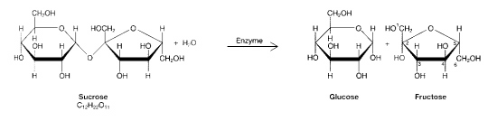
3. The process illustrated in the figure above is called:
a. | condensation.
b. | protein synthesis.
c. | hydrolysis.
d. | denaturation.

4. The products of the process in Figure 03-01 are:
a. | monosaccharides.
b. | molecules of glycerol.
c. | representative of a glycoside linkage.
d. | enzymes.
5. In which of the following reactions must the equivalent of a water molecule be added in order to break a bond?
a. | fatty acids + glycerol  fat
b. | glucose + fructose  sucrose
c. | glycogen  glucose
d. | alanine + glycine  dipeptide

6. Which of the following illustrates hydrolysis?
a. | the reaction of two monosaccharides to form a disaccharide
b. | the reaction of two amino acids to form a dipeptide
c. | the reaction of a hydrogen atom and a hydroxide ion to form water
d. | the reaction of a fat to form glycerol and fatty acids

7. Monosaccharides are water soluble because:
a. | they contain a large number of methyl groups.
b. | they have a large number of polar hydroxyl groups.
c. | they have large numbers of nonpolar carbons in their backbones.
d. | they can form ring structures.

8. A molecule of a saturated triacylglycerol (aka triglyceride) contains:
a. | the maximum number of double bonds between carbons in the fatty acid chains.
b. | the maximum number of triple bonds between carbons in the fatty acid chains.
c. | the maximum number of hydrogen atoms in the fatty acid chains.
d. | alternating single and double bonds between carbons in the fatty acid chains.

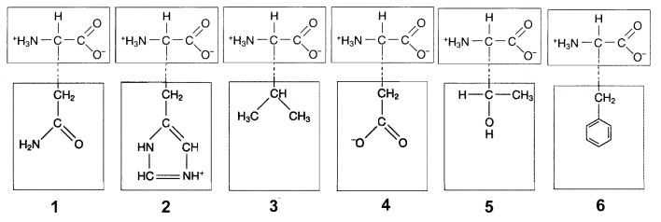
9. In Figure 03-02 (below), ionic attractions would form between the R groups of which amino acids?
a. | 1 and 3
b. | 2 and 4
c. | 3 and 5
d. | None of the above.

10. Hydrophobic interactions would occur between the R groups of which two amino acids in Figure 03-02?
a. | 1 and 4
b. | 2 and 5
c. | 3 and 6
d. | 3 and 5

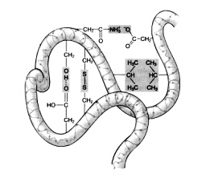
11. Which of the following is responsible for the alpha-helical structure of proteins?
a. | hydrophobic interactions
b. | nonpolar covalent bonds
c. | ionic interactions
d. | hydrogen bonds

12. At which level of protein structure are peptide bonds most important?
a. | primary
b. | secondary
c. | quaternary
d. | globular

13. All of the following types of chemical bonds are responsible for maintaining the tertiary structure of this polypeptide except:

a. | ionic bonds.
b. | peptide bonds.
c. | hydrophobic interactions.
d. | disulfide bonds.

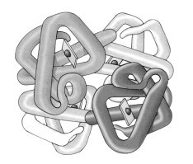
14. If the differently shaded portions of this molecule represent different polypeptide chains, then this figure is representative of:

a. | an amino acid.
b. | The primary structure of a protein
c. | The secondary structure of a protein
d. | The quaternary structure of a protein

15. Analysis of a certain complex compound shows that it contains phosphate groups, ribose groups, and pyrimidines. Based on this information, which of the following is the best description of this compound?
a. | It is most likely ribonucleic acid.
b. | It is DNA.
c. | It is an inorganic compound.
d. | It contains thymine.

16. Which monomer is incorrectly matched with the corresponding polymer?
a. | Amino acids are used to build proteins.
b. | Monosaccharides are used to build polysaccharides.
c. | Fatty acids are used to build nucleic acids.
d. | Glucose molecules are used to build starches.

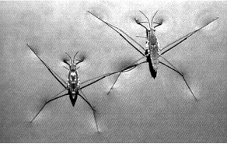
17. Which characteristic of water molecules directly contributes to the remarkable "water walking" success of the aquatic insects pictured in the accompanying figure?
a. | hydrogen bonds
b. | capillary action
c. | nonpolar covalent bonds
d. | ionic bonds

18. A stalk of celery is placed in a solution of blue colored dye. After one hour, the leaves have blue fluid in their veins. Which property of water is being demonstrated?
a. | adhesion and cohesion
b. | evaporation and cooling
c. | lower density as a solid than as a liquid
d. | high specific heat

19. Which of the following pairs of functional groups characterizes the structure of an amino acid?
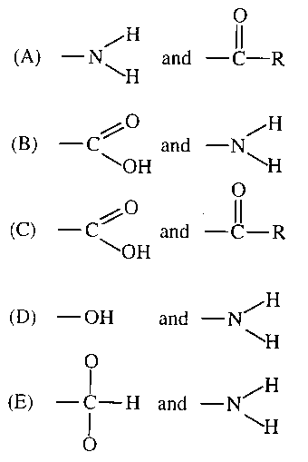

20. A feature of organic compounds NOT found in inorganic compounds is the presence of
(A)ionizing chemical groups
(B) electrons
(C) carbon atoms covalently bonded to each other
(D) oxygen

21. The carbon 'that makes up organic molecules in plants is derived directly from
(A) combustion of fuels
(B) carbon fixed in photosynthesis
(C) carbon dioxide produced in respiration
(D) carbon in the lithosphere

22. Which of the following is responsible for the cohesive property of water?
(A) Hydrogen bonds between the oxygen atoms of two adjacent water molecules
(B)Covalent bonds between the hydrogen atoms of two adjacent water molecules
(C) Hydrogen bonds between the oxygen atom of one water molecule and a hydrogen atom of another water molecule
(D) Covalent bonds between the oxygen atom of one water molecule and a hydrogen atom of another water molecule

Write the letter or letters that correspond to the picture that matches with each description
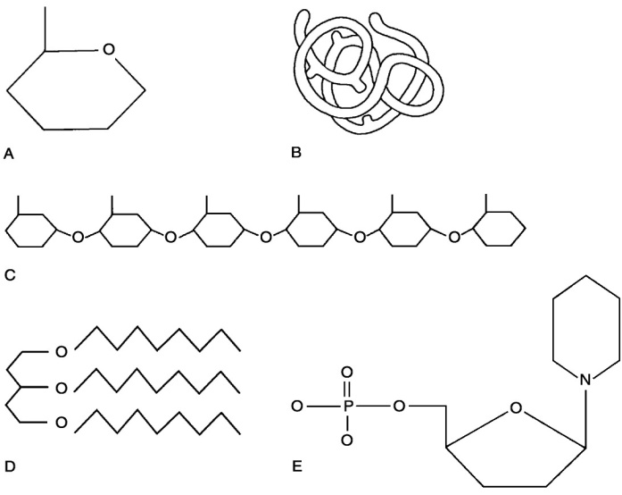
23. Lipid.
24. Functional protein.
25. Nucleotide.
26. Polysaccharide.
27. Monosaccharide.
28. Polymer
29. Tertiary (protein) structure

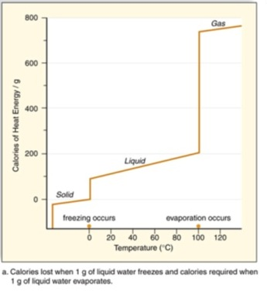
30. The figure shows the calories of heat energy required to convert a gram of water from solid to liquid state, and then again from liquid to a gaseous state. Especially distinctive is the large increase in energy required to move water from liquid to gas form.
This graph predicts which of the following properties of water that would affect plant survival?
a. Plant leaves doing transpiration are cooled down on hot days.
b. Inside a plant stem, cohesion attracts one water molecule to the water molecule above it, allowing a “chain” of water molecules to move up the stem.
c. At a plant’s roots, adhesion attracts water molecules to “stick” to root hairs, aiding absorption.
d. Sugar will dissolve in water, leading to a plant fluid called phloem, which typically flows from the leaves, down towards the roots.
31. Why does the graph to the right show a dramatic increase in energy required to convert liquid water into water vapor?
a. Liquid water has a high heat capacity, and therefore adheres to cooler surfaces. This adhesion leads to a strong attraction of water to any non-water molecule.
b. Liquid water is an excellent solvent, and contains many solutes (sugar, salt, etc.) that dissolve within it; these solutes must crystallize and come out of solution in order for liquid water to turn into water vapor.
c. Liquid water is polar, and thus aligns molecules on a north-south axis; energy must be added to reverse the polarity of water and allow individual water molecules to become vaporized.
d. Liquid water is held together by hydrogen bonds between the water molecules; these bonds must become energized and break so evaporation can happen.
.
32. Air that is dry changes temperature quickly, while air that is moist retains its temperature. What property allows for this regulation of temperature?
a. The heat of fusion in of the nitrogen in the air, due to the free electrons.
b. The high electric potential of the air, which results from the static charges of the molecules in dry conditions.
c. The green house effect, due to the increase in carbon dioxide in the atomosphere.
d. The high specific heat of water, which results from the polarity and hydrogen bonding.

Practice Long Response Questions

1. 2003B:3
Water is important for all living organisms. The functions of water are directly related to its physical properties.
a. Describe how the properties of water contribute to TWO of the following
- transpiration
- thermoregulation in endotherms
- plasma membrane structure
b. Water serves as a reactant and a product in the carbon cycle. Discuss the role of water in the carbon cycle.
c. Discuss the impact of one human activity on the water cycle.

2. 2008:1
The physical structure of a protein often reflects and affects its function.
a. Describe THREE types of chemical bonds/interactions found in proteins. For each type, describe the role in determining protein structure.
b. Discuss how the structure of a protein affects the function of TWO of the following.
- muscle contraction
- regulation of enzyme activity
- cell signaling
c. Abnormal hemoglobin is the identifying characteristic of sickle cell anemia. Explain the genetic basis of abnormal hemoglobin. Explain why the sickle cell allele is selected for in certain areas of the world.

3. Earth is carbon based. Our carbon basis allows for the formation of complex molecules. Pick three of the four groups of complex carbon based molecules (macromolecules) and for each:
a) For each group, discuss the structural components of the molecule group.
b) For each group, discuss two examples of molecules that belong to each of the groups that
you chose. Briefly describe their function.
c) All of these groups of molecules are created from monomers joining to form polymers. Explain the process that joins these molecule
