Burda AP Biology

Condensed Notes : Biochemistry

Modified from Kimball’s Biology

Carbohydrates
Carbohydrates have the general molecular formula CH₂O, and thus were once thought to represent "hydrated carbon". However, the arrangement of atoms in carbohydrates has little to do with water molecules.
Starch and cellulose are two common carbohydrates. Both are macromolecules with molecular weights in the hundreds of thousands. Both are polymers (hence "polysaccharides"); that is, each is built from repeating units, monomers, much as a chain is built from its links.
The monomers of both starch and cellulose are the same: units of the sugar glucose.

Sugars

Monosaccharides
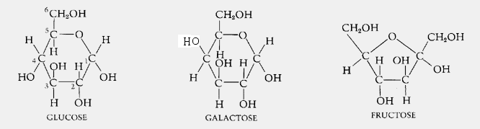
Three common sugars share the same molecular formula: C₆H₁₂O₆. Because of their six carbon atoms, each is a hexose.
They are:
- glucose, "blood sugar", the immediate source of energy for cellular respiration
- galactose, a sugar in milk (and yogurt), and
- fructose, a sugar found in honey.
Although all three share the same molecular formula (C₆H₁₂O₆), the arrangement of atoms differs in each case. Substances such as these three, which have identical molecular formulas but different structural formulas, are known as structural isomers.
Glucose, galactose, and fructose are "single" sugars or monosaccharides. Two monosaccharides can be linked together to form a "double" sugar or disaccharide.

Disaccharides
Three common disaccharides:
- sucrose — common table sugar = glucose + fructose
- lactose — major sugar in milk = glucose + galactose
- maltose — product of starch digestion = glucose + glucose
Although the process of linking the two monomers is rather complex, the end result in each case is the loss of a hydrogen atom (H) from one of the monosaccharides and a hydroxyl group (OH) from the other. The resulting linkage between the sugars is called a glycosidic bond. The molecular formula of each of these disaccharides is
C₁₂H₂₂O₁₁ = 2 C₆H₁₂O₆ − H₂O
All sugars are very soluble in water because of their many hydroxyl groups. Although not as concentrated a fuel as fats, sugars are the most important source of energy for many cells.
Carbohydrates provide the bulk of the calories (4 kcal/gram) in most diets, and starches provide the bulk of that. Starches are polysaccharides.

Polysaccharides

Starches
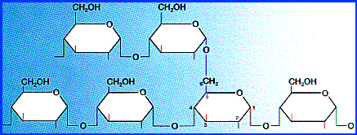
Starches are polymers of glucose. Two types are found:
- amylose consists of linear, unbranched chains of several hundred glucose residues (units). The glucose residues are linked by a glycosidic bond between their #1 and #4 carbon atoms.
- amylopectin differs from amylose in being highly branched. At approximately every thirtieth residue along the chain, a short side chain is attached by a glycosidic bond to the #6 carbon atom (the carbon above the ring). The total number of glucose residues in a molecule of amylopectin is several thousand.
Starches are insoluble in water and thus can serve as storage depots of glucose. Plants convert excess glucose into starch for storage. The image shows starch grains (lightly stained with iodine) in the cells of the white potato. Rice, wheat, and corn (maize) are also major sources of starch in the human diet.
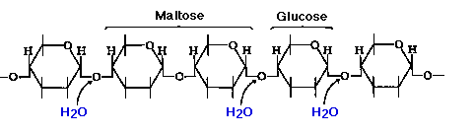
Before starches can enter (or leave) cells, they must be digested. The hydrolysis of starch is done by amylases. With the aid of an amylase (such as pancreatic amylase), water molecules enter at the 1 -> 4 linkages, breaking the chain and eventually producing a mixture of glucose and maltose. A different amylase is needed to break the 1 -> 6 bonds of amylopectin.

Glycogen
Animals store excess glucose by polymerizing it to form glycogen. The structure of glycogen is similar to that of amylopectin, although the branches in glycogen tend to be shorter and more frequent.
Glycogen is broken back down into glucose when energy is needed (a process called glycogenolysis).
In glycogenolysis,
- Phosphate groups — not water — break the 1 -> 4 linkages
- The phosphate group must then be removed so that glucose can leave the cell.
The liver and skeletal muscle are major depots of glycogen.
There is some evidence that intense exercise and a high-carbohydrate diet ("carbo-loading") can increase the reserves of glycogen in the muscles and thus may help marathoners work their muscles somewhat longer and harder than otherwise. But for most of us, carbo loading leads to increased deposits of fat.

Cellulose
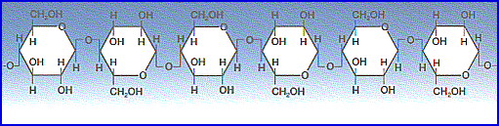
Cellulose is probably the single most abundant organic molecule in the biosphere. It is the major structural material of which plants are made. Wood is largely cellulose while cotton and paper are almost pure cellulose.
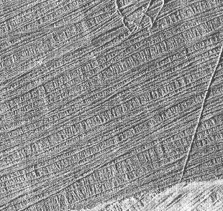
Like starch, cellulose is a polysaccharide with glucose as its monomer. However, cellulose differs profoundly from starch in its properties.
- Because of the orientation of the glycosidic bonds linking the glucose residues, the rings of glucose are arranged in a flip-flop manner. This produces a long, straight, rigid molecule.
- There are no side chains in cellulose as there are in starch. The absence of side chains allows these linear molecules to lie close together.
- Because of the many -OH groups, as well as the oxygen atom in the ring, there are many opportunities forhydrogen bonds to form between adjacent chains.
The result is a series of stiff, elongated fibrils — the perfect material for building the cell walls of plants.
This electron micrograph (courtesy of R. D. Preston) shows the cellulose fibrils in the cell wall of a green alga. These long, rigid fibrils are a clear reflection of the nature of the cellulose molecules of which they are composed.

Polypeptides
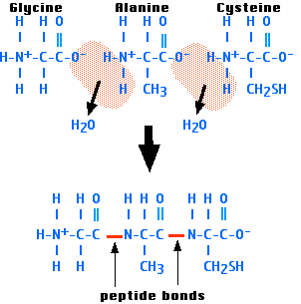
Polypeptides are chains of amino acids. Proteins are made up of one or more polypeptide molecules.
The amino acids are linked covalently by peptide bonds. The graphic on the right shows how three amino acids are linked by peptide bonds into atripeptide.
One end of every polypeptide, called the amino terminal or N-terminal, has a free amino group. The other end, with its free carboxyl group, is called the carboxyl terminal or C-terminal.
The sequence of amino acids in a polypeptide is dictated by the codons in the messenger RNA (mRNA) molecules from which the polypeptide was translated. The sequence of codons in the mRNA was, in turn, dictated by the sequence of codons in the DNA from which the mRNA wastranscribed.
The schematic below shows the N-terminal at the upper left and the C-terminal at the lower right.
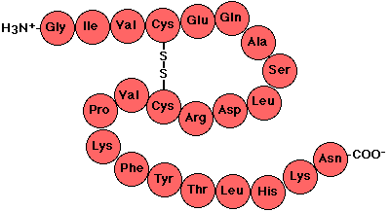
Proteins are made up of one or more polypeptide molecules. Follow these links to examine the various levels of polypeptide organization in proteins.

Proteins
Proteins are macromolecules. They are constructed from one or more unbranched chains of amino acids; that is, they are polymers. A typical protein contains 200–300 amino acids but some are much smaller (the smallest are often called peptides) and some much larger (the largest to date is titin a protein found in skeletal and cardiac muscle; one version contains 34,350 amino acids in a single chain!).
Every function in the living cell depends on proteins.
- Motion and locomotion of cells and organisms depends on proteins. [Examples: Muscles, Cilia and Flagella]
- The catalysis of all biochemical reactions is done by enzymes, which contain protein.
- The structure of cells, and the extracellular matrix in which they are embedded, is largely made of protein. [Examples: Collagens] (Plants and many microbes depend more on carbohydrates, e.g., cellulose, for support, but these are synthesized by enzymes.)
- The transport of materials in body fluids depends of proteins. [See Blood]
- The receptors for hormones and other signaling molecules are proteins.
- Proteins are an essential nutrient for heterotrophs.
- The transcription factors that turn genes on and off to guide the differentiation of the cell and its later responsiveness to signals reaching it are proteins.
- and many more — proteins are truly the physical basis of life.
The protein represented here displays many of the features of proteins. Let's examine some of them as you scroll down the image.
The protein consists of two polypeptide chains, a long one on the left of 346 amino acids — it is called the heavy chain — and a short one on the right of 99 amino acids.

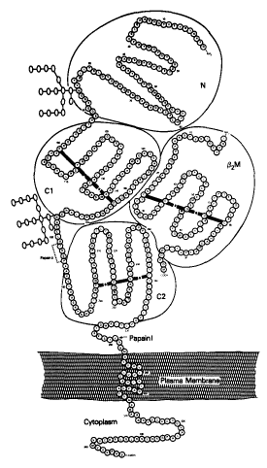

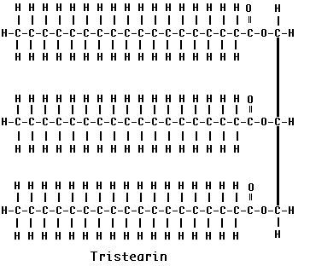

Fats
Fat molecules are made up of four parts:
- a molecule of glycerol (on the right) and
- three molecules of fatty acids.
Each fatty acid consists of a hydrocarbon chain with a carboxyl group at one end. The glycerol molecule has three hydroxyl groups, each able to interact with the carboxyl group of a fatty acid. Removal of a water molecule at each of the three positions forms a triglyceride.
The three fatty acids in a single fat molecule may be all alike (as shown here for tristearin) or they may be different.
They may contain as few as 4 carbon atoms or as many as 24.
Because fatty acids are synthesized from fragments containing two carbon atoms, the number of carbon atoms in the chain is almost always an even number.
In animal fats, 16-carbon (palmitic acid) and 18-carbon (stearic acid - shown here) fatty acids are the most common.

Unsaturated Fats
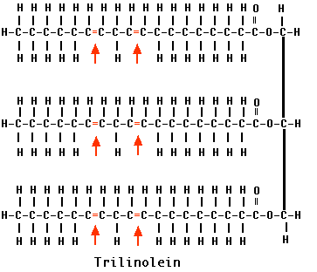
Some fatty acids have one or more double bonds between their carbon atoms. They are called unsaturated because they could hold more hydrogen atoms than they do.
Monounsaturated fats have a single double bond in their fatty acids.
Polyunsaturated fats, such as trilinolein shown here, have two or more.
Double bonds are rigid and those in natural fats introduce a kink in the molecule. This prevents the fatty acids from packing close together and as a result, unsaturated fats have a lower melting point than do saturated fats. Because most of them are liquid at room temperature, we call them oils. Corn oil, canola oil, cottonseed oil, peanut oil, and olive oil are common examples.
As this list suggests, plant fats tend to be unsaturated (therefore "oils"). Fats from such animals as cattle tend to be saturated.

Trans fatty acids
Because
- the most abundant (and least expensive) source of fat is from plant oils but
- many cooking applications, particularly baked products, need solid fats
- the food industry uses hydrogenated oils for things like shortening and margarine.
In hydrogenation, plant oils are exposed to hydrogen at a high temperature and in the presence of a catalyst.
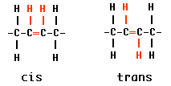
Two things result:
- some double bonds are converted into single bonds.
- other double bonds are converted from cis to trans configuration.
- both these effects straighten out the molecules so they can lie closer together and become solid rather than liquid.

Omega fatty acids
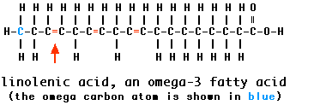
One system for naming unsaturated fatty acids is to indicate the position of the first double bond counting from the opposite end from the carboxyl group. That terminal carbon atom (shown here in blue) is called the omega carbon atom. Thus a monounsaturated fatty acid with its single double bond after carbon #3 (counting from and including the omega carbon) is called an omega-3 fatty acid. But so is apolyunsaturated fatty acid, such as linolenic acid (shown here), if its first double bond is in that position.
Some studies have suggested that omega-3 fatty acids help protect against cardiovascular disease. For this reason, a Dietary Reference Intake (DRI) of 1.1 grams/day for women (1.6 for men) was established in September 2002.

Nucleotides
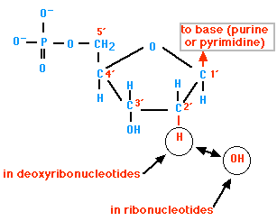
Nucleic acids are linear, unbranched polymers of nucleotides.
Nucleotides consist of three parts:

1.
A five-carbon sugar (hence a pentose). Two kinds are found:
- Deoxyribose, which has a hydrogen atom attached to its #2 carbon atom (designated 2'), and
- Ribose, which has a hydroxyl group there.
Deoxyribose-containing nucleotides, the deoxyribonucleotides, are the monomers of deoxyribonucleic acids (DNA).
Ribose-containing nucleotides, the ribonucleotides, are the monomers of ribonucleic acids (RNA).

2.
A nitrogen-containing ring structure called a base. The base is attached to the 1' carbon atom of the pentose. In DNA, four different bases are found:
- two purines, called adenine (A) and guanine (G)
- two pyrimidines, called thymine (T) and cytosine (C)
RNA contains:
- The same purines, adenine (A) and guanine (G).
- RNA also uses the pyrimidine cytosine (C), but instead of thymine, it uses the pyrimidine uracil (U).

The Pyrimidines

The Purines
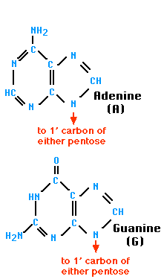
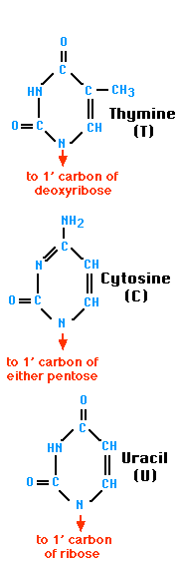

The combination of a base and a pentose is called a nucleoside.

3.
One (as shown in the first figure), two, or three phosphate groups. These are attached to the 5' carbon atom of the pentose. The product in each case is called a nucleotide.
Both DNA and RNA are assembled from nucleoside triphosphates.
For DNA, these are dATP, dGTP, dCTP, and dTTP.
For RNA, these are ATP, GTP, CTP, and UTP.
In both cases, as each nucleotide is attached, the second and third phosphates are removed.
The nucleosides and their mono-, di-, and triphosphates
 | Base | Nucleoside | Nucleotides
DNA | Adenine (A) | Deoxyadenosine | dAMP | dADP | dATP
 | Guanine (G) | Deoxyguanosine | dGMP | dGDP | dGTP
 | Cytosine (C) | Deoxycytidine | dCMP | dCDP | dCTP
 | Thymine (T) | Deoxythymidine | dTMP | dTDP | dTTP
RNA | Adenine (A) | Adenosine | AMP | ADP | ATP
 | Guanine (G) | Guanosine | GMP | GDP | GTP
 | Cytosine (C) | Cytidine | CMP | CDP | CTP
 | Uracil (U) | Uridine | UMP | UDP | UTP

The polymerization of nucleotides.
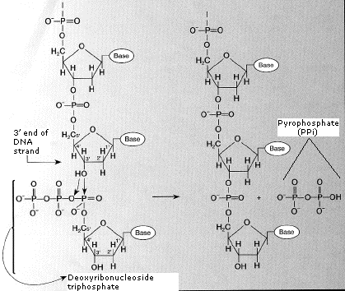
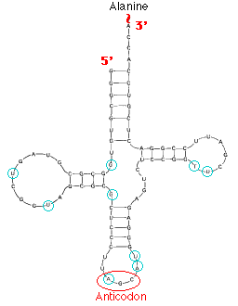
The nucleic acids, both DNA and RNA, consist of polymers of nucleotides. The nucleotides are linked covalently between the 3' carbon atom of the pentose and the phosphate group attached to the 5' carbon of the adjacent pentose. The figure on the right shows the polymer structure of DNA.
Most intact DNA molecules are made up of two strands of polymer, forming a "double helix".
RNA molecules, while single-stranded, usually contain regions where two portions of the strand twist around each other to form helical regions. Alanine transfer RNA, shown on the left, is an example.
The two strands of DNA and the helical regions of RNA are held together by base pairing.
The polymerization of DNA is described more fully in DNA Replication.

Hydrogen Bonds
Polar molecules, such as water molecules, have a weak, partial negative charge at one region of the molecule (the oxygen atom in water) and a partial positive charge elsewhere (the hydrogen atoms in water).
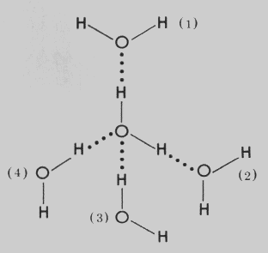
Thus when water molecules are close together, their positive and negative regions are attracted to the oppositely-charged regions of nearby molecules. The force of attraction, shown here as a dotted line, is called a hydrogen bond. Each water molecule is hydrogen bonded to four others.
The hydrogen bonds that form between water molecules account for some of the essential — and unique — properties of water.
- The attraction created by hydrogen bonds keeps water liquid over a wider range of temperature than is found for any other molecule its size.
- The energy required to break multiple hydrogen bonds causes water to have a high heat of vaporization; that is, a large amount of energy is needed to convert liquid water, where the molecules are attracted through their hydrogen bonds, to water vapor, where they are not.
Two outcomes of this:
- The evaporation of sweat, used by many mammals to cool themselves, cools by the large amount of heat needed to break the hydrogen bonds between water molecules.
- Reduction of temperature extremes near large bodies of water like the ocean.
The hydrogen bond has only 5% or so of the strength of a covalent bond. However, when many hydrogen bonds can form between two molecules (or parts of the same molecule), the resulting union can be sufficiently strong as to be quite stable.

