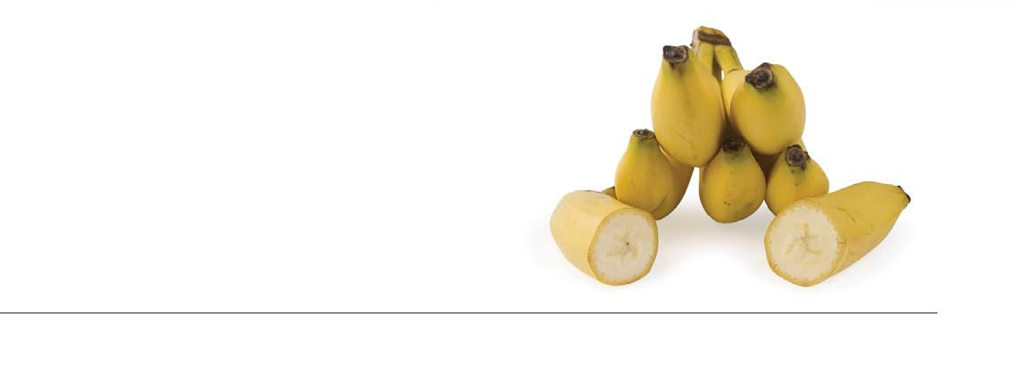
Name:________________________________________Date:_____________________Period:_____________
Banana Split:
To Eat, or Not to Eat

*Case Study Modified from Washington State University and Ithaca College*

Part I – The Past
Narrator: This is a conversation between Ethan Brown, the chairman of the fictitious major fruit company Integrated Fruit, and Bill Snowe, a banana breeder in one of the company’s research stations in Central America. The conversation takes place in the 1970s. Ethan Brown was dedicated to making positive changes in Integrated Fruit, but the company was struggling financially, faced with intense competition and a backlash in the form of increased regulation from a Latin American government. Bill Snowe had been breeding bananas for the company for many years, was widely regarded as an expert on banana cultivation, and was also well known for his empathy for the banana workers.
Bill Snowe: You know, Ethan, the longer I work on developing a better banana for the U.S. market, the more I wonder about the whole enterprise. How did we end up in the business of selling such a fragile fruit that lasts only a couple of weeks, has to be picked when it’s green and transported thousands of miles in refrigerated ships to prevent ripening, and then ripened artificially?
Ethan Brown: And consumers are accustomed to inexpensive bananas—they cost less per pound than apples or oranges that are grown in the U.S. The narrow profit margin is killing the company.
Bill Snowe: What if we could charge more for bananas? The company would make more money, but would the banana workers get paid more?
Ethan Brown: I know how you feel about the treatment of banana workers. Integrated Fruit has been criticized (sighing) for exploitation ever since the company’s founder, Major Streif, discovered that he could make a lot of money by growing bananas along the railroad lines he was building in Costa Rica in the 1870s. He built the rail in exchange for lots of cheap land, courtesy of the Costa Rican government. What I’ve never understood is why the company acquired so much land, when most of it wasn’t being used to grow bananas.
Bill Snowe: It took a lot of land to grow bananas in the tropics back then. Most of the nutrients in tropical soils are bound up in the vegetation. Many of those nutrients are lost when the rainforest is cleared to grow crops like bananas. And then when you grow the same crop on the same land year after year, you quickly use up what nutrients are left in the soil. When the nutrients in the soil were depleted, the fields were abandoned. At first the company had a policy of giving the abandoned land back to the local government, but then Panama disease showed up. It spread quickly through banana plantations, which then had to be abandoned. To satisfy the demand for bananas, the rate at which company managers cleared rainforest to establish new plantations intensified.
Ethan Brown: That explains why the company owned so much land. I remember hearing that in the 1950s, Integrated Fruit owned 70% of the farmland in Honduras. The country’s president, Pedro Ancho, tried to reclaim the abandoned banana fields for the people, but he wasn’t willing to pay much to Integrated Fruit—just what the land was assessed for taxes. Integrated Fruit officials prevented what they viewed as a land grab, and what Ancho saw as land reform, by convincing the U. S. president that Ancho and his top officials were Communists. In 1954, the U.S. military and CIA helped overthrow the Ancho government.
Bill Snowe: Good old U.S. hegemony. What I hate is that the people in these countries are put between a rock and a hard place. Integrated Fruit owns much of the land, so this is where the jobs are. But when the workers try to organize to get better wages and improve their substandard housing and almost non-existent health care, the company packs up and moves to another country … or worse. I think it stinks. In order to avoid striking workers and Panama disease, Integrated Fruit has destroyed enormous amounts of rainforest.
Ethan Brown: Hmm. The striking workers I get. But this Panama disease—why is it so bad?
Bill Snowe: Turns out that “Gros Michel,” the only banana cultivar that was being grown for export, was highly susceptible to this soil fungus that infects banana roots. When plants are infected, the fungus clogs up the vascular system; water can’t get from the roots to the rest of the plant, and so the leaves wilt and the bananas turn black. That’s Panama disease. And there’s nothing we can do about it. There’s no way to keep the fungus from infecting the banana roots, and no practical way to eliminate the fungus from the soil.
Ethan Brown: So why isn’t it a problem now?
Bill Snowe: This is where the story gets interesting. Royale Fruit, one of our major competitors, was already exporting a new variety in 1947, called “Cavendish.” Cavendish was resistant to Panama disease. Royale Fruit had less land than Integrated Fruit and they didn’t have the option of outrunning the disease. Integrated Fruit didn’t switch over to Cavendish until 1961. But Cavendish is susceptible to other things, such as bacteria, another fungal disease called Sigatoka, nematodes, caterpillars, aphids, and root weevils. I’m a pretty good plant breeder, but breeding a banana that is resistant to all these pests is a tall order!
Ethan Brown: But a banana that’s resistant could save the company. What’s your biggest challenge?
Bill Snowe: No seeds. In most banana varieties, there are only about 25 seeds in 250,000 bananas. Cavendish is totally seedless so we can’t even use it as part of a cross. But I do have some varieties that can resist many of the most serious diseases. It’s just that consumers won’t buy them because they don’t look and taste exactly like a Cavendish.
Ethan Brown: I guess we were lucky that consumers accepted Cavendish, come to think of it. It’s not as sweet as the old Gros Michel. You said that Cavendish is susceptible to other types of diseases and pests. How can it be grown then?
Bill Snowe: These other diseases and pests can be controlled with pesticides. That has actually been the main research done here. Some call this research station “La Quimica.” The most challenging disease is Sigatoka. It was a problem with Gros Michel as well. But the Sigatoka fungus infects plants through the leaves, so it can be controlled by spraying the leaves with a pesticide. The first one that was used for Sigatoka was a concoction called “Bordeaux mixture.” The mixture contained copper sulfate, which, unfortunately, got into the workers who sprayed it. It turned them blue and made them sick. Many died. Bordeaux mixture was eventually abandoned because too much copper in the soil kills the banana plants, not because of what it did to the workers.
Ethan Brown: Ouch. Aren’t there other pesticides available to control Sigatoka?

Bill Snowe: Sure, but what worries me is that we’re no longer dealing with the original Sigatoka disease. Now there’s a different fungus that causes black Sigatoka, and this one is much more destructive. We have to spray up to 40 times a year to control just this one disease.
Ethan Brown: That explains why pesticides are 25% of the production costs. (Brown shakes his head.) I really thought I could turn this company around. But in addition to all these production problems, I’m now faced with new taxes on each box of bananas coming out of the Honduras. The company is already operating in the red. I know that if I pay a 1.25 million dollar bribe to the Honduran government, I can get the tax reduced and the company will survive. But you know Bill, I consider myself an ethical businessman. Moses said, “Bribery blinds the eyes of the wise, and perverts the words of the just.” Bill, what do you think I should do?
Questions: Please use the following questions as a guide to writing a reflection for this case study. The reflection should be approximately three paragraphs in length (1 per question) and should thoroughly answer each of the following questions.
- Bill Snowe was trying to develop a “better banana”; based on information presented, what qualities would this banana need to have in order for it to be better than the Cavendish? How are Snowe’s challenges in developing a better banana different from that of an apple breeder?
- What are the challenges Ethan Brown faces in keeping Integrated Fruit from going bankrupt?
- What should Ethan Brown do? What are the potential consequences of his decision?

