Name: __________________________________________________ Date: _______________________ Period: ______

AP Biology: Unit 5, DBA #1 Review

Objectives Assessed: Topic 1 (Cell Types and Structure), Learning Targets A-D
Practice Questions: Answer the following questions thoroughly and accurately in preparation for your Daily Biology Assessment.

1. Which cell structures are found in BOTH prokaryotic and eukaryotic cells?

2. Which cell structures are found only in plant cells? What about animal cells?

3. Where in an animal cell can DNA be found? (Remember: Some organelles other than the nucleus contain DNA!)

4. Where in a plant cell can DNA be found? (Remember: Some organelles other than the nucleus contain DNA!)

5. What is the overall function of the endomembrane system?

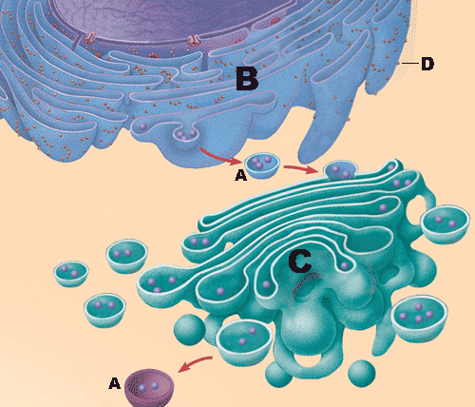

6. Label the endomembrane system image to the right with the following terms: Golgi, Vesicle, Ribosome, Rough ER

What is missing from the diagram to the right?

7. Label the organelles in the image below…

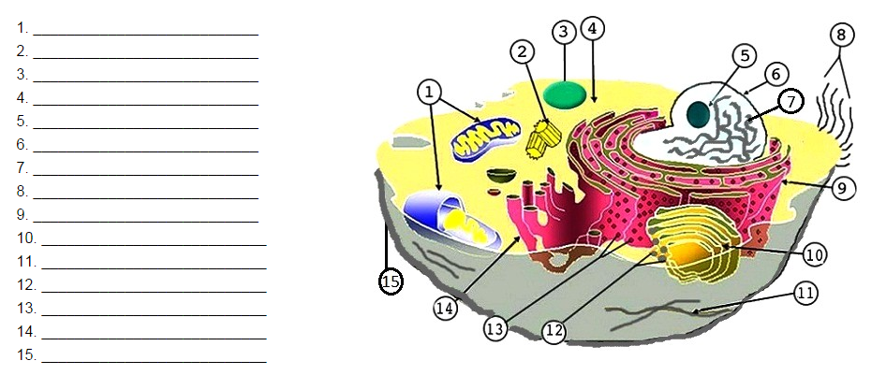

What type of cell is this, and how do you know?

8. Label the organelles in the image below…

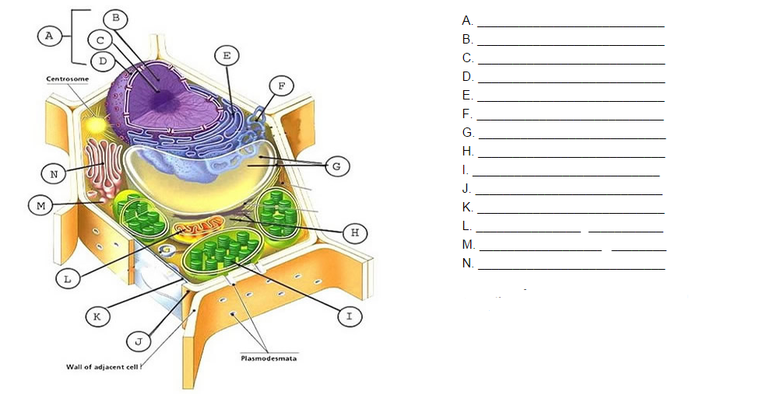

What type of cell is this, and how do you know?

9. Identify the organelle that is used for each function given below.

________________________A. Used to regulate the transport of materials into and out of the cell.

________________________B. Used to digest food, old cell parts, etc. using enzymes.

________________________C. Used to capture solar energy and convert it to the chemical energy stored in the molecule glucose.

________________________D. A network of proteins inside the cell that provide structural support for the cell.

________________________E. Structures made of microtubules that are used for movement… they are short and numerous on the outside of the cell.

________________________F. Structures made of microtubules that are used for movement… they are long and there are usually 1-3 of them on the outside of a cell.

________________________G. A structure that contains the cell’s DNA and has a double membrane.

________________________H. A structure within the nucleus that creates ribosomes.

________________________I. A structure used to create proteins that is found in both prokaryotic and eukaryotic cells.

________________________J. The region between the nucleus and cell membrane that contains a jelly-like fluid used to cushion organelles.

________________________K. A structure made of membrane with attached ribosomes that is used to create proteins that will exit the cell (aka secretory proteins). This structure also serves as a highway to move substances around the cell.

________________________L. A structure made of membranous tubes and sacs that is used to modify and package protein products and send them to the cell membrane.

________________________M. A structure made of membrane with no attached ribosomes that is used to create lipids (ex: steroid hormones) and remove / destroy toxins.

________________________N. A structure found on the outside of plant cells that is used to provide protection and support.

________________________O. A structure found only inside animal cells that is used to assist with cell division.

________________________P. A structure that is used to convert glucose into ATP. T

________________________Q. A structure that is used to store substances (ex: water, food, wastes, enzymes).

________________________R. A network of glycoproteins outside animal cells that strengthens them and connects them to one another.

